INPUT OUTPUT:-

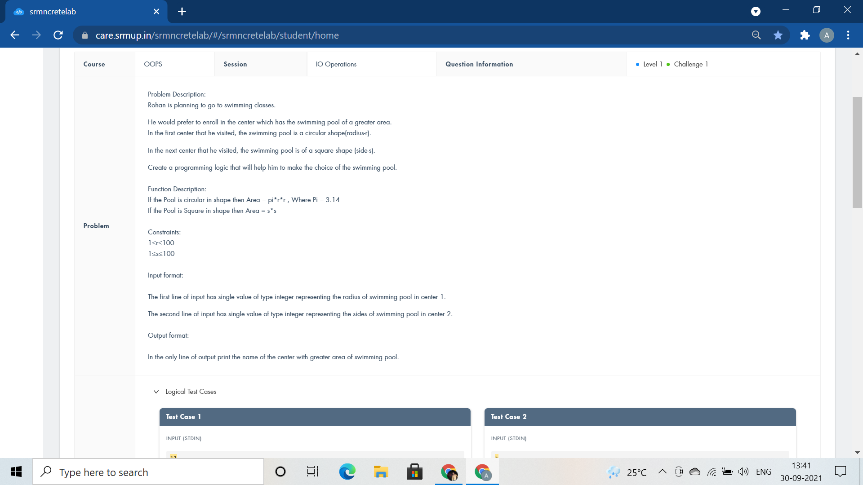

#include <iostream>

using namespace std;

int main()

{

int r,s,cpool,spool;

cin>>r>>s;

cpool=3.14*r*r;

spool=s*s;

if(cpool>spool)

cout<<"I Prefer Centre 1";

else

cout<<"I Prefer Centre 2";

return 0;

}

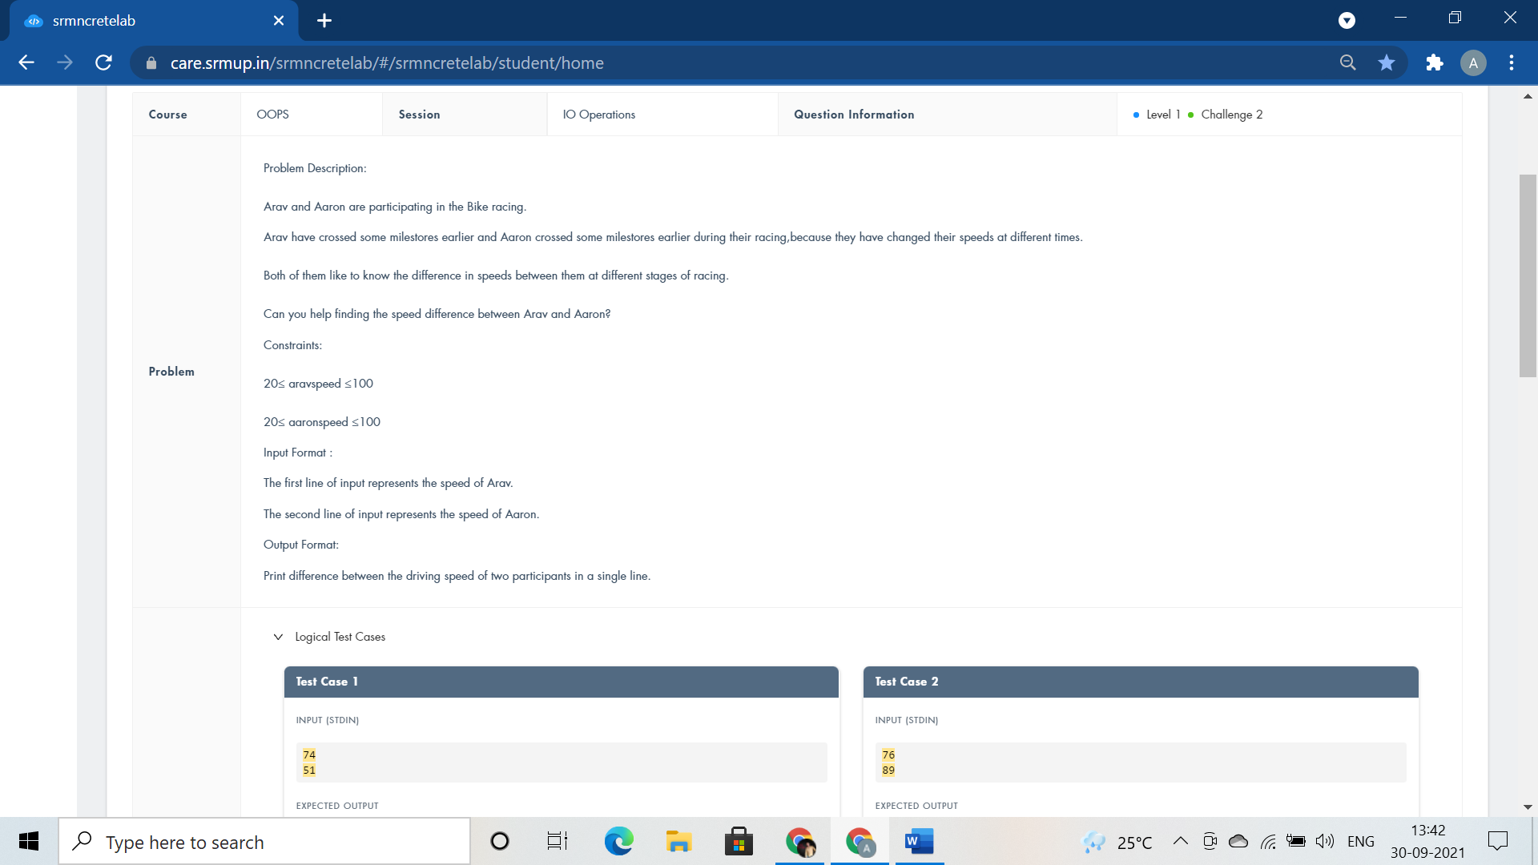

#include <iostream>

using namespace std;

int main()

{

int aravspeed,aaronspeed,speeddiff;

cin>>aravspeed>>aaronspeed;

if(aravspeed>aaronspeed)

speeddiff=aravspeed - aaronspeed;

else

speeddiff=aaronspeed - aravspeed;

cout<<speeddiff;

return 0;

}

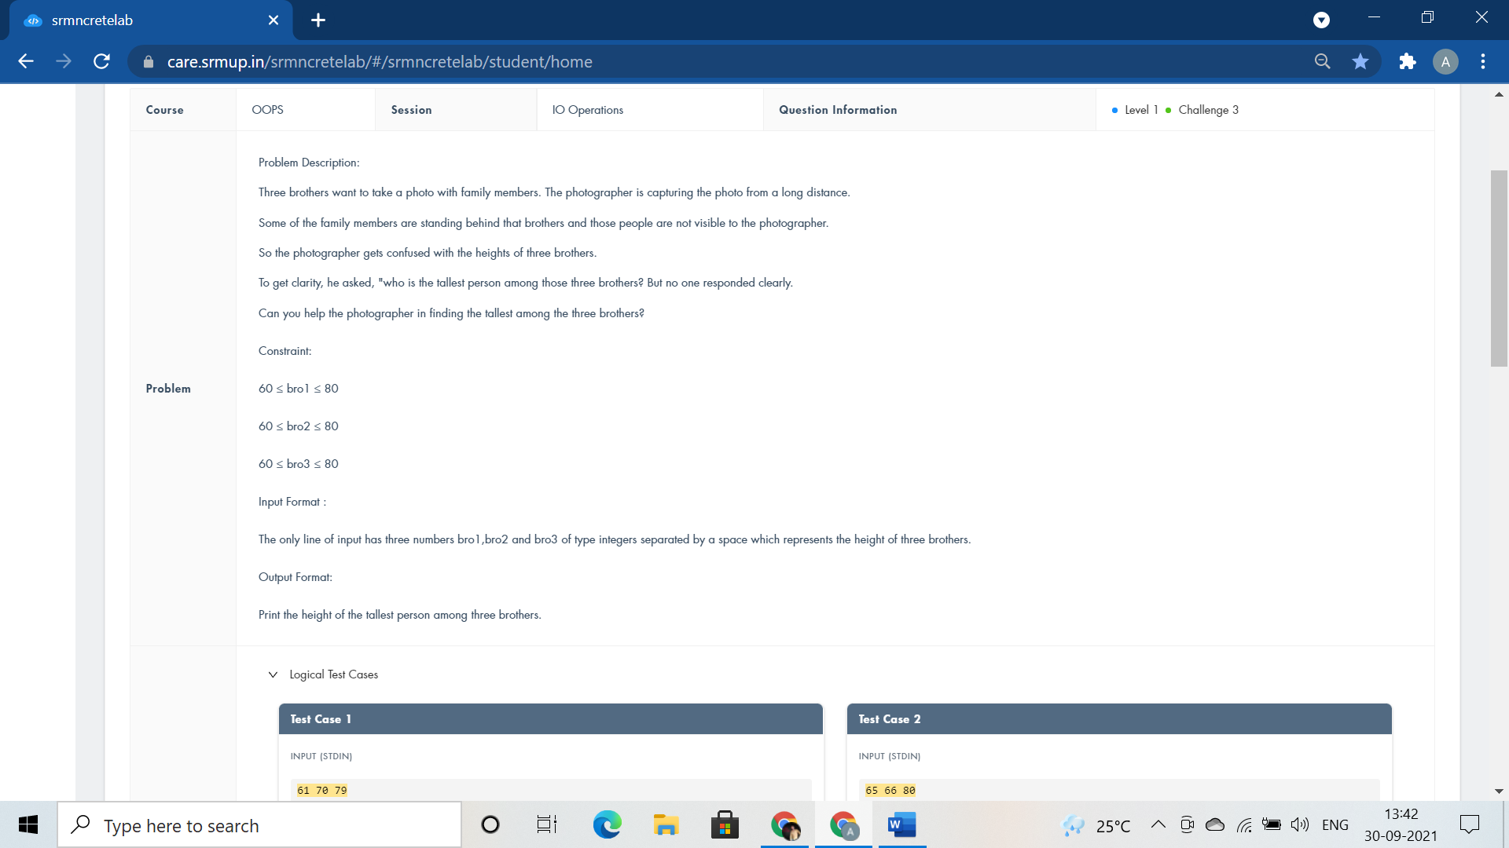

#include <iostream>

using namespace std;

int main() {

int bro1,bro2,bro3;

cin>>bro1>>bro2>>bro3;

if(bro1>bro2) {

if(bro1>bro3)

cout<<bro1;

else

cout<<bro3;

}

else if(bro2>bro3)

cout<<bro2;

else

cout<<bro3;

return 0;

}

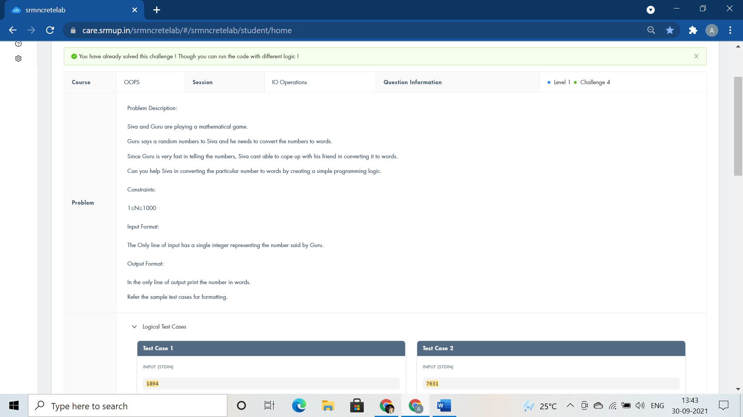

#include <iostream>

using namespace std;

int main()

{

int n,dig=0,rem;

cin>>n;

while(n!=0)

{

rem=n%10;

dig=dig*10+rem;

n/=10;

}

while(dig!=0)

{

rem=dig%10;

switch(rem)

{

case 0:

cout<<"Zero ";

break;

case 1:

cout<<"One ";

break;

case 2:

cout<<"Two ";

break;

case 3:

cout<<"Three ";

break;

case 4:

cout<<"Four ";

break;

case 5:

cout<<"Five ";

break;

case 6:

cout<<"Six ";

break;

case 7:

cout<<"Seven ";

break;

case 8:

cout<<"Eight ";

break;

case 9:

cout<<"Nine ";

break;

};

dig/=10;

}

return 0;

}

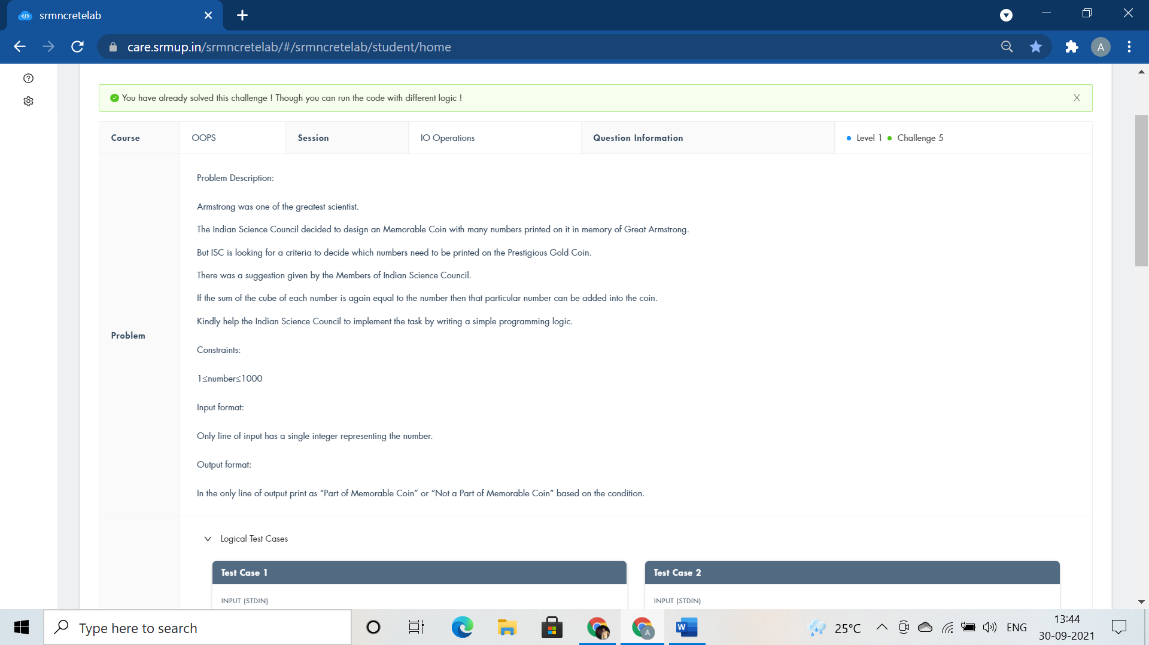

#include <iostream>

using namespace std;

int main()

{

int number,num,rem,result=0;

cin>>number;

num=number;

while(num!=0) {

rem = num%10;

result+=rem*rem*rem;

num/=10;

}

if(result==number)

cout<<"Part of Memorable Coin";

else

cout<<"Not a Part of Memorable Coin";

return 0;

}

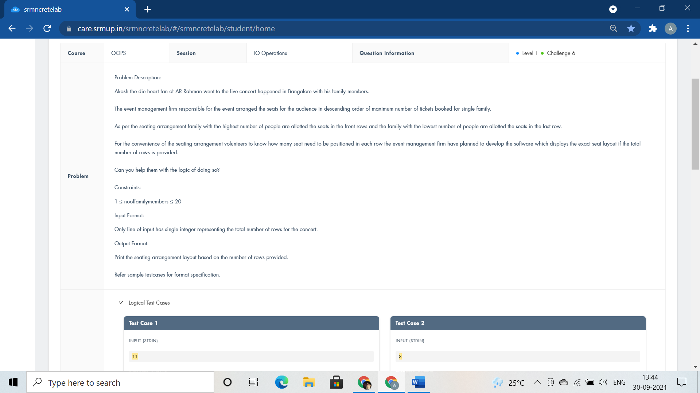

#include <iostream>

using namespace std;

int main()

{

int nooffamilymembers,i,j;

cin>>nooffamilymembers;

for(i=nooffamilymembers;i>0;i--)

{

for(j=0;j<i;j++)

cout<<i<<" ";

cout<<endl;

}

return 0;

}

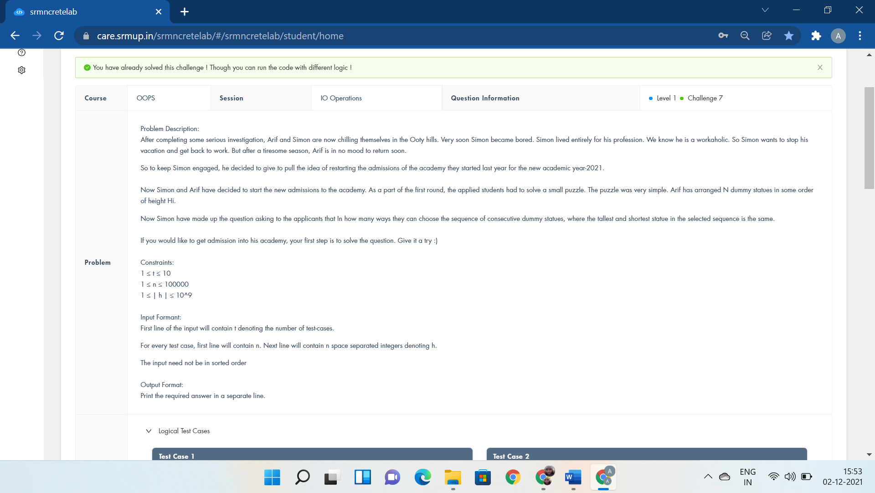

#include <iostream>

using namespace std;

int main()

{

int t,n,h,i,l=1,count;

cin>>t;

while(t--)

{

l=1;

count=0;

cin>>n;

for(i=1;i<=n;i++) {

cin>>h;

if(h==l) {

count+=2;

}

if(h>l) {

l=h;

count++;

}

}

cout<<count<<endl;

}

return 0;

}

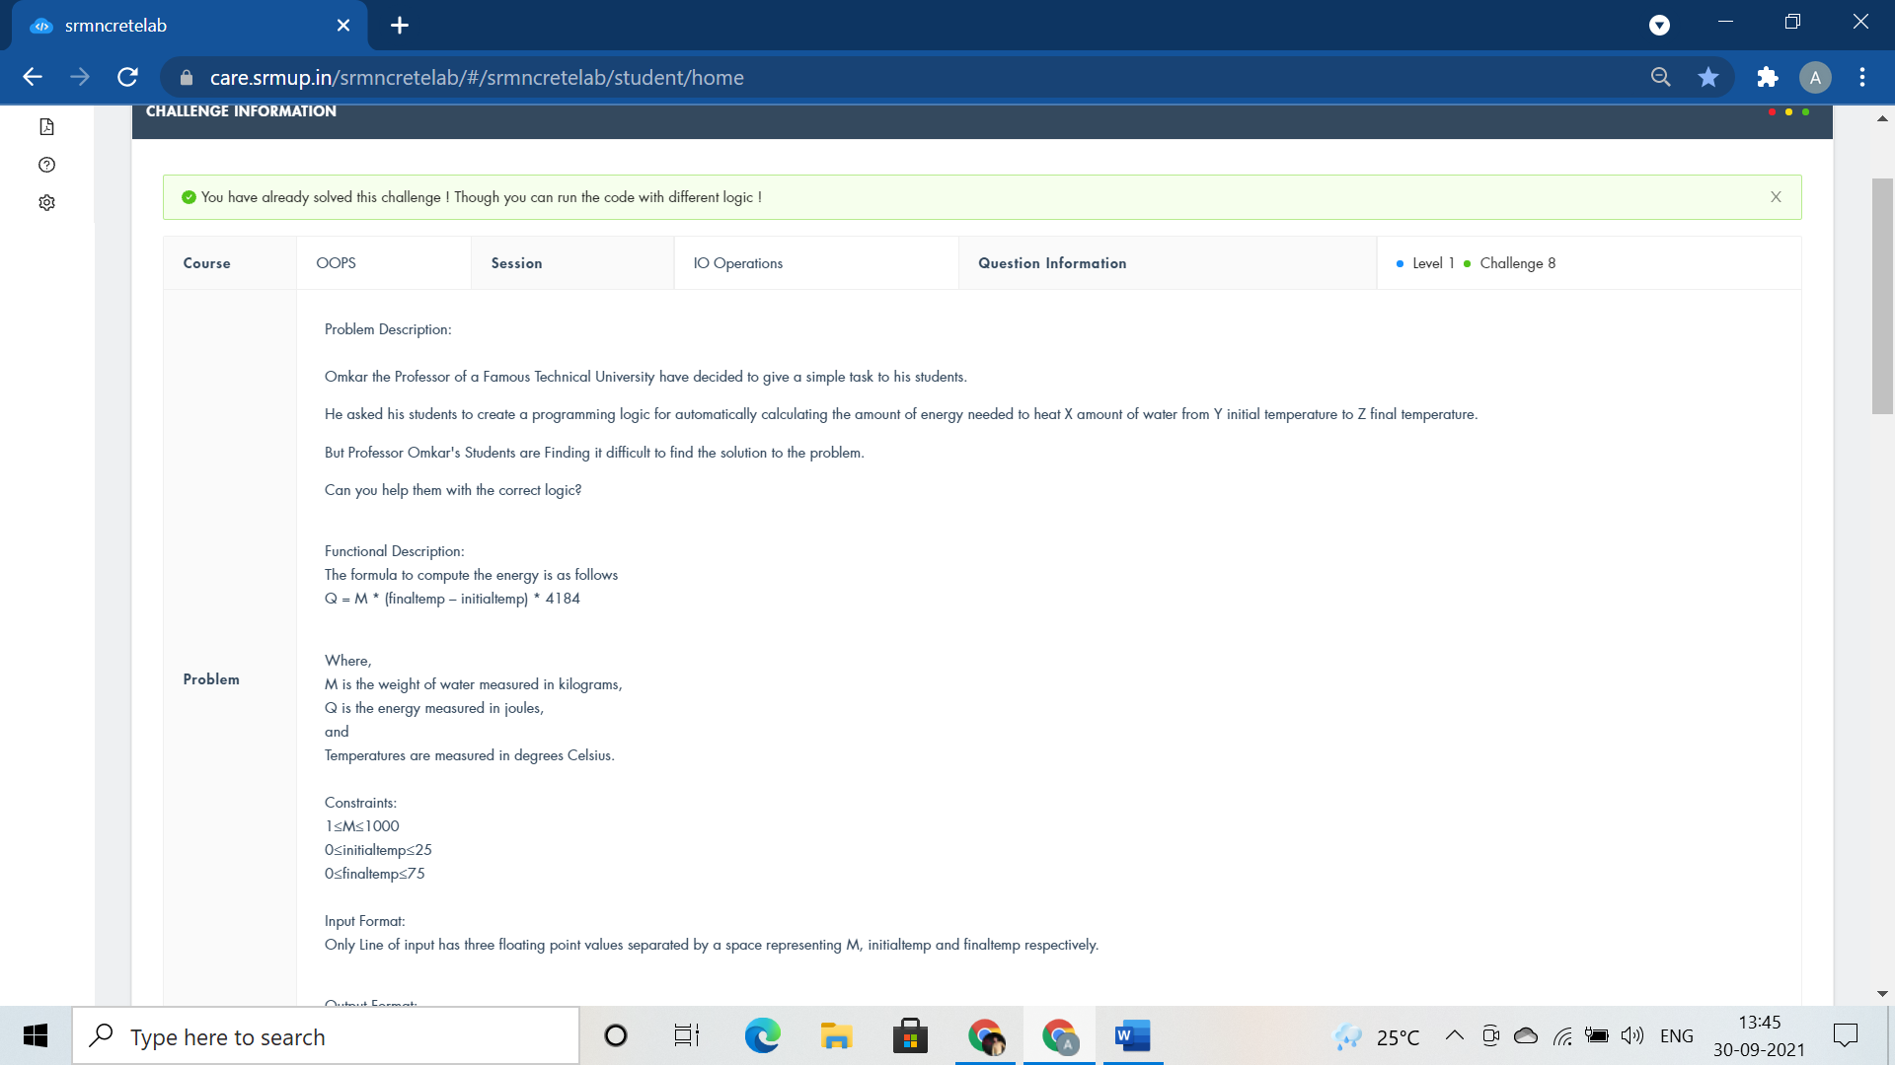

#include <iostream>

using namespace std;

int main()

{

int M,initialtemp,finaltemp;

float Q;

cin>>M>>initialtemp>>finaltemp;

Q=M*(finaltemp - initialtemp)*4184;

cout<<""<<Q;

return 0;

}

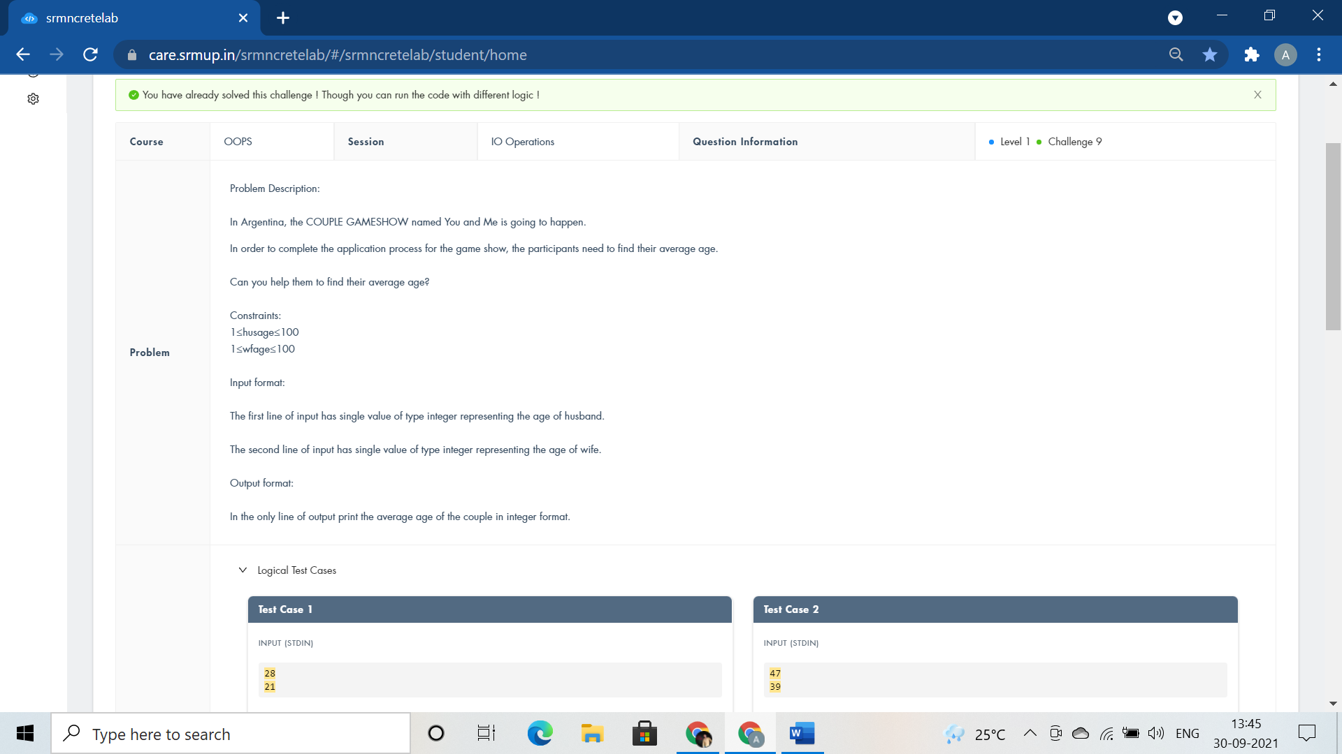

#include <iostream>

using namespace std;

int main()

{

int husage,wfage,coupleavgage;

cin>>husage>>wfage;

coupleavgage=(husage+wfage)/2;

cout<<"I am "<<husage<<endl<<"You are "<<wfage<<endl<<"We are around "<<coupleavgage;

return 0;

}

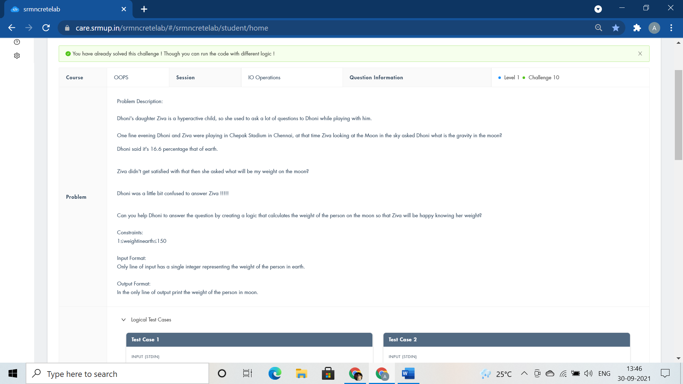

#include <iostream>

using namespace std;

int main()

{

int weightinearth;

cin>>weightinearth;

float weightinmoon;

weightinmoon=0.166*weightinearth;

cout<<weightinmoon;

return 0;

}

CLASSES METHODS AND CONSTRUCTORS:-

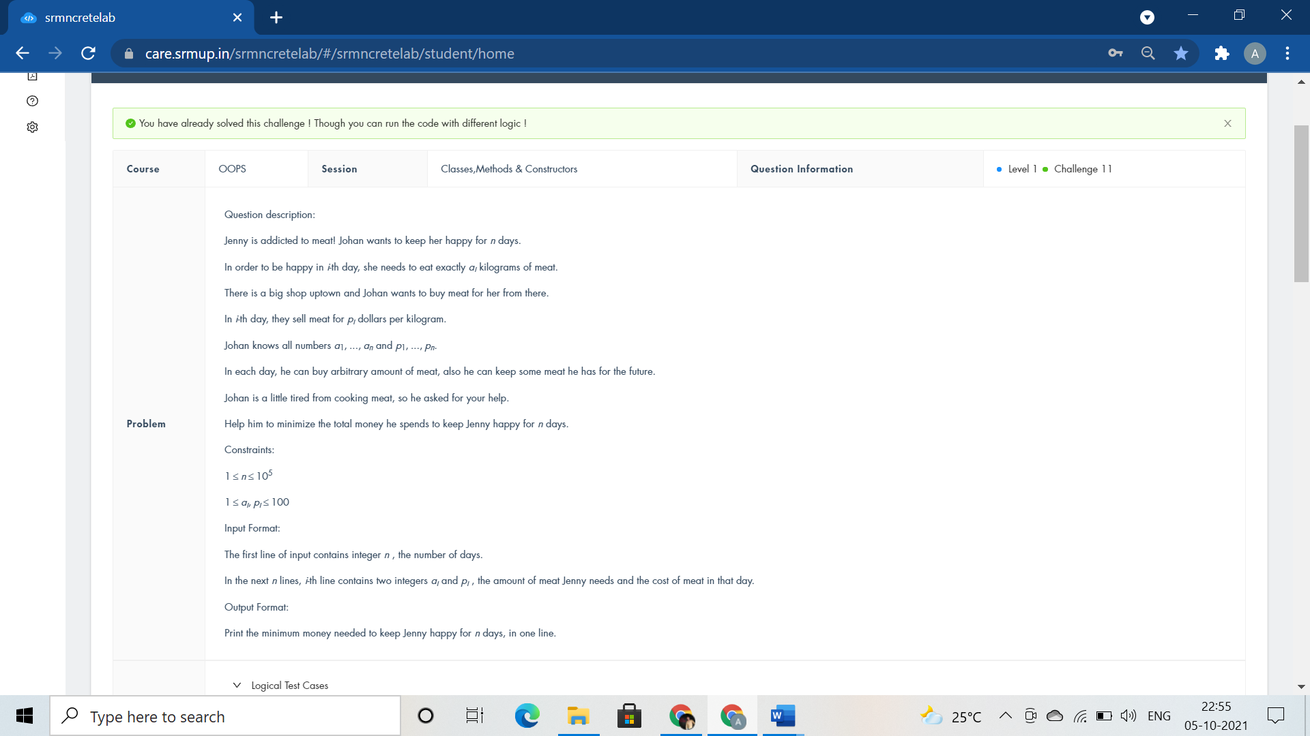

#include <iostream>

using namespace std;

class Happiness{

public:int Meat(){

int n,a,b,max=100,sum=0;

cin>>n;

while(n--)

{

cin>>a>>b;

//max=b;

if(b>=max)

sum+=a*max;

// cout<<max<<endl;

// cout<<sum<<endl;

else

{

max=b;

sum+=a*b;

// cout<<max<<endl;

// cout<<sum<<endl;

}

}

return sum;

}

};

int main(){

Happiness Purchase;

cout<<Purchase.Meat();

}

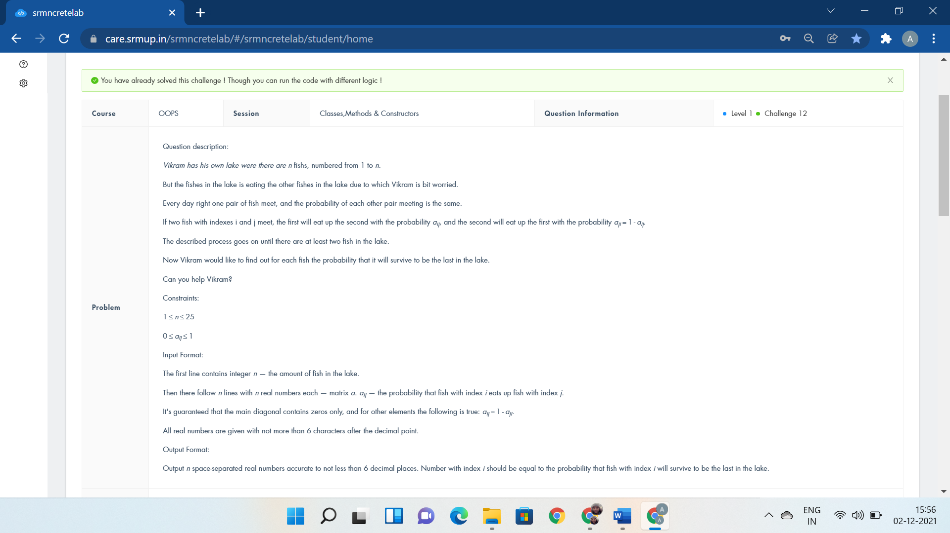

#include <iostream>

#include <string.h>

#include <stdio.h>

using namespace std;

double a[18][18], b[1 << 18];

int fun(int x) {

int s = 0;

while (x)

{

s += x & 1;

x >>= 1;

}

return s;

}

int main() {

if(0)

cout<<"class Lake public:void survival() fish.survival();";

int n, i, r, t, j;

cin >> n;

for (i = 0; i < n; i++)

for (j = 0; j < n; j++)

scanf("%lf", &a[i][j]);

memset(b, 0, sizeof(b));

b[(1 << n) - 1] = 1;

for (i = (1 << n) - 1; i >= 0; i--) {

int c = fun(i);

c = c * (c - 1) / 2;

for (r = 0; r < n; r++)

if (i & (1 << r))

for (t = 0; t < n; t++)

if (i & (1 << t))

b[i - (1 << t)] += b[i] * a[r][t] / c;

}

for (r = 0; r < n - 1; r++)

printf("%.6lf ", b[1 << r]);

printf("%.6lf\n", b[1 << r]);

}

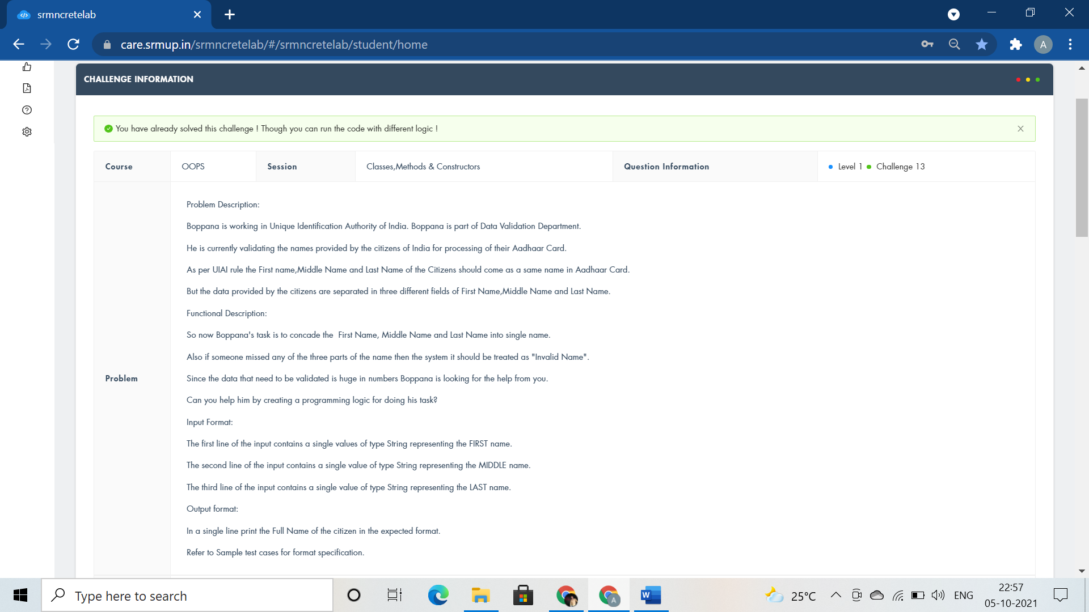

#include <iostream>

#include<cstring>

#include<string>

using namespace std;

class aadhaar

{

public:

void NameofCitizen(string fn,string mn,string ln)

{

if(fn.empty() || mn.empty() || ln.empty() )

{

cout<<"Invalid Name";

}

//cout<<"Invalid name"; exit(0) :

else

cout<<fn<<mn<<ln;

}

};

int main()

{

aadhaar Card;

string fn,mn,ln;

cin>>fn>>mn>>ln;

Card.NameofCitizen(fn,mn,ln);

return 0;

}



#include <iostream>

using namespace std;

class TollBooth

{

public:

int cars;

float tollcollected;

TollBooth(){

cars=0;

tollcollected=0;

}

void payingcar(double pay){

cars++;

tollcollected+=pay;

}

void nonpayingcar(){

cars++;

}

void display(){

cout<<cars<<endl<<tollcollected<<endl;

}

};

int main()

{

TollBooth obj;

char VehicleNo[10];

float TollAmt;

int carpassed,i;

cin>>carpassed;

for(i=0;i<carpassed;i++)

{

cin>>VehicleNo>>TollAmt;

if(TollAmt>0) obj.payingcar(TollAmt);

else obj.nonpayingcar();

}

obj.display();

return 0;

}

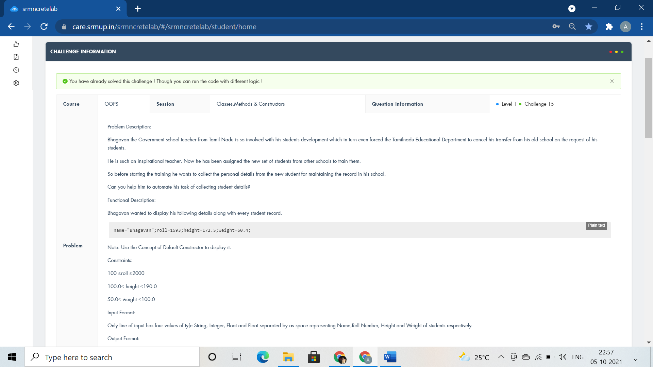

#include <bits/stdc++.h>

//#include<iomanip>

//#include<string>

using namespace std;

class student

{

string name;

int roll;

float height,weight;

public:

student(){name="Bhagavan";roll=1593;height=172.5;weight=60.4;}

void getdata() {

cin>>name>>roll>>height>>weight;

}

void displaydata(){

cout<<name<<" "<<roll<<" "<<height<<" "<<weight<<endl;

}

};

int main()

{

student s1,s2;

s1.getdata();

s1.displaydata();

s2.displaydata();

return 0;

}

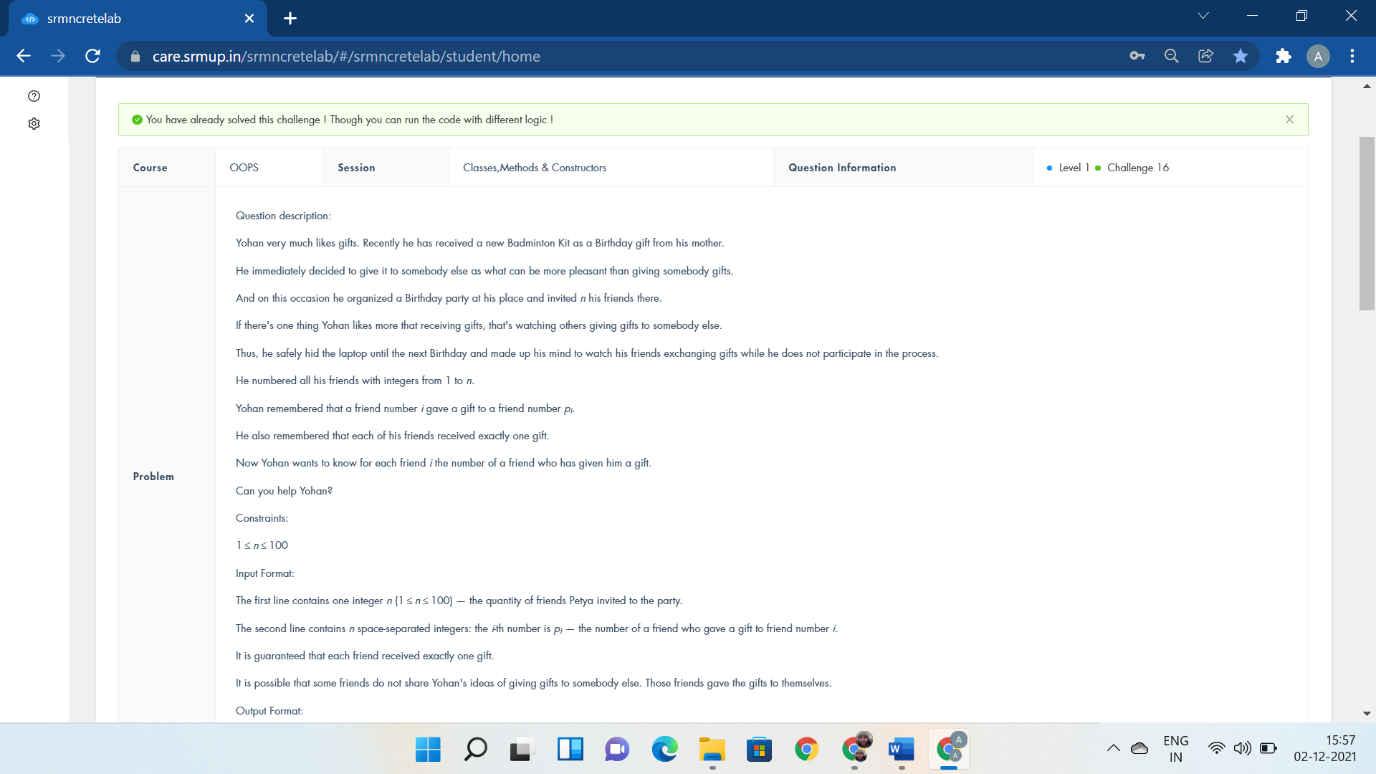

#include <iostream>

using namespace std;

class Friends

{

public:void Gifts(){

int i, n, a, b[50] = { 0 };

cin >> n;

for (i = 1; i < n+1; i++)

{

cin >> a;

b[a] = i;

}

for (i = 1; i < n+1; i++)

cout<< b[i]<<" ";

}

};

int main()

{

Friends Sharing;

Sharing.Gifts();

}

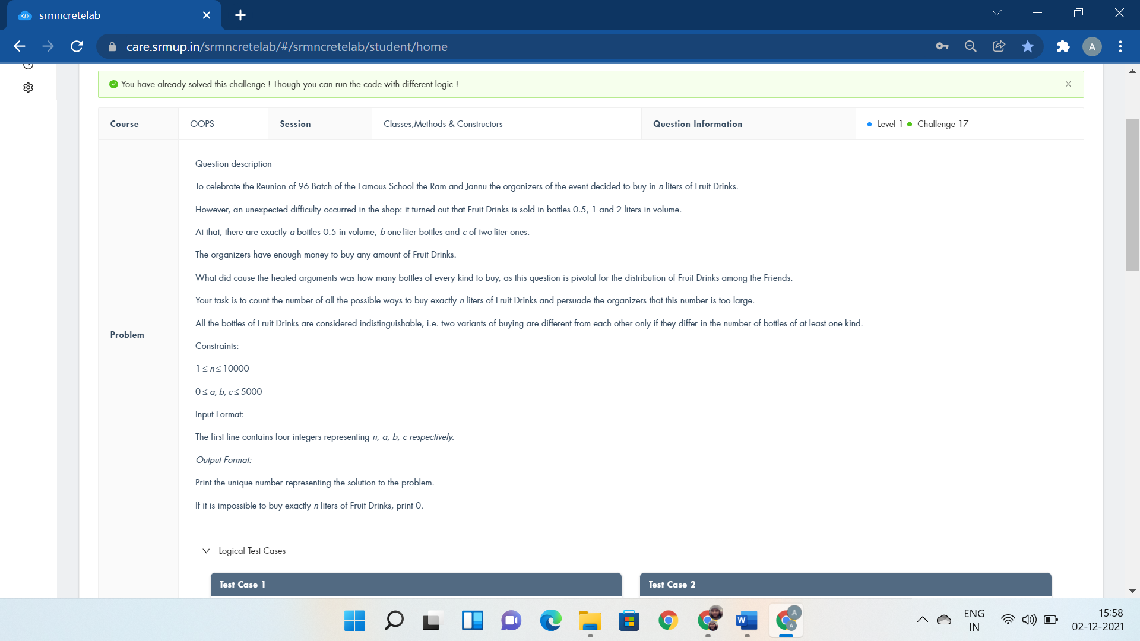

#include<bits/stdc++.h>

using namespace std;

class Drinks{

int n,a,b,c,t,ans=0;

public:void Shop(){

cin>>n>>a>>b>>c;

}

void display(){

for(int i=0;i<=b;i++)

for(int j=0;j<=c;j++)

if(2*(n-i-j*2)>=0&&2*(n-i-j*2)<=a)

ans++;

cout<<ans;

}

};

int main(){

Drinks Buy;

Buy.Shop();

Buy.display();

}



#include <bits/stdc++.h>

using namespace std;

class IndianArmy

{

public:int ResumesofCamdidates(){

long long n;

cin>>n;

long long k=n*(n-1)*(n-2)*(n-3)*(n-4)/120;

cout<<k+k*(n-5)/6+k*(n-5)*(n-6)/42;

return 1;

}

};

int main(){

IndianArmy GroupingofResumes;

GroupingofResumes.ResumesofCamdidates();

return 0;

}

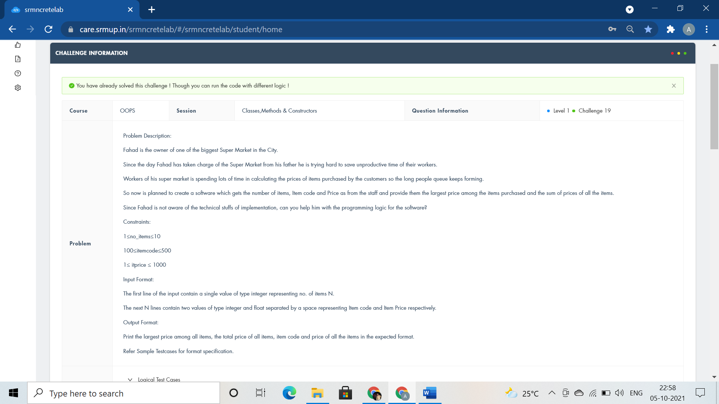

#include <iostream>

using namespace std;

class ITEM

{

public:

int n;

float large=0,summ=0;

float arr[100],code[100];

void getdata(int b){

n=b;

for(int i=0;i<n;i++)

cin>>code[i]>>arr[i];

}

void largest(){

for(int i=0;i<n;i++)

{

if(arr[i]>=large)

large=arr[i];

}

}

void sum(){

for(int i=0;i<n;i++)

summ+=arr[i];

}

void displayitems(){

cout<<"Largest Price="<<large<<endl;

cout<<"Sum of Prices="<<summ<<endl;

cout<<"Code and Price"<<endl;

for(int i=0;i<n;i++)

cout<<code[i]<<" and "<<arr[i]<<endl;

}

};

using namespace std;

int main()

{

ITEM order;

int b;

cin>>b;

order.getdata(b);

order.largest();

order.sum();

order.displayitems();

return 0;

}

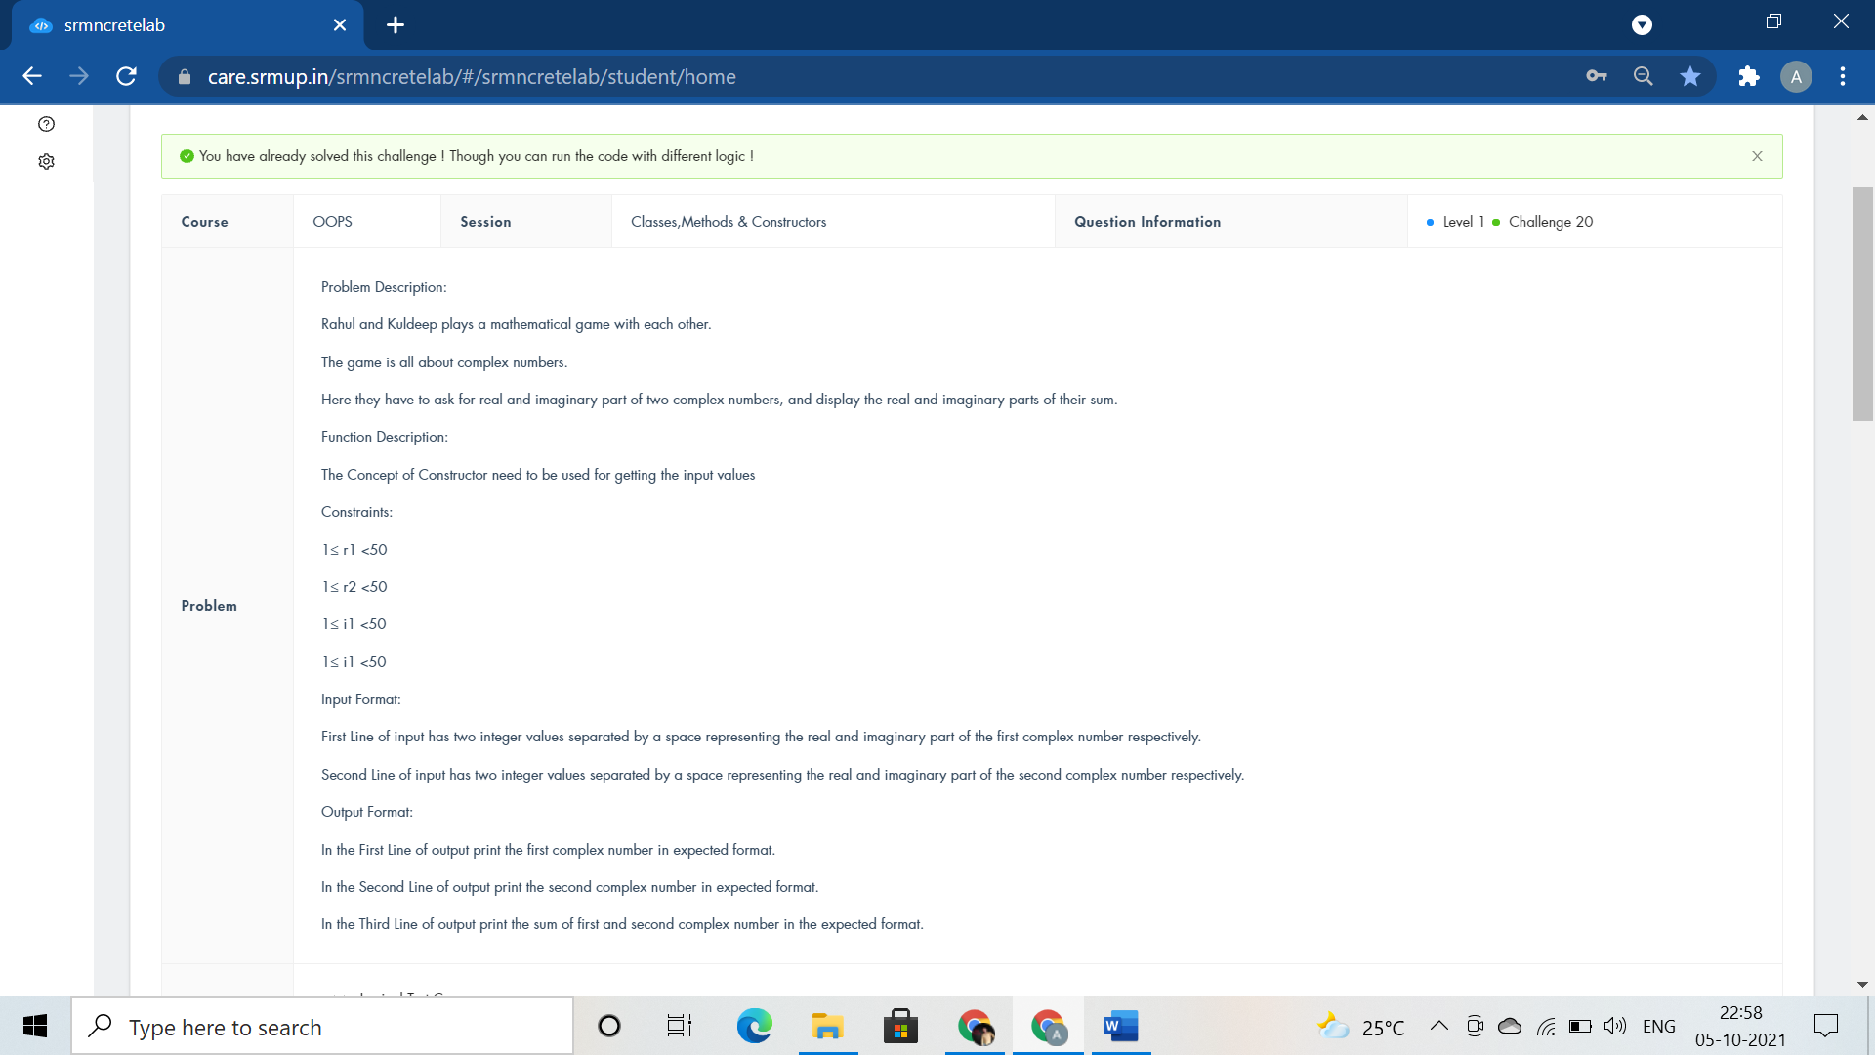

#include<iostream>

using namespace std;

class Complex{

public:

int r1,i1,r2,i2,r3,i3;

Complex(){cin>>r1>>i1;cin>>r2>>i2;}

void addcomplex(){

r3=r1+r2;

i3=i1+i2;

}

void displaycomplex(){

cout<<r1<<"+"<<i1<<"i"<<endl;

cout<<r2<<"+"<<i2<<"i"<<endl;

cout<<r3<<"+"<<i3<<"i"<<endl;

}

};

int main(){

Complex calculate;

calculate.addcomplex();

calculate.displaycomplex();

return 0;

}

Constructor Overloading:-



#include <iostream>

using namespace std;

class Student

{

public:

void Identity(string name,int id){

cout<<name<<" "<<id<<endl;

}

void Identity(int id,string name){

cout<<name<<" "<<id<<endl;

}

};

int main()

{

Student Details;

string name;

int id;

cin>>name>>id;

Details.Identity(name,id);

cin>>id>>name;

Details.Identity(id,name);

return 0;

}

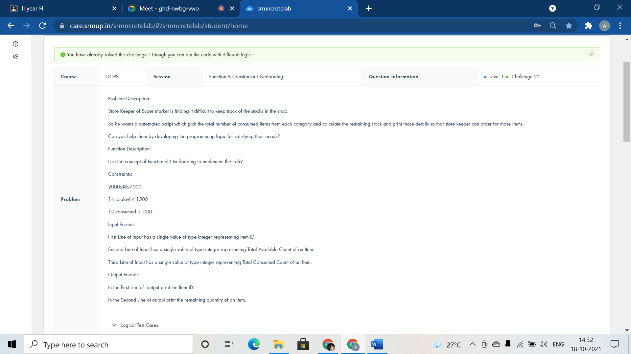

#include <iostream>

using namespace std;

class Store{

public:

void itemcount(int id){

cout<<id<<endl;

}

void itemcount(int totalavl,int consumed){

cout<<totalavl - consumed<<endl;

}

};

int main()

{

Store purchase;

int id,totalavl,consumed;

cin>>id>>totalavl>>consumed;

purchase.itemcount(id);

purchase.itemcount(totalavl,consumed);

return 0;

}



#include<bits/stdc++.h>

using namespace std;

int i,n,a,mx=INT_MIN,c[1000];

int res(int n);

int dis(int n,int mx);

int main(){

cin>>n;

mx=res(n);

cout<<dis(n,mx);

return 0;

cout<<"int* GazalCoin(int arr[],int n) int* GazalCoin(int arr[],int n,int i) GazalCoin(arr,n,0);";

}

int res(int n){

for(i=0;i<n;i++){

cin>>a;

c[a]++;

mx=max(mx,c[a]);

}

return mx;

}

int dis(int n,int mx){

if(n%mx==1 && n%11!=0)

return mx+1;

if(n%mx==1 && n%11 == 0)

return mx;

if(n%mx==2)

return mx+1;

return mx;

}

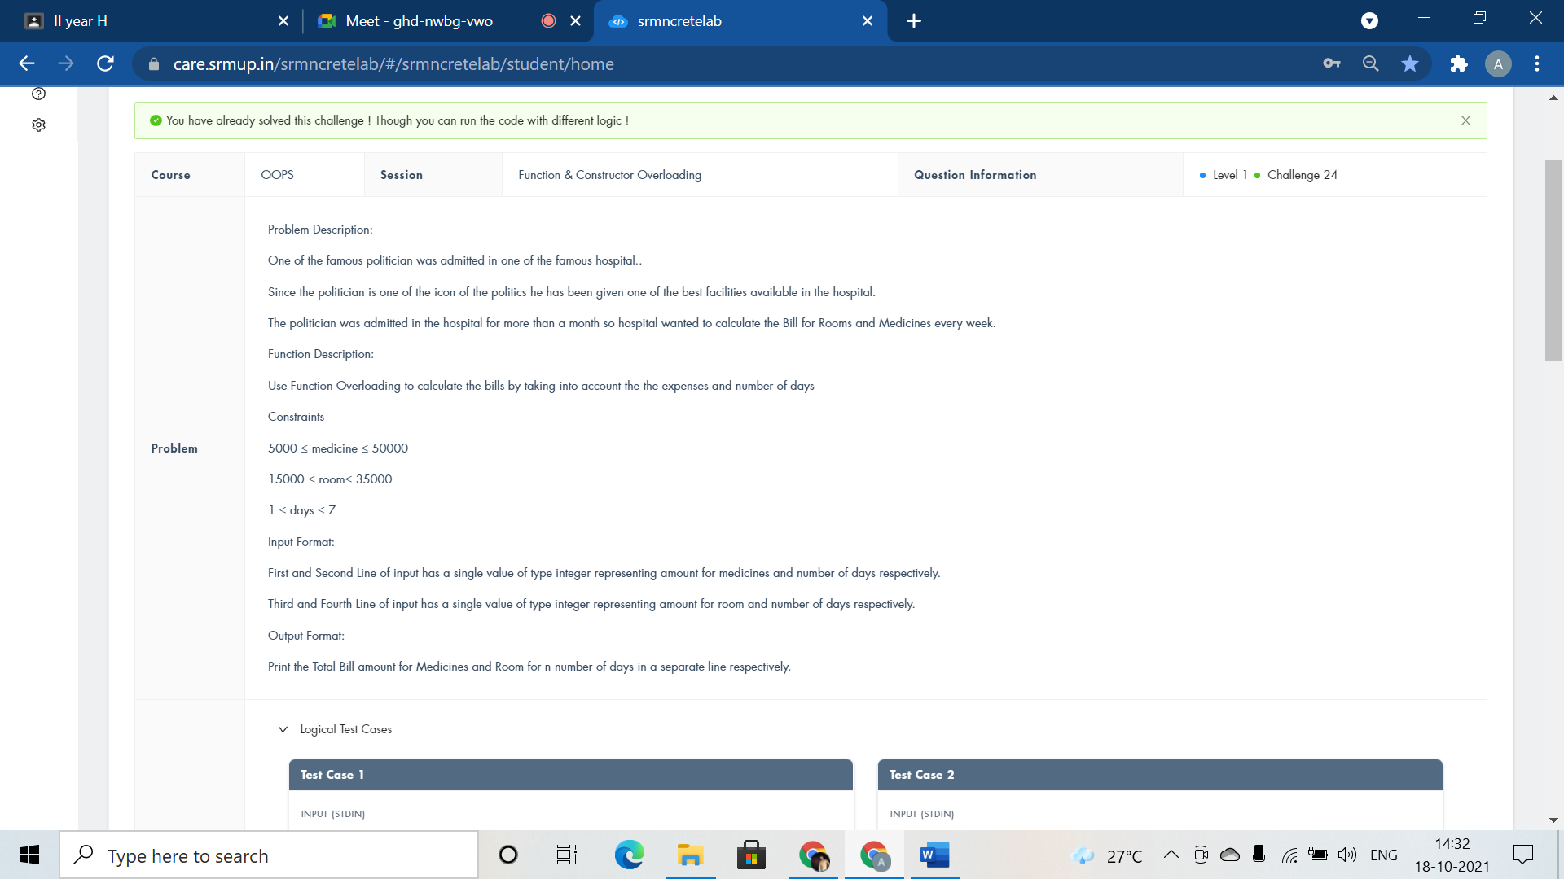

#include <iostream>

using namespace std;

class Hospital{

public:

void bill(long int mdeicinebill,int days){

cout<<mdeicinebill*days<<endl;

}

void bill(int roomrent,int days){

cout<<roomrent*days;

}

};

int main()

{

Hospital ob;

long int mdeicinebill,days;

int roomrent;

cin>>mdeicinebill>>days;

ob.bill(mdeicinebill,days);

cin>>roomrent>>days;

ob.bill(roomrent,days);

return 0;

}

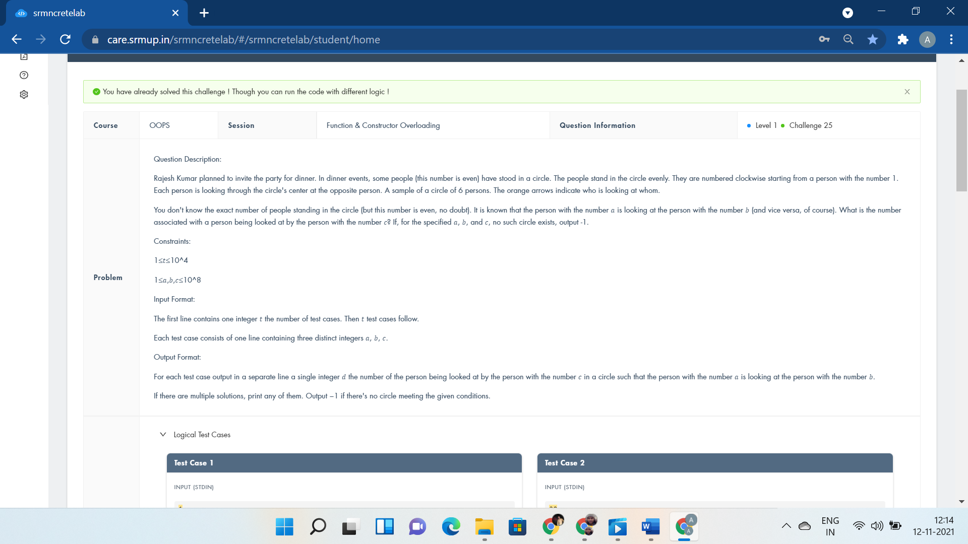

#include<bits/stdc++.h>

using namespace std;

int i,T,a,b,c,n;

#define f(i,a,n) for(i=a;i<n;i++)

class solve{

public:

void get(){

std::cin>>a>>b>>c;

n=2*abs(a-b);

}

void get2(){

if(c>n||max(a,b)>n)

cout<<"-1"<<endl;

else if(c>n/2)

cout<<c-n/2<<endl;

else

cout<<c+n/2<<endl;

}

};

int main(){

cin>>T;

solve p;

f(i,0,T){

p.get();

p.get2();

}

return 0;

cout<<"void pline(int v[],int n) void pline(int v) else if(x>n||x<=0)";

}

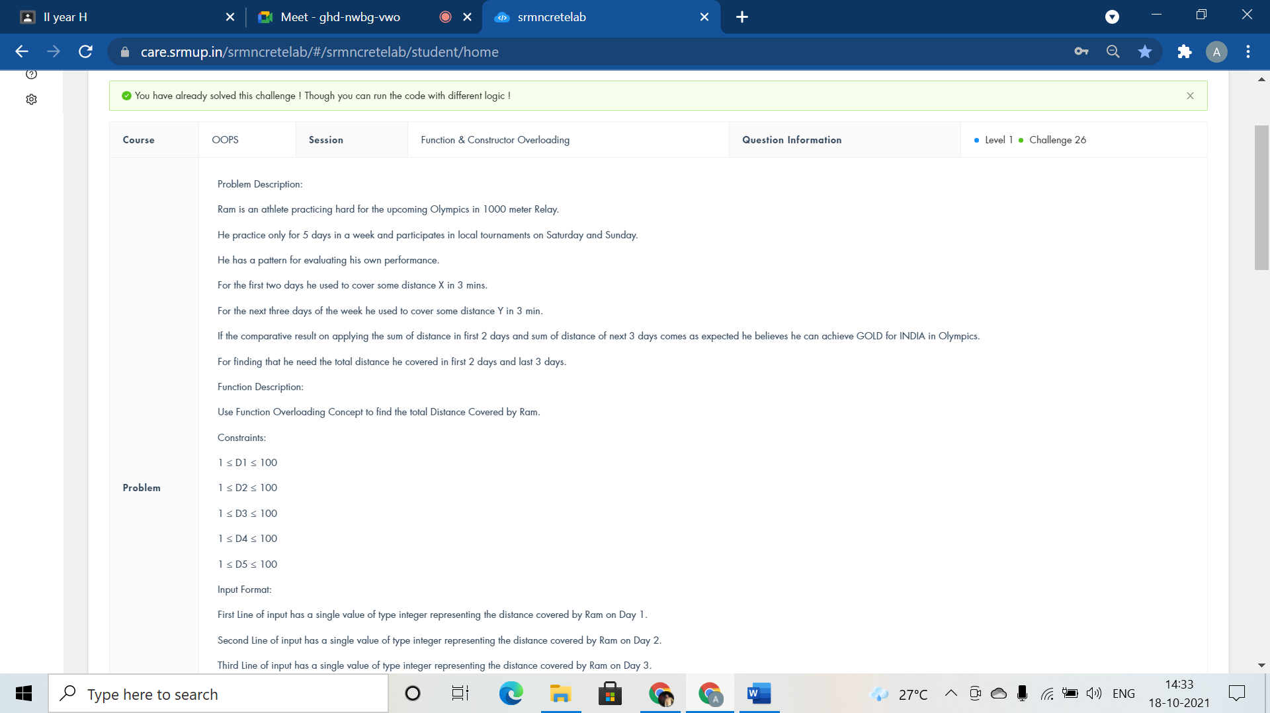

#include <iostream>

using namespace std;

class Olympic{

public:

void distance(int D1,int D2){

cout<<D1+D2<<" meters"<<endl;

}

void distance(int D3, int D4, int D5){

cout<<D3+D4+D5<<" meters"<<endl;

}

};

int main()

{

Olympic Medal;

int D1,D2,D3,D4,D5;

cin>>D1>>D2>>D3>>D4>>D5;

Medal.distance(D1,D2);

Medal.distance(D3,D4,D5);

return 0;

}



#include <iostream>

using namespace std;

int power(int x,int p);

int power(int x,int y,int p);

int main()

{

int t;

cin>>t;

while(t--){

int n,odd=0;

cin>>n;

int z=power(n,odd);

//cout<<n<<z;

power(n,z,1);

}

return 0;

}

int power(int x,int p){

int a[2*x];

for(int i=0;i<2*x;i++){

cin>>a[i];

if(a[i]%2==1)

p++;

}

return p;

}

int power(int x,int y,int p){

if(x==y)

cout<<"Yes"<<endl;

else

cout<<"No"<<endl;

return 1;

}

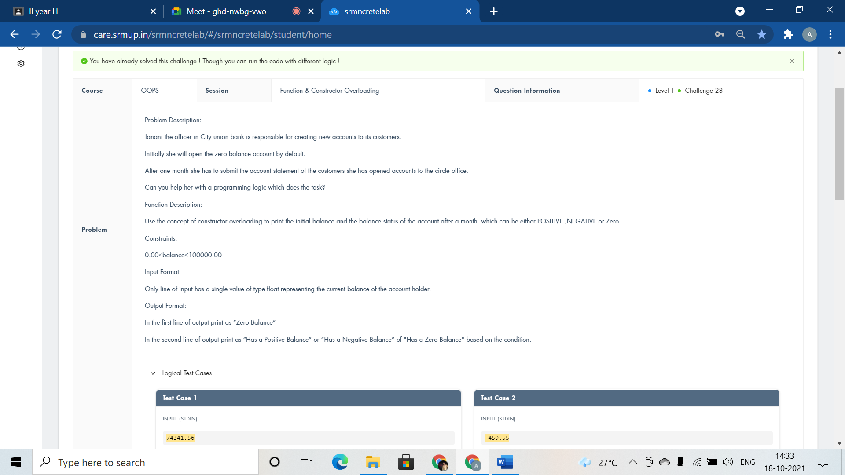

#include <iostream>

using namespace std;

class AccBalance{

public:

AccBalance(){cout<<"Zero Balance"<<endl;}

AccBalance(int balance){

if(balance<0)

cout<<"Has a Negative Balance";

else if(balance==0)

cout<<"Has a Zero Balance";

else

cout<<"Has a Positive Balance";

}

};

int main()

{

AccBalance defltBal;

int balance;

cin>>balance;

AccBalance currBal(balance);

return 0;

}



#include <iostream>

using namespace std;

class Country{

public:

Country(){cout<<"Country:INDIA"<<endl;}

Country(char statename[100],int area,int density)

{

cout<<"State:"<<statename<<endl<<"Area:"<<area<<endl<<"Density:"<<density<<endl;

}

};

int main()

{

Country country;

char statename[100];

int area,density;

cin>>statename>>area>>density;

Country statesofindia(statename,area,density);

return 0;

}

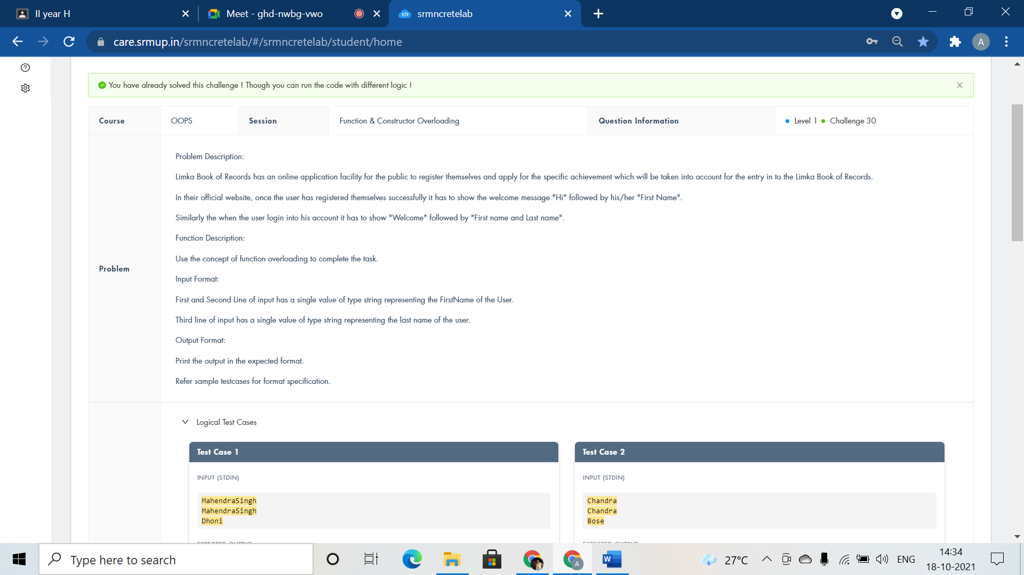

#include <iostream>

using namespace std;

class Welcomemsg{

public:

void msg(string fname){

cout<<"Hi "<<fname<<endl;

}

void msg(string fname,string lname){

cout<<"Welcome "<<fname<<" "<<lname;

}

};

int main()

{

Welcomemsg ob;

string fname,lname;

cin>>fname;

ob.msg(fname);

cin>>fname>>lname;

ob.msg(fname,lname);

return 0;

}

Operator Overloading:-

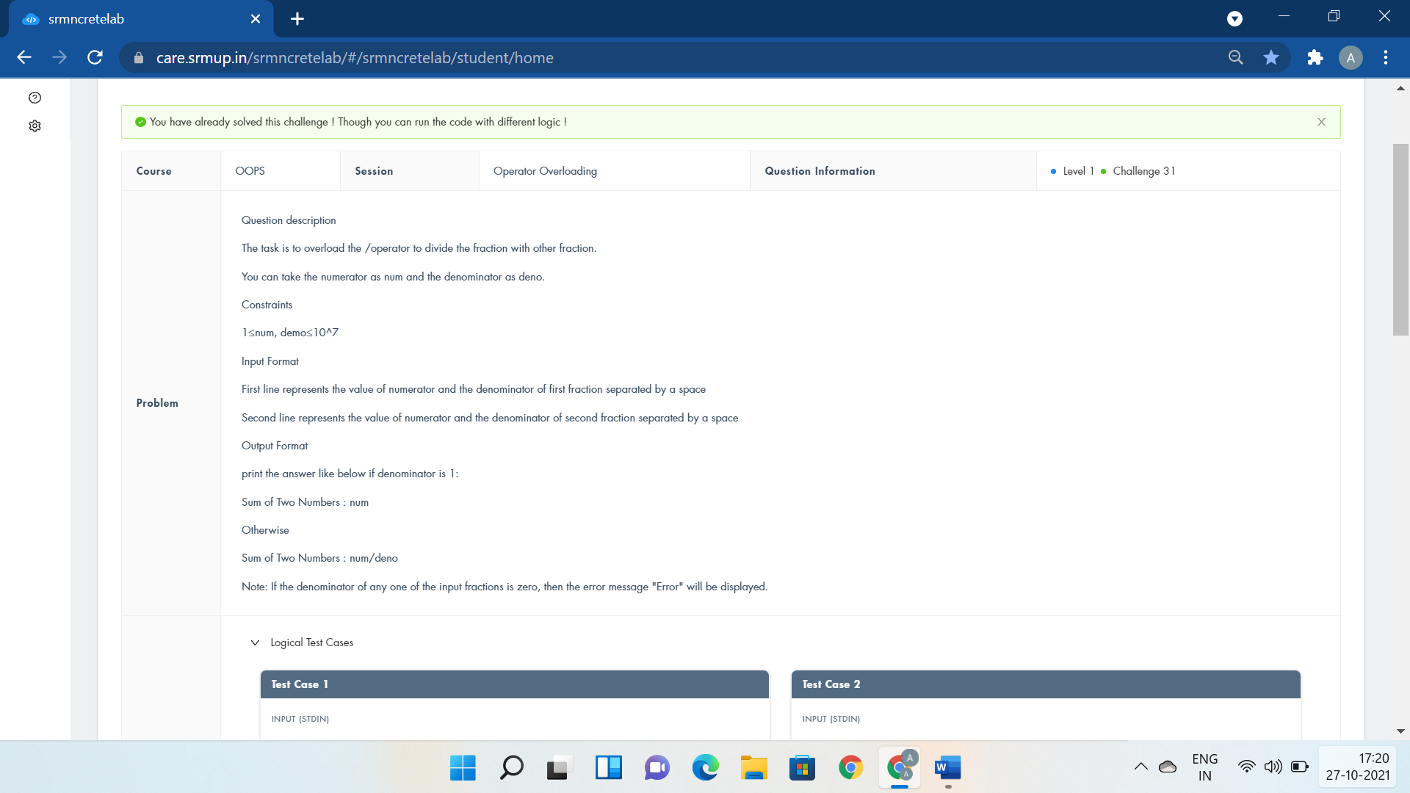

#include <iostream>

using namespace std;

class Fraction{

public:

int num,den;

Fraction(int n=0, int d=0)

{

num=n;

den=d;

}

Fraction operator /(Fraction const &obj){

Fraction res;

res.num=num * obj.den;

res.den=den * obj.num;

return res;

}

void display1(){

cout<<num/den;

}

void display2(){

cout<<num<<"/"<<den;

}

void display3(){

cout<<"Error";

}

};

int main()

{

int a,b,c,d;

cin>>a>>b;

cin>>c>>d;

Fraction ob1(a,b), ob2(c,d);

Fraction ob3 = ob1/ob2;

if(ob1.den==0 || ob2.den==0){

cout<<"Error";

return 0;

}

if(ob3.den==1)

ob3.display1();

else{

for(int i=2;i<50;i++)

{

if(ob3.num%i==0 && ob3.den%i==0)

{

ob3.num=ob3.num/i;

ob3.den=ob3.den/i;

}

}

ob3.display2();

}

return 0;

}



#include <iostream>

using namespace std;

class Time

{

int h,m,s;

public:

Time()

{

cin>>h>>m>>s;

}

void check()

{

if(h>23 || m>59 ||s>59 )

cout<<"Invalid time format\n";

}

bool operator ==(Time t2);

};

bool Time::operator==(Time t2)

{

if(h==t2.h && m==t2.m && s==t2.s)

return true;

else

return false;

}

int main()

{

Time t1,t2;

t1.check();

t2.check();

if(t1==t2)

cout<<"Both clocks are showing the same time";

else

cout<<"Clocks are showing different times";

return 0;

}



#include <iostream>

using namespace std;

class Scrum{

public:

int n;

Scrum(int h)

{

n=h;

}

Scrum operator -- (int){

Scrum T(int h);

--n;

return 1;

}

void display(){

int res=1;

for(int i=1;i<=n;i++){

res=res*i;

}

cout<<res;

}

};

int main()

{

int n;

cin>>n;

Scrum T(n);

T--;

T.display();

return 0;

}

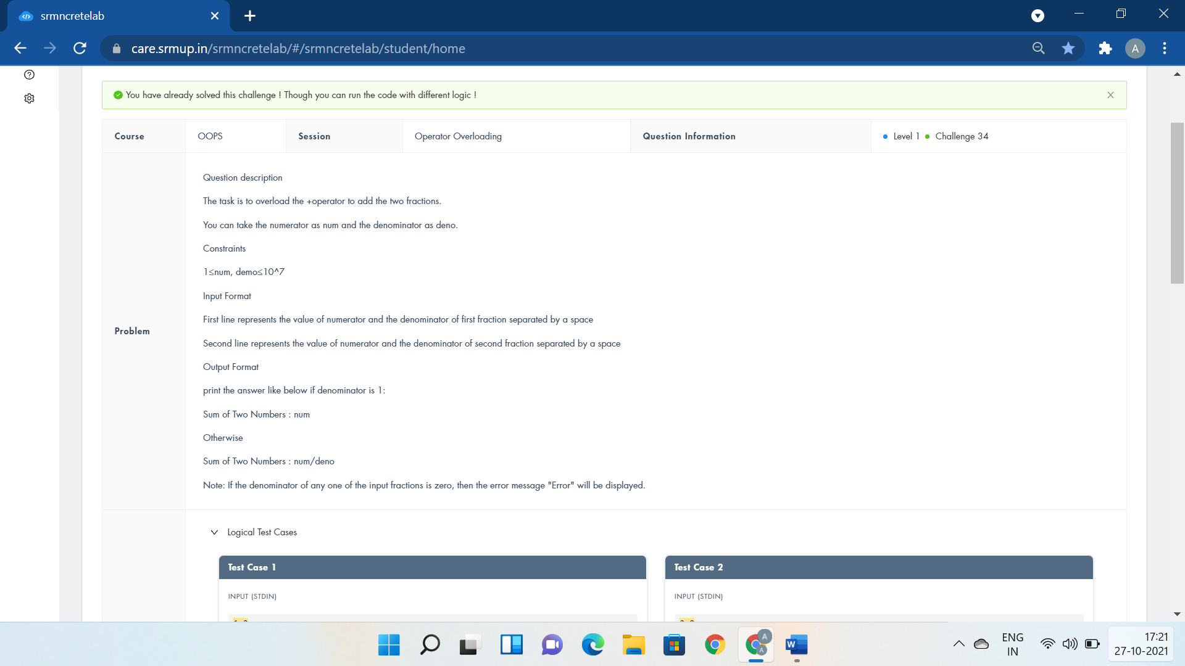

#include<iostream>

using namespace std;

class Fraction

{

public:

int num,den;

Fraction()

{

num=0;

den=0;

}

void getinput()

{

cin>>num>>den;

}

Fraction operator +(Fraction obj)

{

Fraction temp;

temp.num=(num*obj.den)+(den*obj.num);

temp.den=den*+obj.den;

return temp;

}

};

int main()

{

Fraction f1,f2,add;

f1.getinput();

f2.getinput();

add=f1+f2;

if(add.den==0)

cout<<"Error";

else if(add.num%add.den == 0)

cout<<add.num/add.den;

else

cout<<add.num<<"/"<<add.den;

return 0;

}



#include <iostream>

using namespace std;

class matrix{

public:

int operator ~(){

int a,b,c,d;

cin>>a>>b>>c>>d;

return a*d-b*c;

}

};

int main()

{

matrix t;

cout<<~t;

return 0;

}



#include<iostream>

using namespace std;

class Complex {

private:

int real, imag;

public:

Complex(int r = 0, int i =0) {real = r; imag = i;}

Complex operator+(int a) {

Complex res;

res.real = real + a;

res.imag = imag;

return res;

}

Complex operator+(Complex obj) {

Complex res;

res.real = real + obj.real;

res.imag = imag + obj.imag;

return res;

}

void print() { cout << real << " + " << imag <<"i"<< endl; }

};

int main()

{

int a,b,c;

cin>>a>>b>>c;

Complex i1(a, b);

Complex i2 = i1 + c;

i1.print();

i2.print();

(i1+i2).print();

}



#include<iostream>

using namespace std;

class compare{

public:

int first,sum1=0;

compare(int x){

first=x;

}

void f(){

//first1=first;

for(int i=1; i<=first/2 ; i++)

{

//finding and adding divisors of first number

if(first%i==0)

sum1=sum1+i;

}

}

void operator ==(compare t2){

if(first==t2.sum1 && t2.first==sum1)

cout<<"Friendly Pair";

else

cout<<"Not a Friendly Pair";

}

};

//main program

int main()

{

int first,second;

//user input

cin>>first;

//user input

cin>>second;

compare t1(first),t2(second);

t1.f();

t2.f();

t1==t2;

return 0;

}

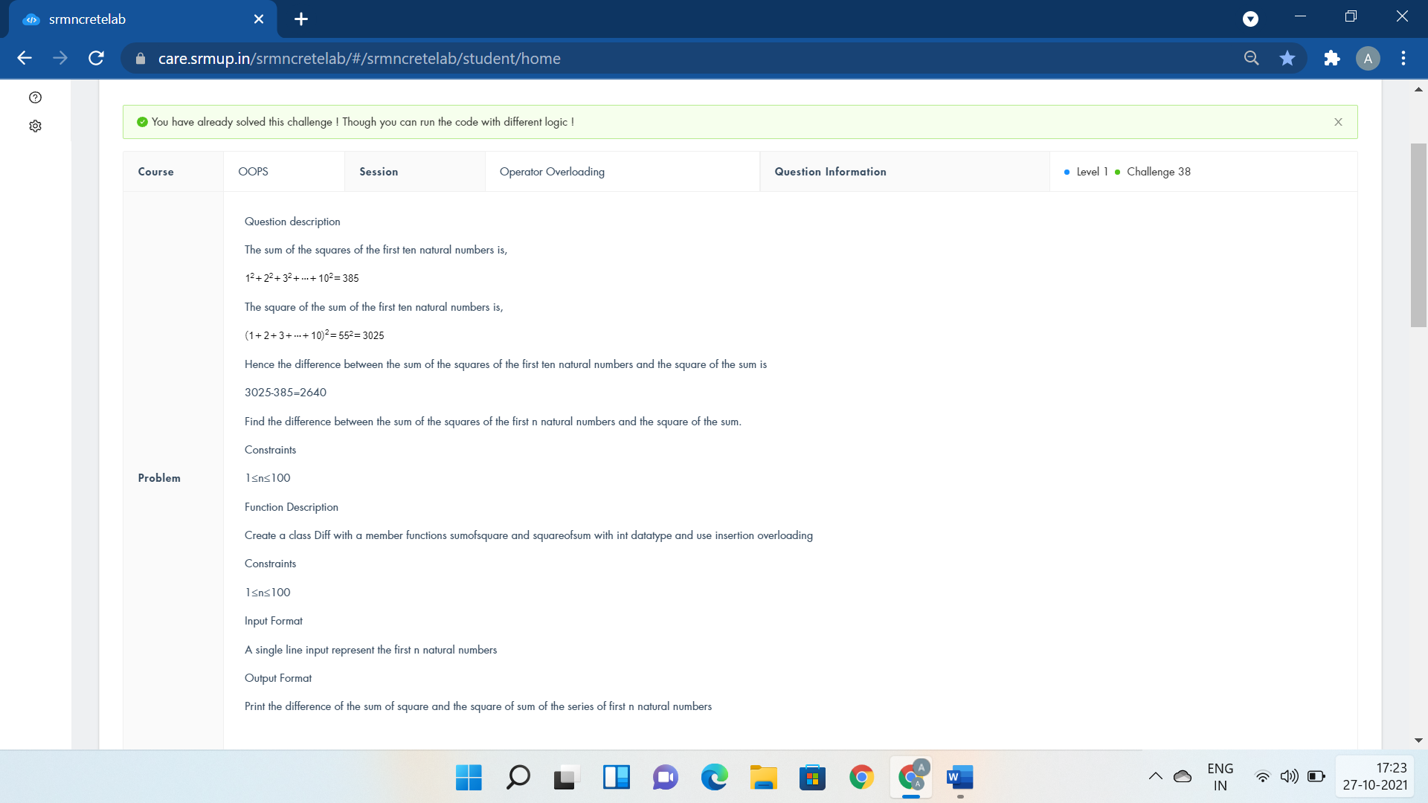

#include <iostream>

using namespace std;

class Diff{

public:

int n;

void getdata(){

cin>>n;

}

int sumofsquare();

int sumofnumsq(){

return n*(n+1)*(2*n+1)/6;

}

};

int Diff :: sumofsquare(){

return n*n*(n+1)*(n+1)/4;

}

int main()

{

Diff n;

if(0)

cout<<"friend void operator >> (istream &in, Diff &obj )";

n.getdata();

//int sq=n*n*(n+1)*(n+1)/4;

//int sq2=n*(n+1)*(2*n+1)/6;

cout<<n.sumofsquare()-n.sumofnumsq();

return 0;

}

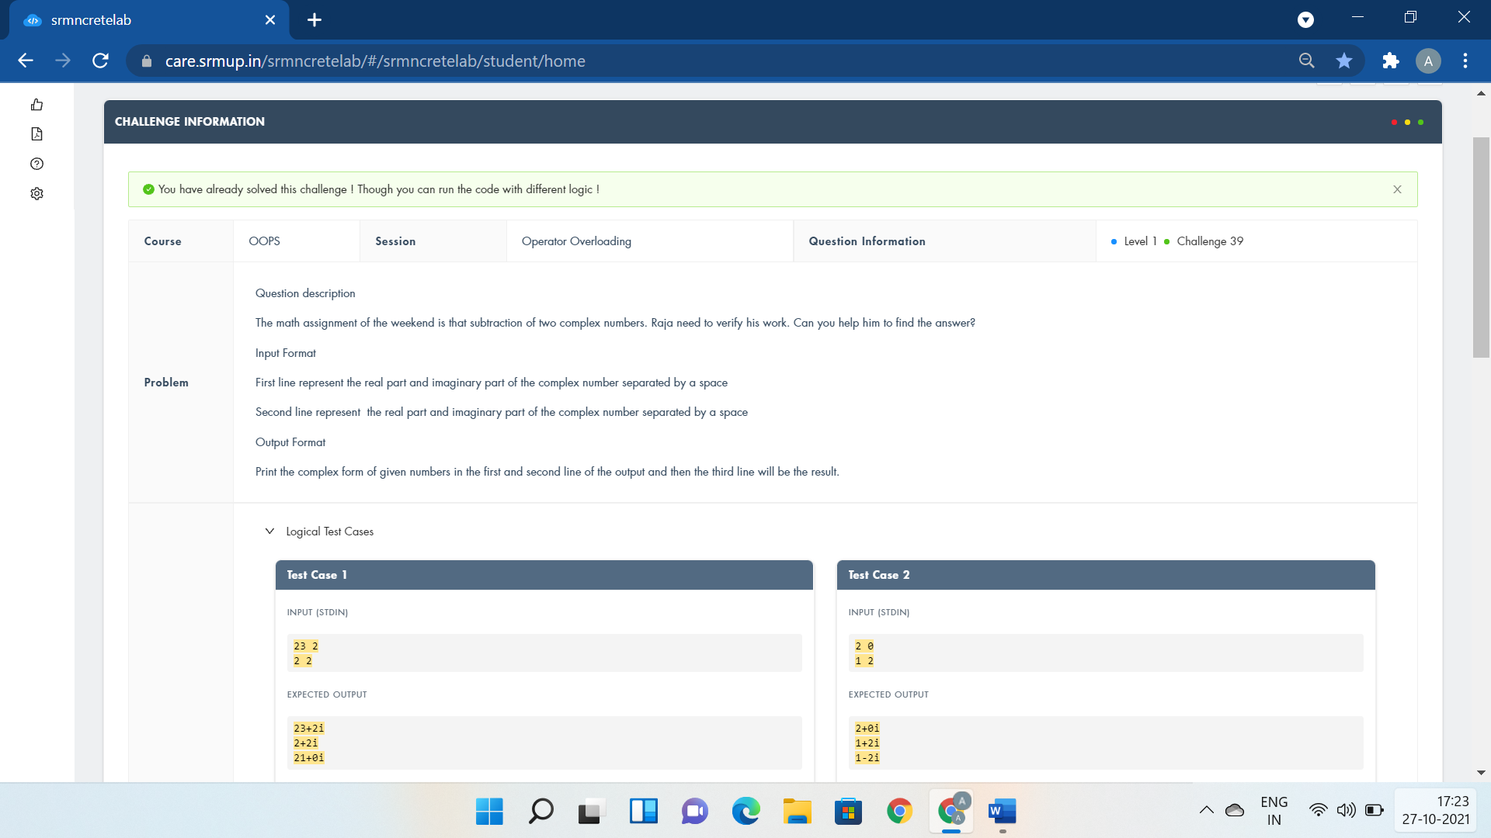

#include <iostream>

using namespace std;

class complex

{

private:

float real;

float imag;

public:

complex() {cin>>real>>imag;}

complex operator-(complex ob)

{

complex t;

t.real = real - ob.real;

t.imag = imag - ob.imag;

return t;

}

void output()

{

if(imag < 0)

cout<< real << imag << "i"<<endl;

else

cout<< real << "+" << imag << "i"<<endl;

}

};

int main()

{

complex c1, c2;

c1.output();

c2.output();

(c1 - c2).output();

return 0;

}

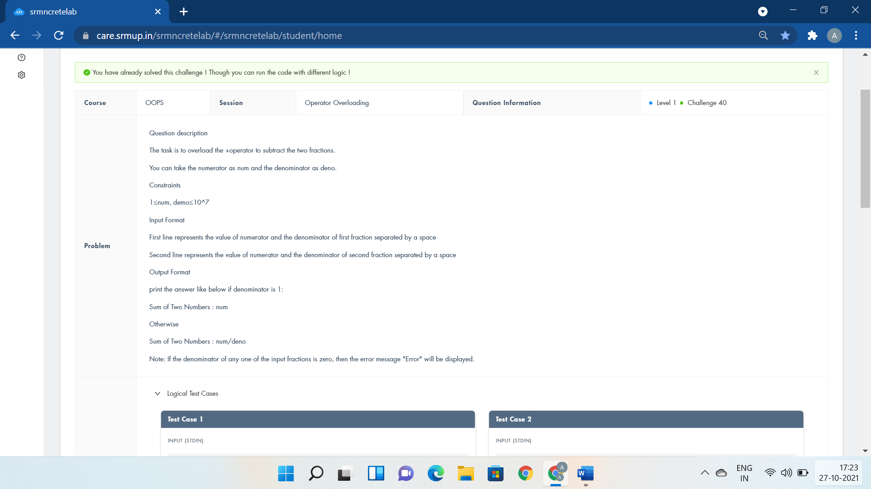

#include<iostream>

using namespace std;

class Fraction

{

public:

int num,den;

Fraction()

{

num=0;

den=0;

}

void getinput()

{

cin>>num>>den;

}

Fraction operator -(Fraction obj)

{

Fraction temp;

temp.num=(num*obj.den)-(den*obj.num);

temp.den=den*+obj.den;

return temp;

}

};

int main()

{

Fraction f1,f2,add;

f1.getinput();

f2.getinput();

add=f1-f2;

if(add.den==0)

cout<<"Error";

else if(add.num%add.den == 0)

cout<<add.num/add.den;

else

cout<<add.num<<"/"<<add.den;

return 0;

}

Inheritance:-

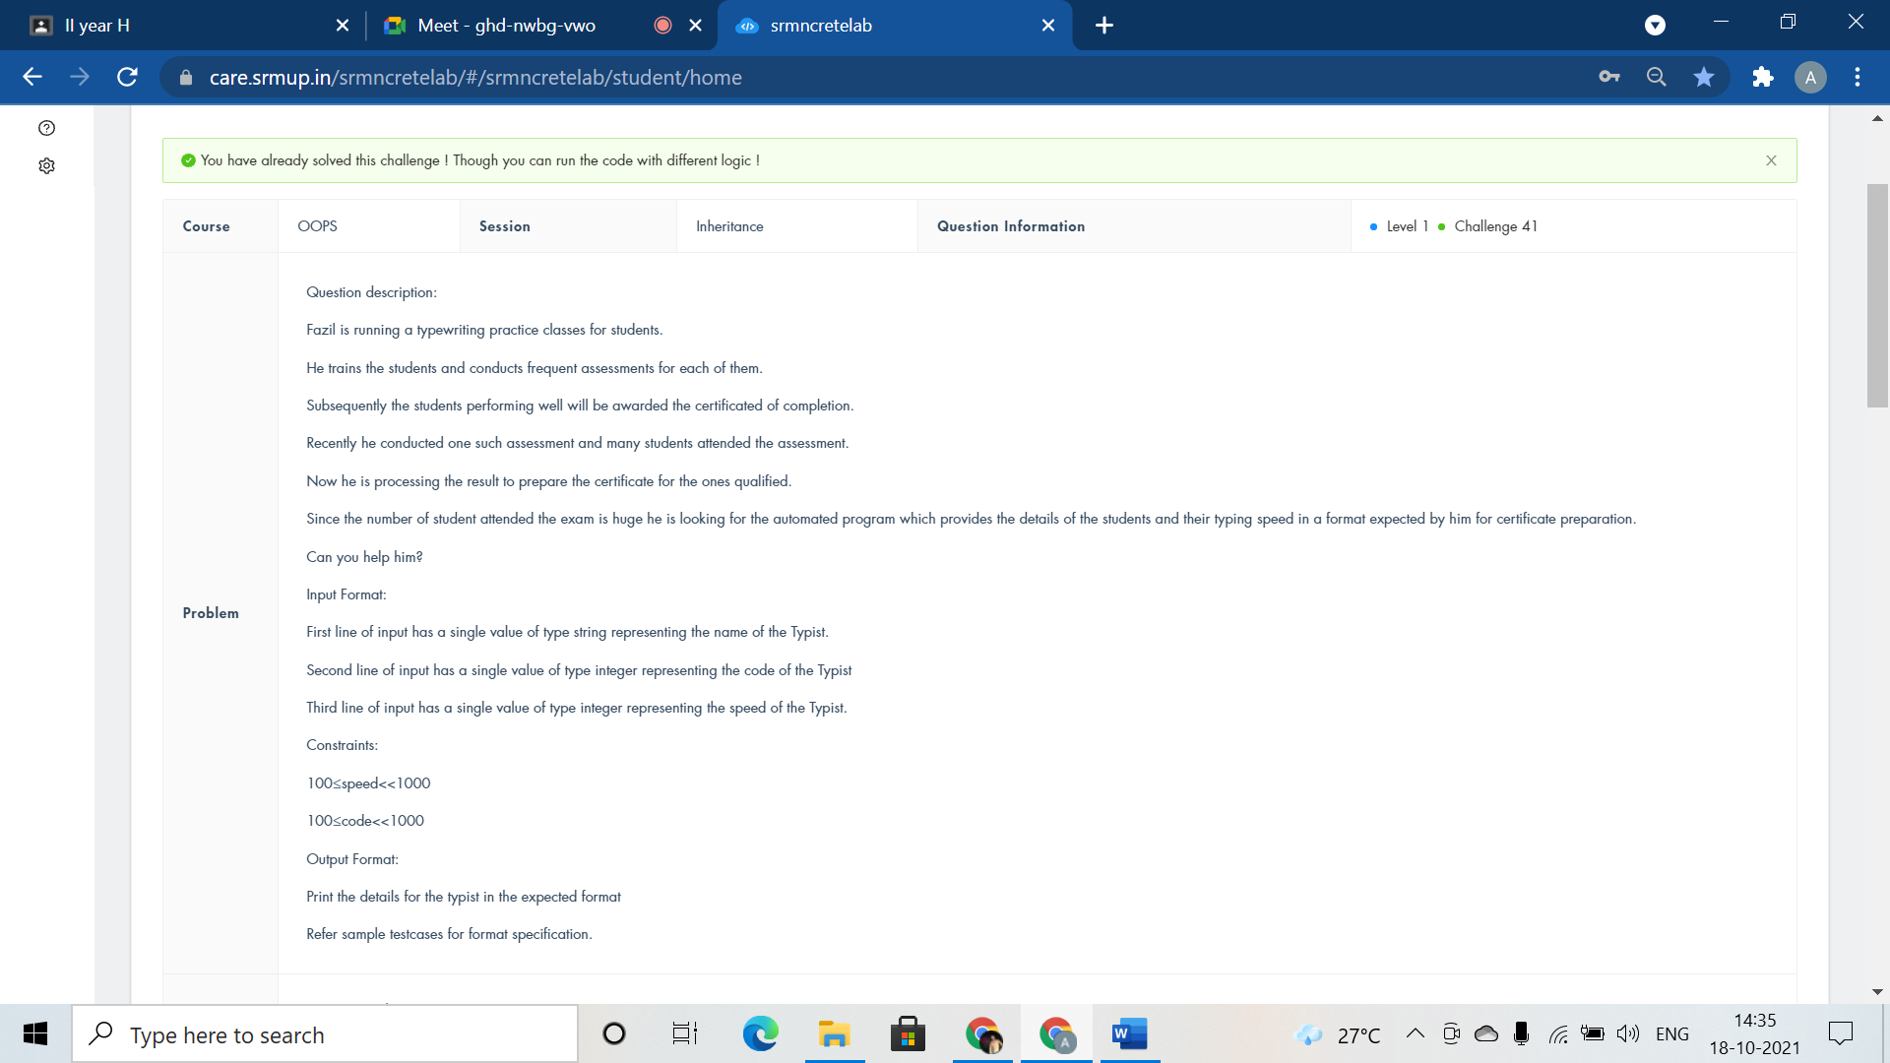

#include <iostream>

using namespace std;

class staff{

public:

int code,speed;

string name;

void getdata();

void display();

};

void staff::getdata(){

cin>>name>>code>>speed;

}

void staff::display(){

cout<<"Name:"<<name<<endl<<"Code:"<<code<<endl<<"Speed"<<speed;

}

class typist: public staff{

public:

void getdata();

void display();

};

void typist::getdata(){

cin>>name>>code>>speed;

}

void typist::display(){

cout<<"Name:"<<name<<endl<<"Code:"<<code<<endl<<"Speed:"<<speed;

}

int main()

{

typist t;

t.getdata();

t.display();

return 0;

}

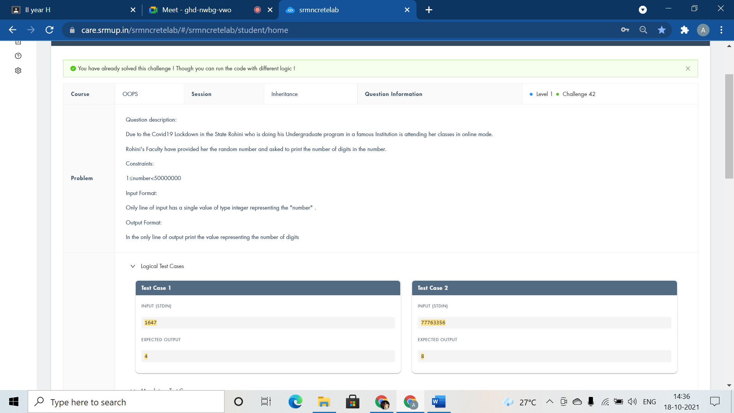

#include <iostream>

using namespace std;

class Assignement{

public:

int num;

void get(){

cin>>num;

}

void display(){

int count=0;

while(num!=0){

count++;

num/=10;

}

cout<<count;

}

};

class Student:public Assignement{

};

int main()

{

Student obj;

obj.get();

obj.display();

return 0;

}

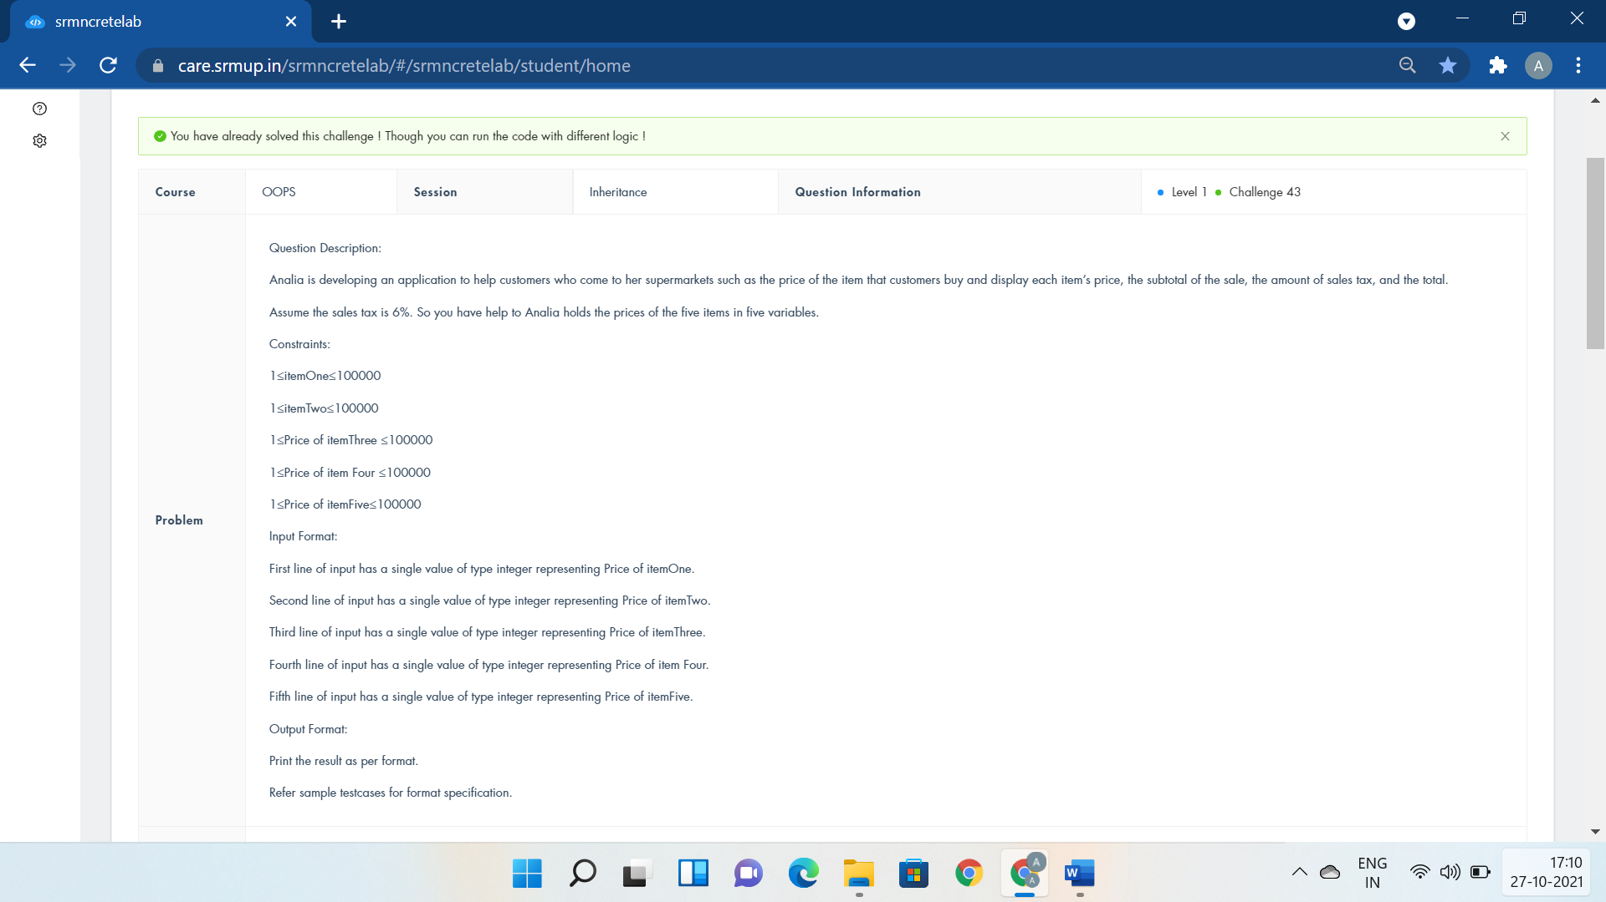

#include <iostream>

using namespace std;

class market{

public:

float i1,i2,i3,i4,i5;

float Subtotal,tax;

void items(){

cin>>i1>>i2>>i3>>i4>>i5;

}

void buy(){

Subtotal=(i1+i2+i3+i4+i5);

cout<<"Subtotal=$"<<Subtotal<<endl;

tax=0.06*i1+0.06*i2+0.06*i3+0.06*i4+0.06*i5;

cout<<"Tax=$"<<tax<<endl;

cout<<"Total=$"<<Subtotal+tax;

}

};

class customer:public market{

};

int main()

{

customer c;

c.items();

c.buy();

}

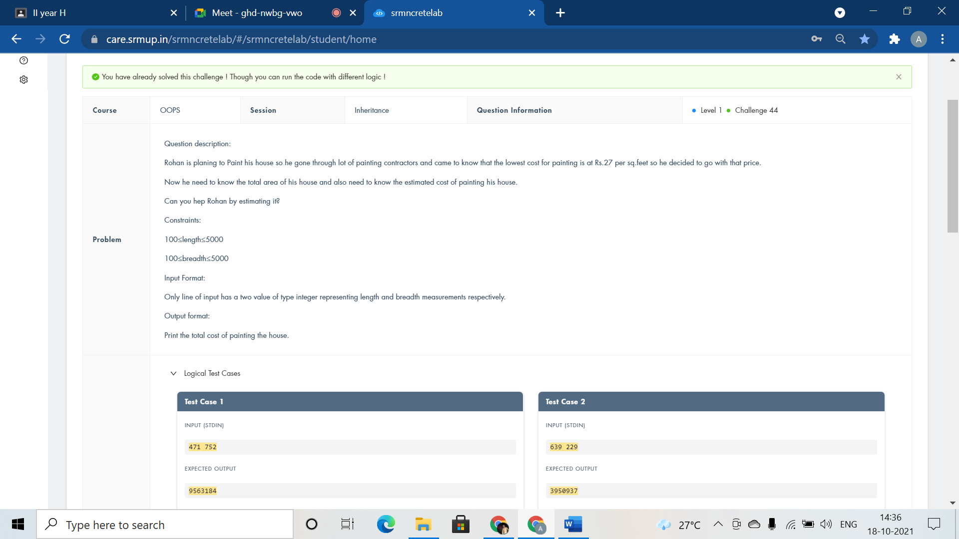

#include <iostream>

using namespace std;

class ReceiveMesurement{

public:

int l,b;

void painingarea(){

cin>>l>>b;

cout<<l*b*27;

}

};

class CalculateArea : public ReceiveMesurement{

};

int main()

{

CalculateArea mt;

mt.painingarea();

return 0;

}



#include <iostream>

using namespace std;

class Bank{

public:

int n;

void get(){

cin>>n;

}

void display(){

cout<<"500: "<<n/500<<endl;

n=n%500;

cout<<"200: "<<n/200<<endl;

n=n%200;

cout<<"100: "<<n/100<<endl;

n=n%100;

cout<<"50: "<<n/50<<endl;

n=n%50;

cout<<"10: "<<n/10<<endl;

n=n%10;

cout<<"5: "<<n/5<<endl;

n=n%5;

cout<<"1: "<<n<<endl;

}

};

class CashCounting:public Bank{

};

int main()

{

CashCounting obj;

obj.get();

obj.display();

return 0;

}

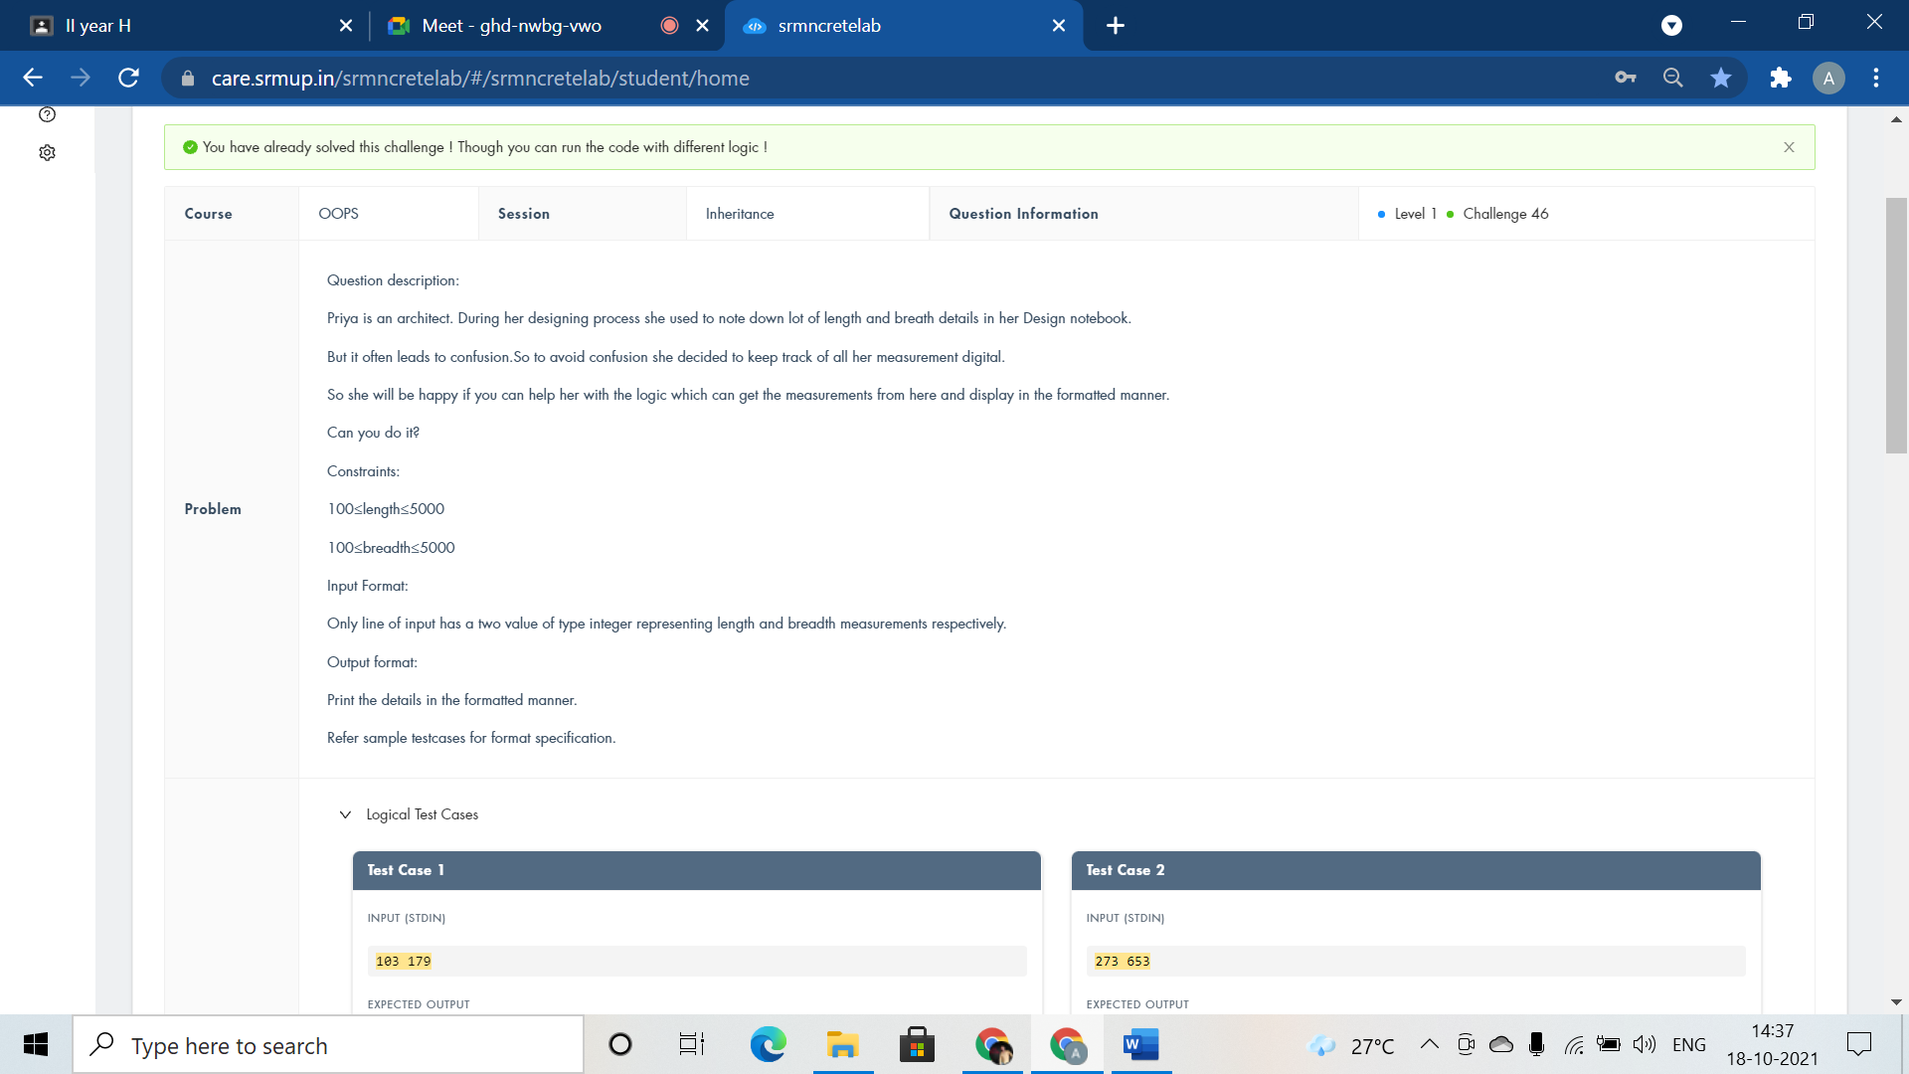

#include <iostream>

using namespace std;

class ReceiveMesurement{

public:

int l,b;

void display(){

cin>>l>>b;

cout<<"Length:"<<l<<" metres"<<endl;

cout<<"Breadth:"<<b<<" metres";

}

};

class FormatMesurement : public ReceiveMesurement{

};

int main()

{

FormatMesurement mt;

mt.display();

return 0;

}



#include <bits/stdc++.h>

using namespace std;

class graph{

public:

void edge(){

}

};

class pairs:public graph{

public:

long long int n,m,k=0;

void vertex(){

cin>>n>>m;

cout<<max(0ll,n-2*m)<<" ";

while(k*(k-1)/2<m) k++;

cout<<n-k<<endl;

}

};

int main()

{

pairs pa;

pa.edge();

pa.vertex();

return 0;

}

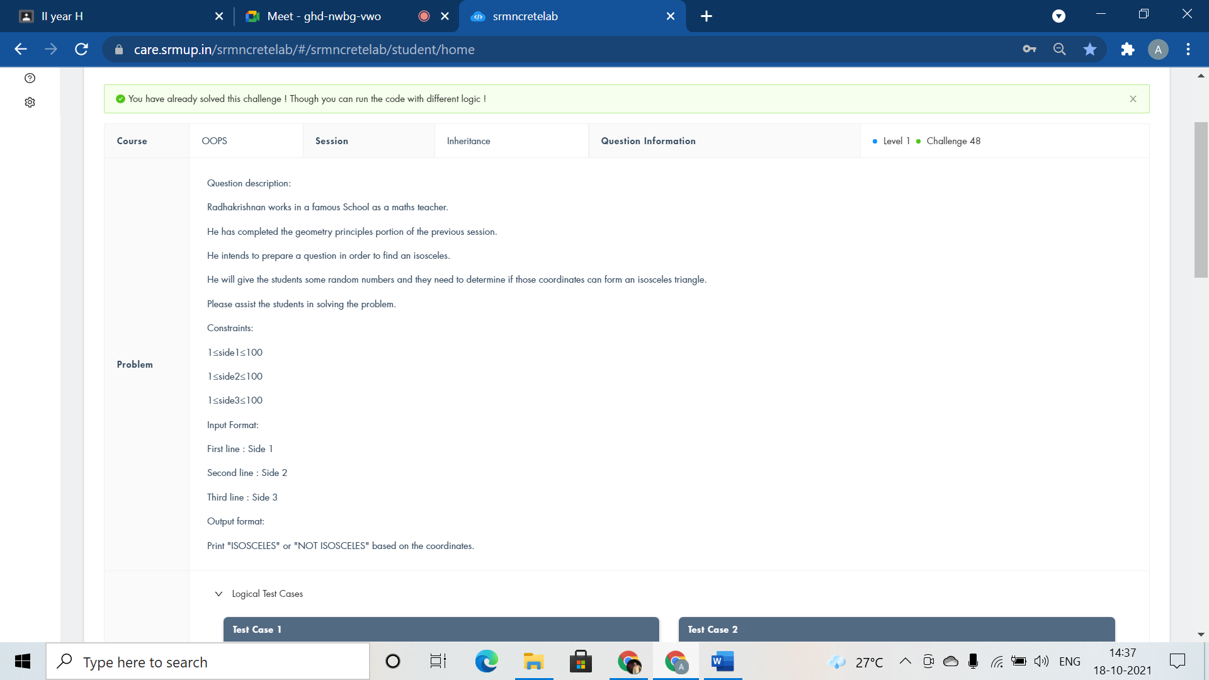

#include <iostream>

using namespace std;

class triangle{

public:

int a,b,c;

void read(){

cin>>a>>b>>c;

}

void check(){

if(a==b || b==c || a==c)

cout<<"ISOSCELES";

else

cout<<"NOT ISOSCELES";

}

};

class isosceles : public triangle {

};

int main()

{

isosceles obj;

obj.read();

obj.check();

return 0;

}

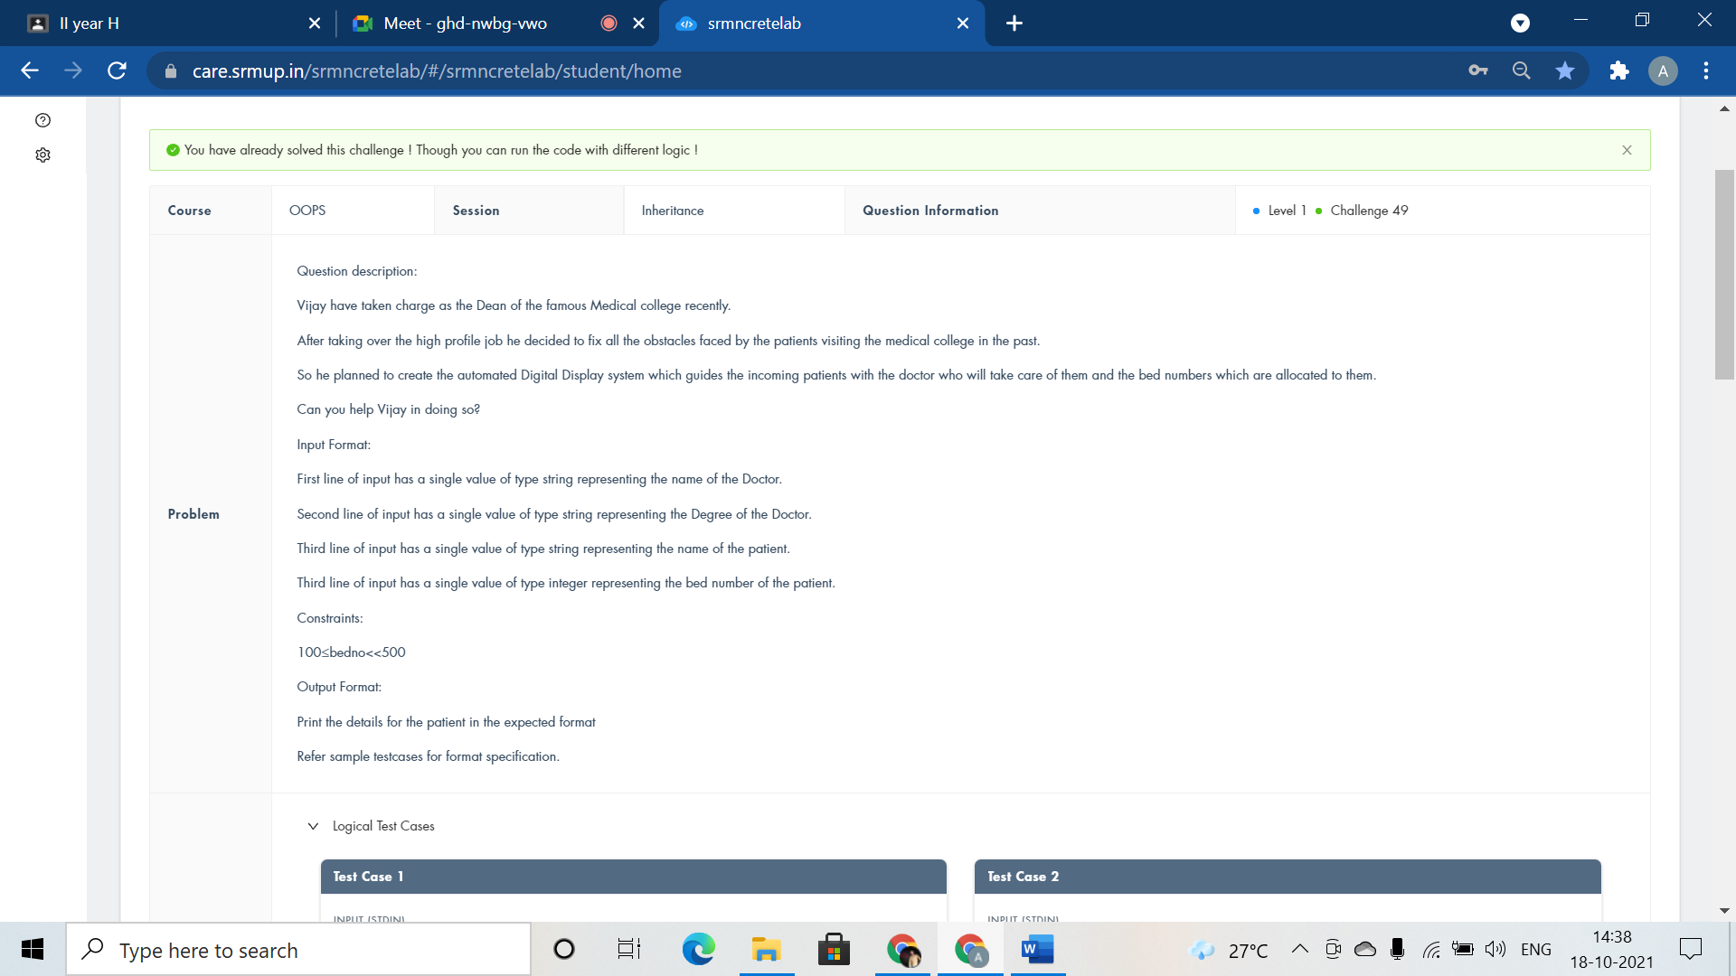

#include <iostream>

using namespace std;

class doctor{

public:

string name,degree,pname;

int no;

void getedu(){

cin>>name>>degree>>pname;

}

void getdata(){

cin>>no;

}

void dispedu(){

cout<<"Doctor Name:"<<name<<endl<<"Doctorate Degree:"<<degree<<endl<<"Patient Name:"<<pname<<endl;

}

void dispdata(){

cout<<"Bed Number:"<<no;

}

};

class patient:public doctor{

};

int main()

{

patient p;

p.getedu();

p.getdata();

p.dispedu();

p.dispdata();

return 0;

}



#include <iostream>

using namespace std;

class teacher{

public:

int num;

void setdata(int n)

{

if(n==1)

num=10;

else

num=7;

}

void setdata2(int n)

{

if(n==2)

num=3;

else

num=8;

}

void tentable(){

for(int i=1;i<=10;i++)

cout<<num<<"*"<<i<<"="<<num*i<<endl;

}

};

class ten:public teacher{

};

class three:public teacher{

};

class eight:public teacher{

};

class seven:public teacher{

};

int main()

{

int n;

cin>>n;

teacher t;

if(n==1 || n==4)

t.setdata(n);

if(n==2 || n==3)

t.setdata2(n);

t.tentable();

return 0;

}

Abstract Class and Virtual Functions:-



#include <iostream>

using namespace std;

class School{

public:

int roll;

string name;

virtual void getdata(){};

virtual void display(){};

};

class District : public School{

void getdata();

void display();

};

void District :: getdata(){

cin>>roll>>name;

}

void District :: display(){

cout<<"Student Name is: "<<name<<endl<<"Student Roll no is: "<<roll;

}

int main()

{

District obj;

School* ptr;

ptr = &obj;

ptr -> getdata();

ptr -> display();

return 0;

}



#include <bits/stdc++.h>

using namespace std;

int a,b,c,d,i;

class Holiday{

public:virtual void Expenses()=0;

};

class Citizen:public Holiday{

public:

void Expenses(){

cin>>c;

for (i=0; i<c; i++){

cin>>a;

if (d<a) d=a;

b=b+a;

}

cout<<d*c-b;

}

};

int main (){

Citizen obj;

obj.Expenses();

return 0;

}

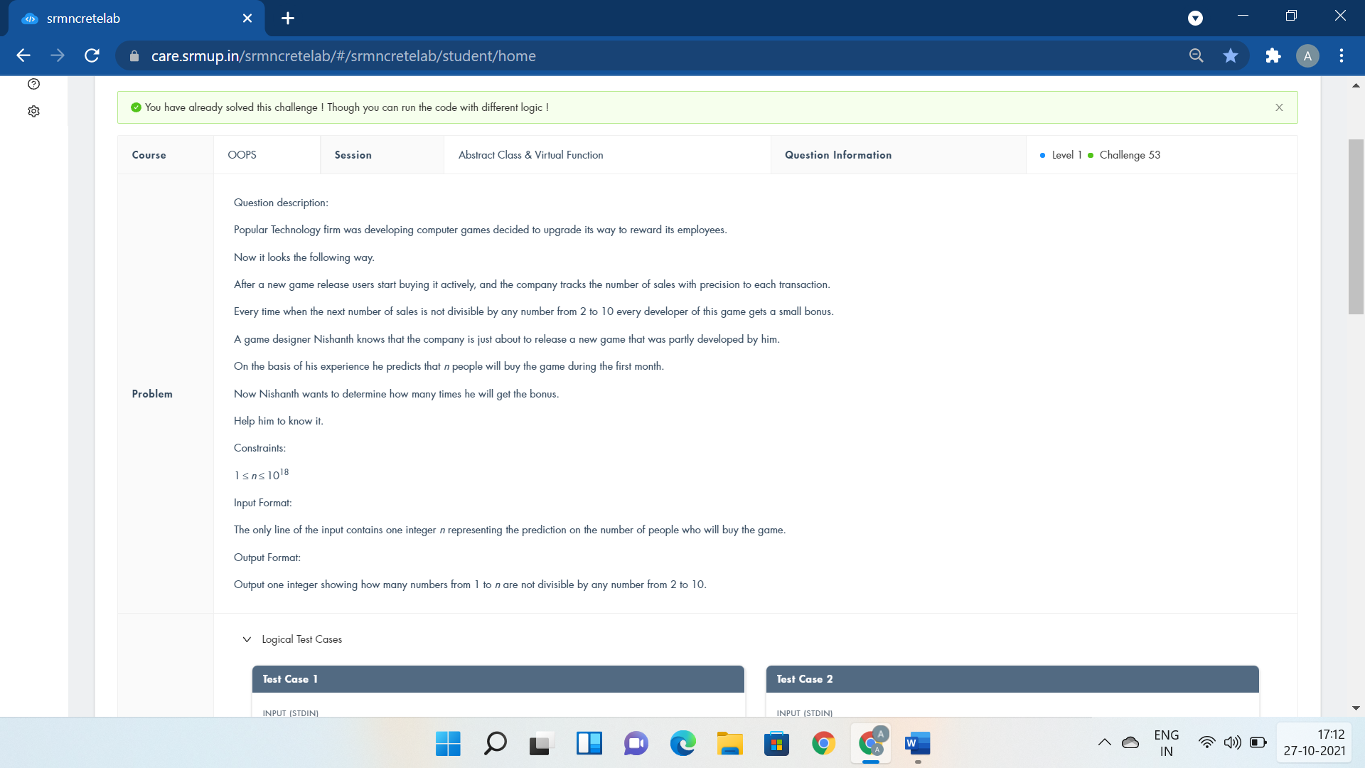

#include <bits/stdc++.h>

using namespace std;

class Employees{

public:virtual void BuyingGame()=0;

};

class Reward:public Employees{

public:

int n;

void BuyingGame(){

cin>>n;

cout<<n - n / 2 - n / 3 - n / 5 - n / 7

+ n / 6 + n / 10 + n / 14 + n / 15 + n / 21 + n / 35

- n / 30 - n / 42 - n / 70 - n / 105 + n / 210;

}

};

int main()

{

Reward obj;

obj.BuyingGame();

return 0;

}



#include <iostream>

using namespace std;

class Employee{

public:

int s1,s2;

};

class Developer : public Employee{

public:

void getSalary(){

cin>>s1;

cout<<"Salary of Developer:"<<s1<<endl;

}

};

class Driver : public Employee{

public:

void getSalary(){

cin>>s2;

cout<<"Salary of Driver:"<<s2<<endl;

}

};

int main()

{

Developer d1;

Driver d2;

d1.getSalary();

d2.getSalary();

return 0;

}

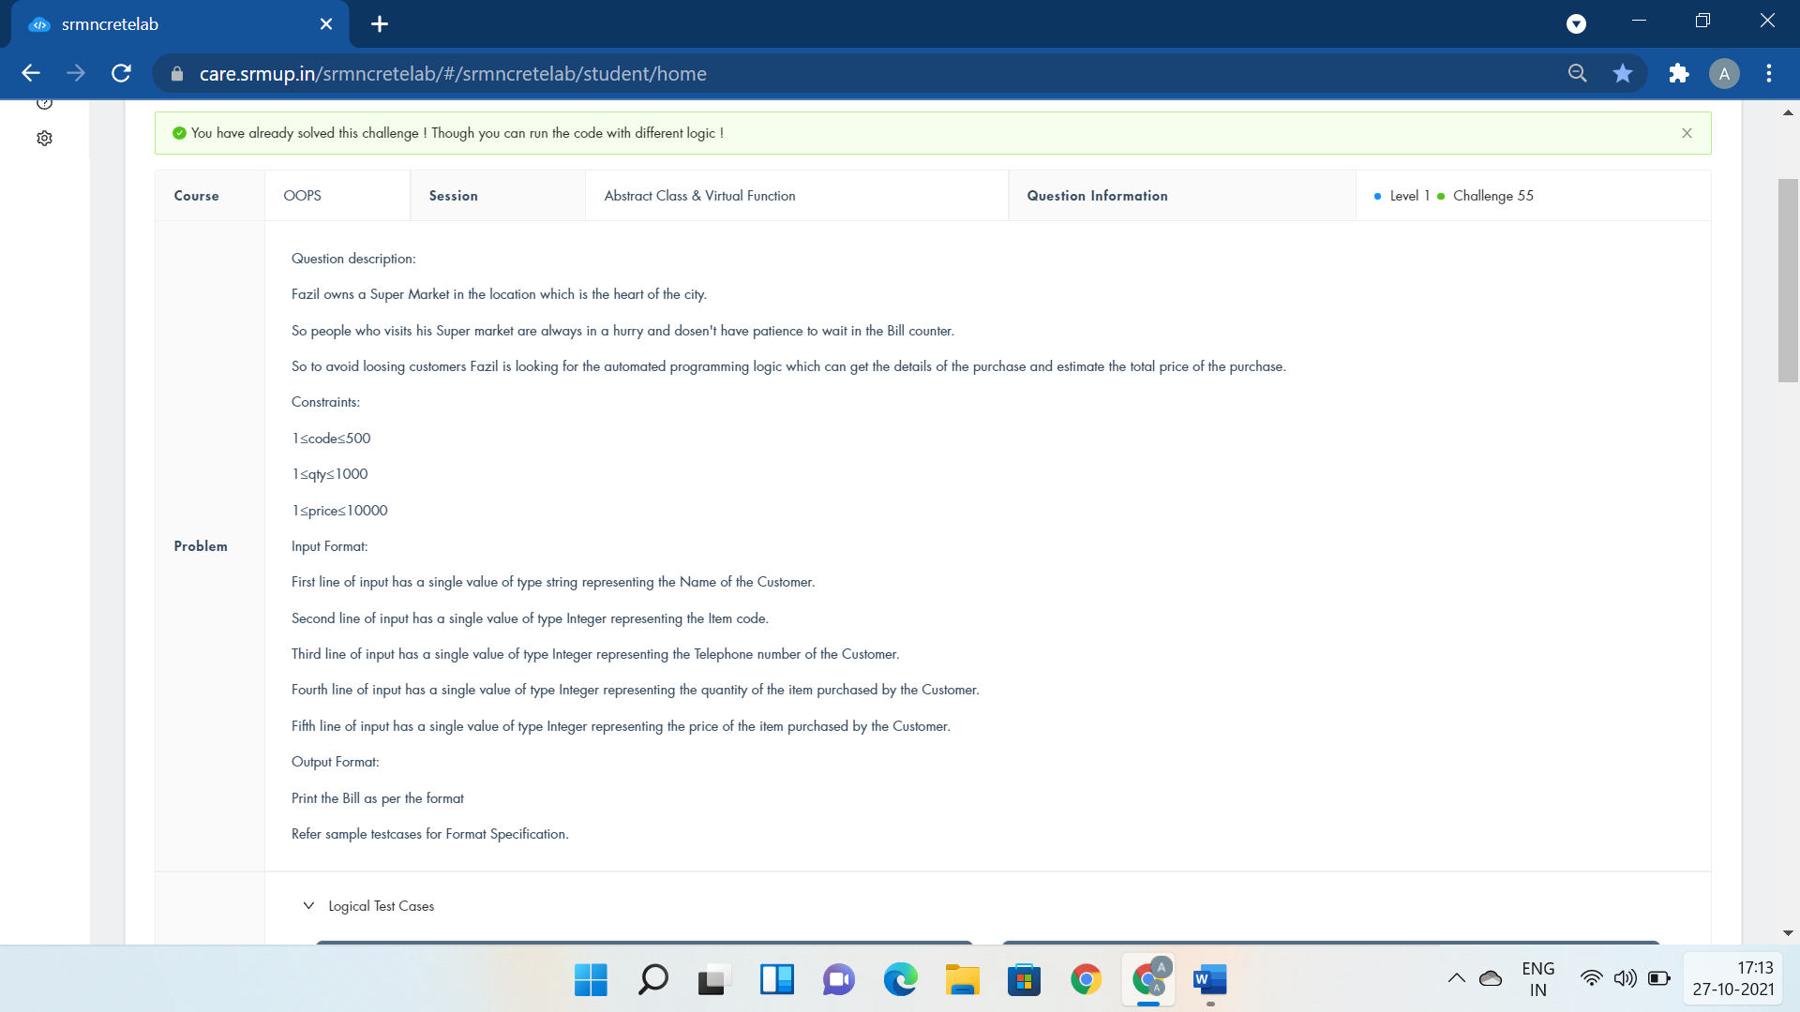

#include <iostream>

using namespace std;

class consumer{

public:

string name;

virtual void getdata()=0;

virtual void display()=0;

};

class transaction: public consumer{

public:

int code;

long tel;

int quan,price;

void getdata(){

cin>>name>>code;

cin>>tel;

cin>>quan;

cin>>price;

}

void display(){

cout<<"Name : "<<name<<endl<<"Code : "<<code<<endl<<"Telephone : "<<tel<<endl;

cout<<"Quantity : "<<quan<<endl<<"Price : "<<price<<endl<<"Total Price : "<<quan*price<<endl;

}

};

int main()

{

consumer* o1;

transaction o2;

o1=&o2;

o1->getdata();

o1->display();

return 0;

}



#include<iostream>

using namespace std;

class Problem {

public:virtual void Divisor()=0;

};

class Calculation:public Problem{

public:

int n,k,i;

void Divisor(){

cin>>n>>k;

}

int Display()

{

int count;

for(i=1;i<=n;++i)

{

if(n%i==0)

{

count++;

if(count==k){

cout<<i;

return 1;

}

}

}

cout<<-1;

return 1;

}

};

int main()

{

Calculation obj;

obj.Divisor();

obj.Display();

return 0;

}

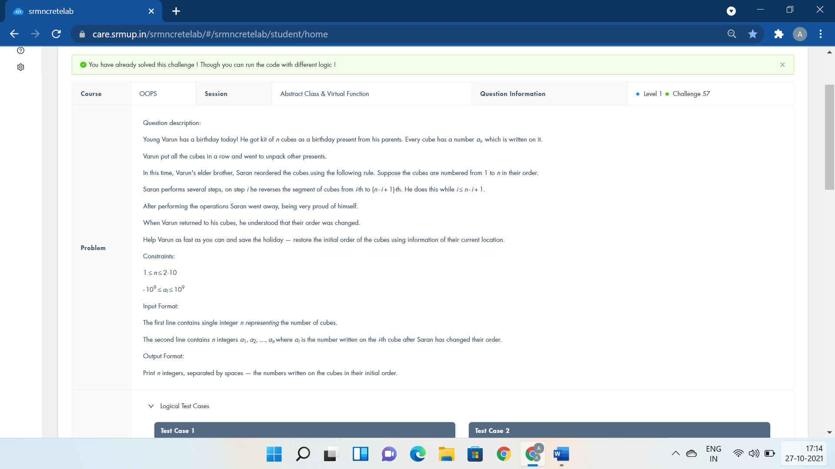

#include <iostream>

using namespace std;

class Gift {

public:virtual void Cubes()=0;

};

class Birthday:public Gift{

public:

int a[10],n;

void Cubes(){

cin>>n;

for(int i=0;i<n;i++)

cin>>a[i];

for(int i=0;i<n/2;i+=2)

/*int temp=a[i];

a[i]=a[n-i-1];

a[n-i-1]=temp;*/

swap(a[i],a[n-i-1]);

for(int i=0;i<n;i++)

cout<<a[i]<<" ";

}

};

int main()

{

Birthday obj;

obj.Cubes();

return 0;

}

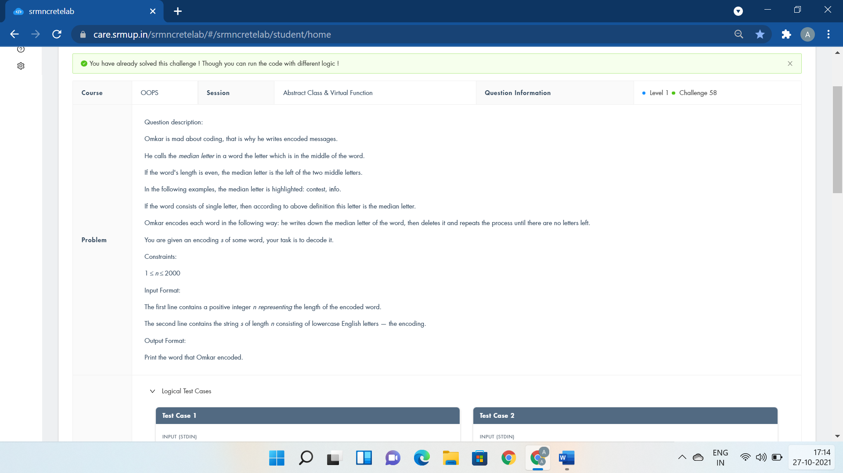

#include <iostream>

#include<string>

using namespace std;

class Decode{

public:virtual void Convert()=0;

};

class Word:public Decode{

public:

string s1,s2;

int n;

void Convert(){

cin>>n>>s1;

for(int i=0;i<n;i++){

if((n-i)%2==1)

s2=s2+s1[i];

else

s2=s1[i]+s2;

}

cout<<s2;

}

};

int main()

{

Word obj;

obj.Convert();

}

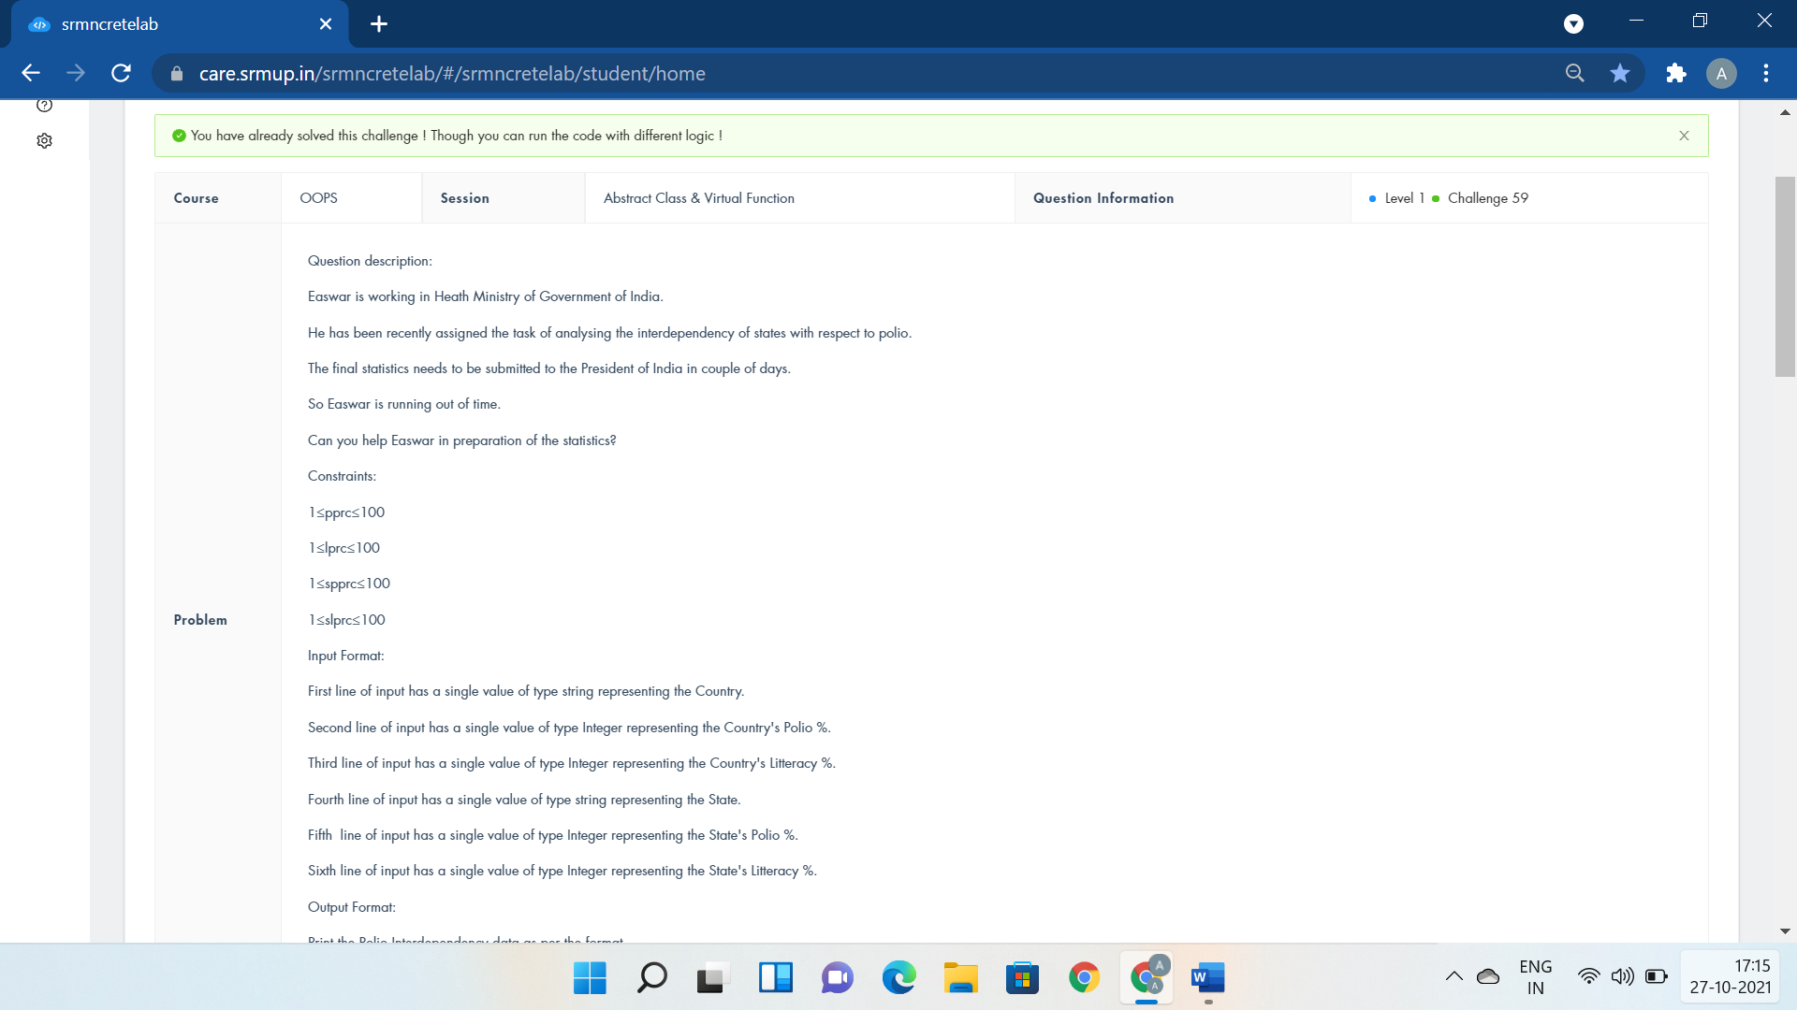

#include <iostream>

using namespace std;

class country

{

public:

virtual void getdata() = 0;

virtual void display() = 0;

};

class state:public country

{

public:

char a[20];

int b,c;

char d[20];

int e,f;

void getdata(){

cin>>a>>b>>c>>d>>e>>f;

}

void display()

{

cout<<"Country:"<<a<<endl<<"Country's Polio %:"<<b<<endl;

cout<<"Country Literacy %:"<<c<<endl<<"Interdependency Rate:"<<(float)b/c<<endl;

cout<<"State Name:"<<d<<endl<<"% of Polio of State:"<<e<<endl;

cout<<"% of Literacy of State:"<<f<<endl<<"Interdependency Rate:"<<(float)e/f;

}

};

int main() {

if(0)

cout<<"country::getdata();";

country *o1;

state o2;

o1=&o2;

o1->getdata();

o2.display();

return 0;

}

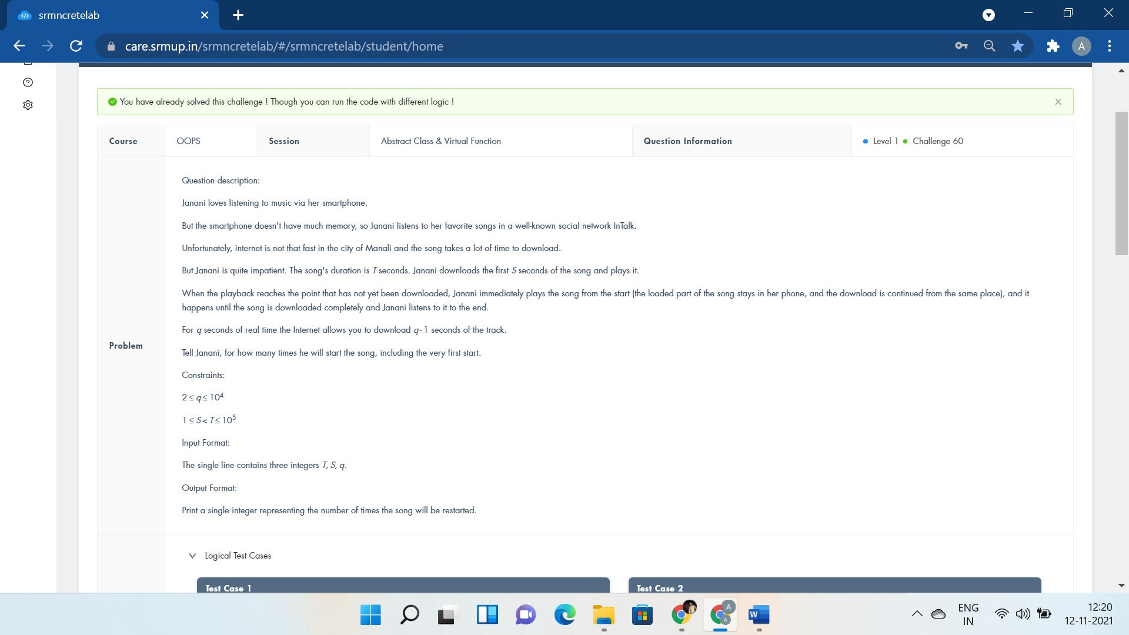

#include<iostream>

using namespace std;

class Smartphone{

public:virtual void Listening()=0;

};

class LoveForMusic:public Smartphone{

public:

int T,S,q,c=0;

void Listening(){

cin>>T>>S>>q;

while(S<T){

c++;

S*=q;

}

cout<<c;

}

};

int main()

{

LoveForMusic obj;

obj.Listening();

return 0;

}

Templates:-

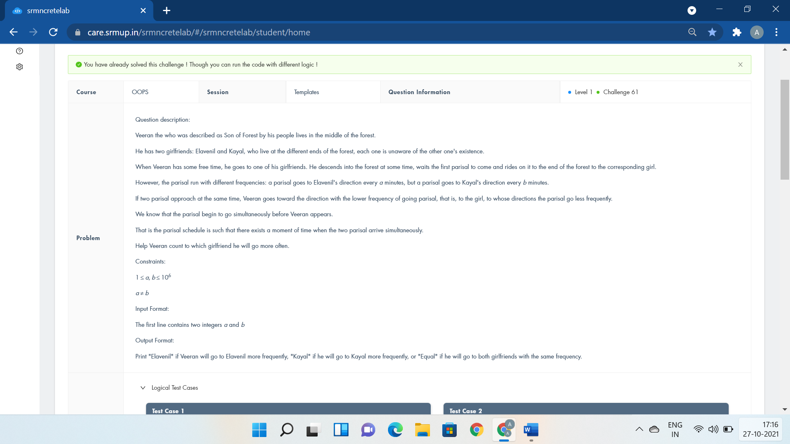

#include <bits/stdc++.h>

using namespace std;

template <class Forest>

Forest Visit(Forest a,Forest b){

if(a>b)

cout<<"Kayal\n";

else

cout<<"Elavenil\n";

return 1;

}

int main()

{

int a,b;

cin>>a>>b;

if(a%(a-b)==0 && b%(a-b)==0)

cout<<"Equal\n";

else

Visit(a,b);

return 0;

}

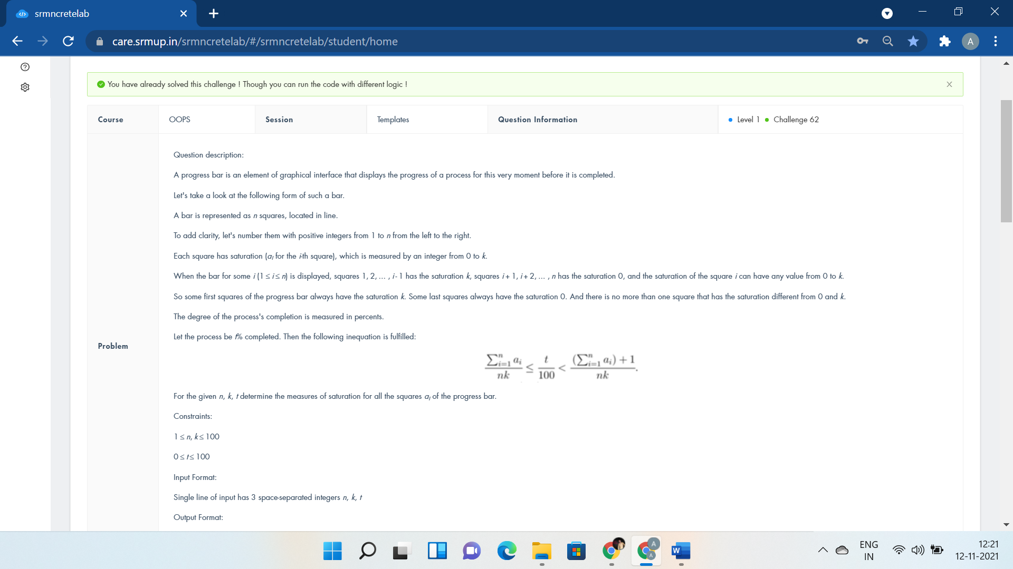

#include <iostream>

using namespace std;

template <class Interface>

Interface Bar(Interface n,Interface k,Interface t){

t = t*k*n/100.0;

while(n--){

cout<<min(t,k)<<" ";

t-=min(t,k);

}

return 1;

}

int main()

{

int n,k,t;

cin>>n>>k>>t;

Bar(n,k,t);

return 0;

}

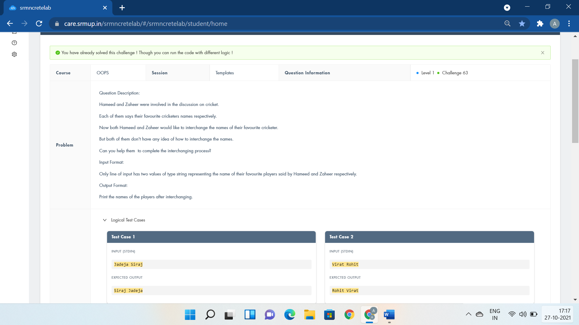

#include <iostream>

using namespace std;

template <class T>

void InterchangeFavPlayers(T &player1,T &player2){

cout<<player2<<" "<<player1;

}

int main()

{

string player1,player2;

cin>>player1>>player2;

InterchangeFavPlayers(player1,player2);

return 0;

}

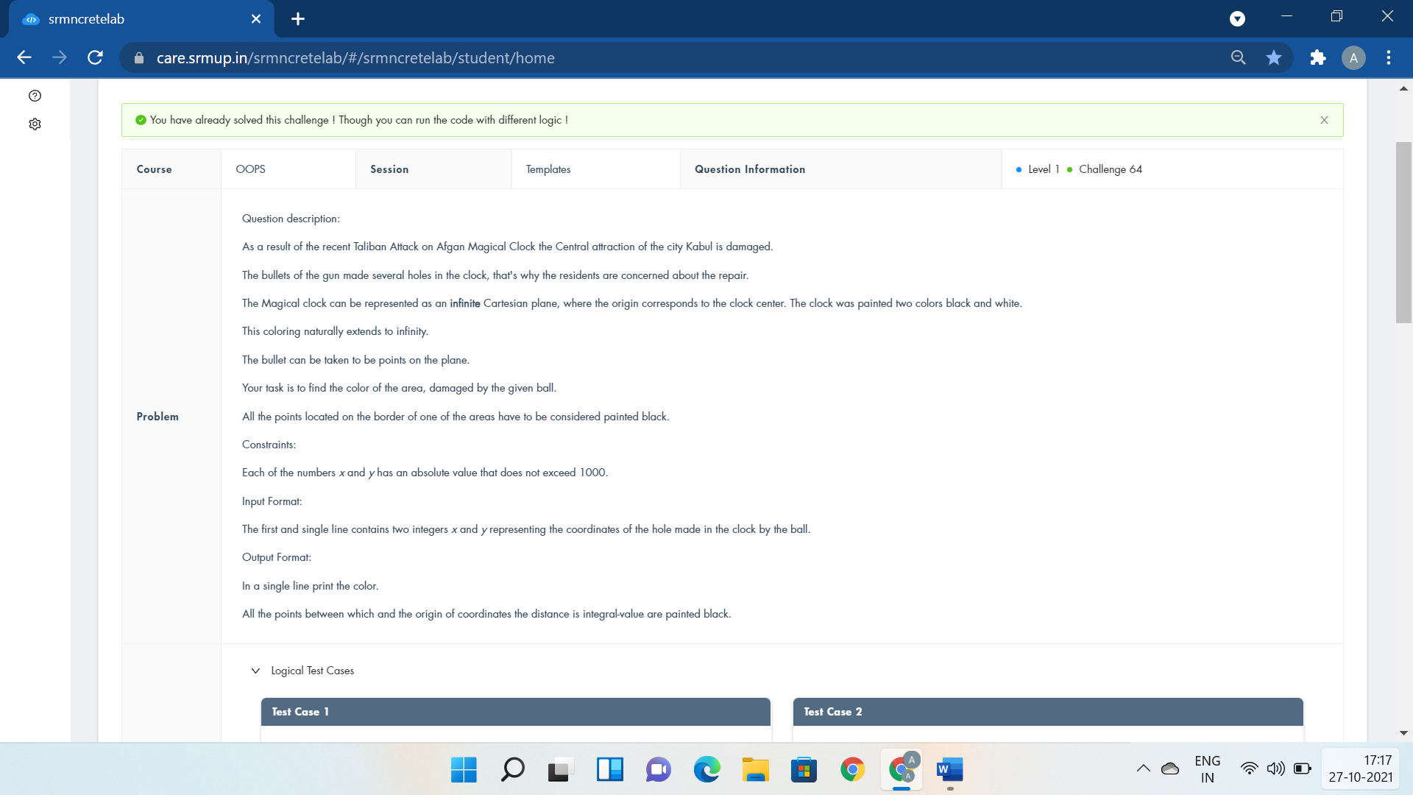

#include <iostream>

#include<cmath>

using namespace std;

template <class Hole>

Hole MagicClocl(Hole x,Hole y){

int c;

c=sqrt(x*x+y*y);

if(c*c==x*x+y*y){

cout<<"black\n";

return 0;

}

if(x*y<0)

c++;

if(c%2==0)

cout<<"black";

else cout<<"white";

return 1;

}

using namespace std;

int main()

{

int x,y;

cin>>x>>y;

MagicClocl(x,y);

return 0;

}

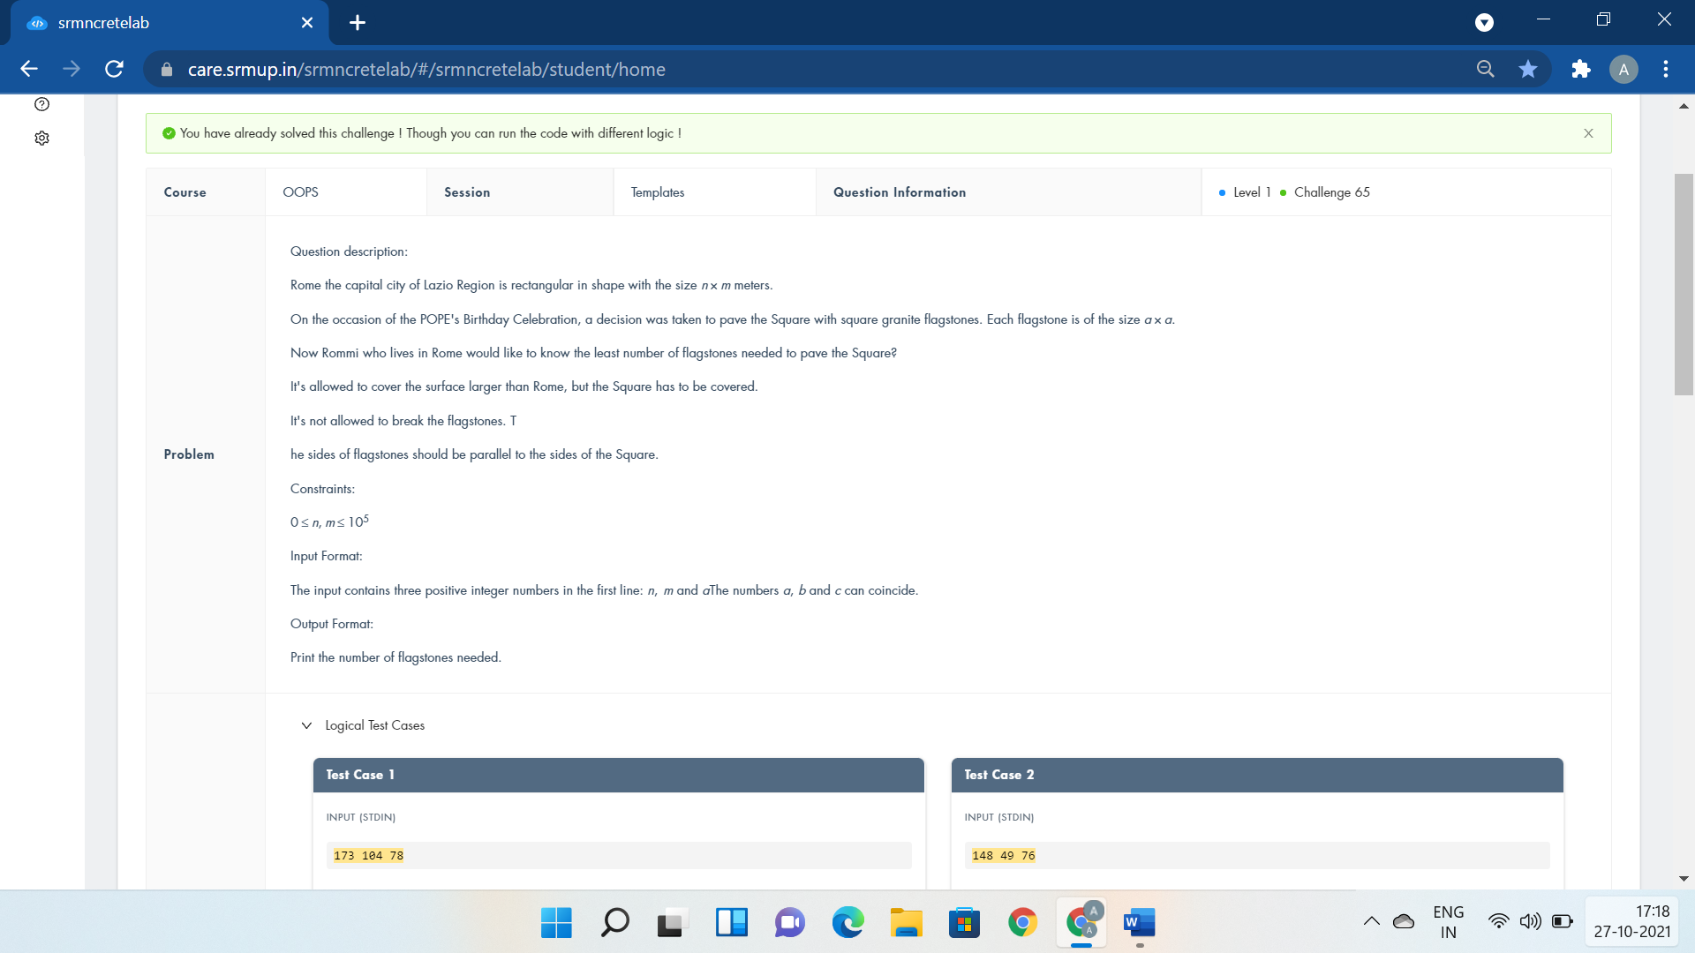

#include <iostream>

using namespace std;

template <class Celebration>

Celebration Rome(Celebration a,Celebration b,Celebration c){

cout<<((b+c-1)/c)*((a+c-1)/c);

return 1;

}

int main()

{

int a,b,c;

cin>>a>>b>>c;

Rome(a,b,c);

return 0;

}

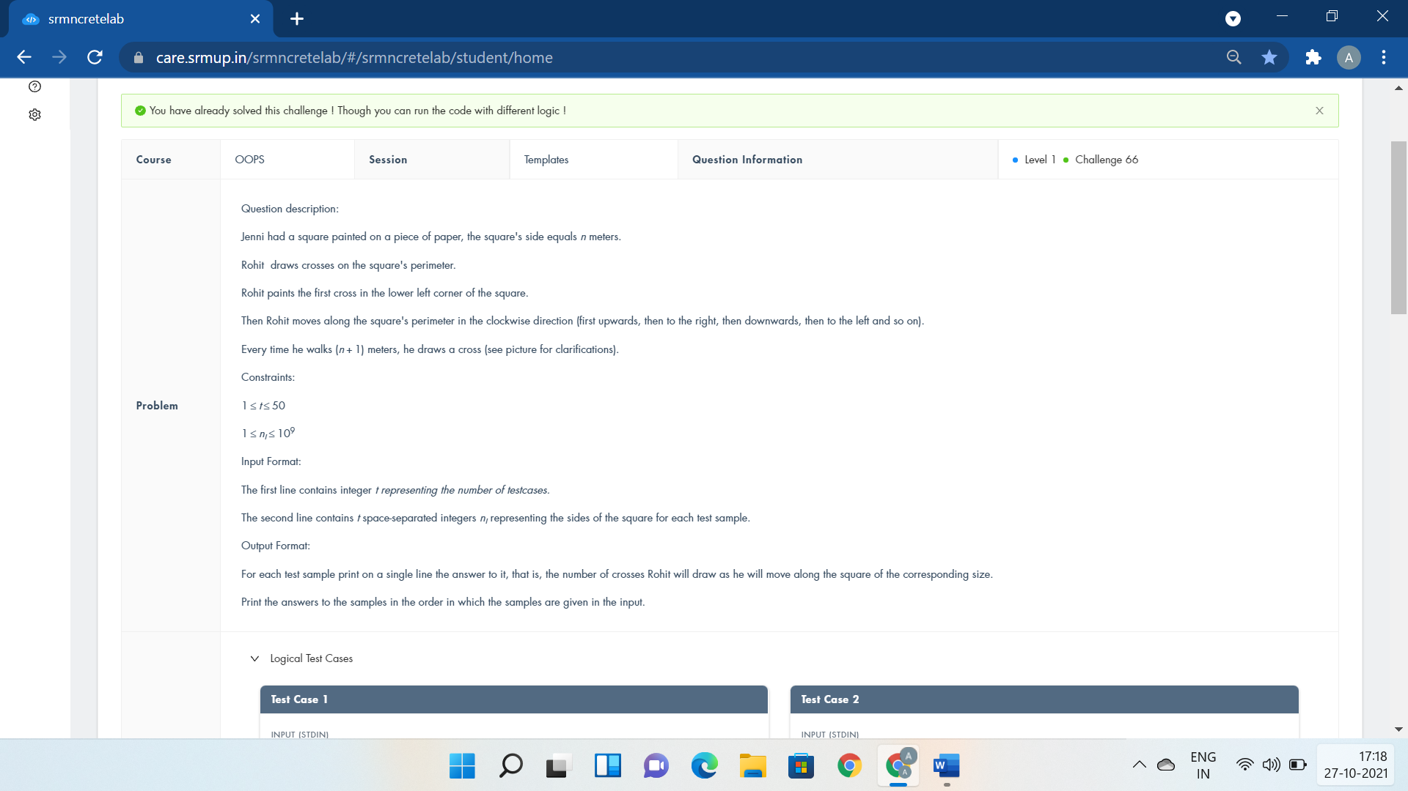

#include <iostream>

using namespace std;

template <class Paper>

Paper Square(Paper T){

if(T%2==0)

return 4*T+1;

else if(T%4==1)

return 2*T+1;

else

return T+1;

}

int main()

{

int T,n;

cin>>T;

while(T--){

cin>>n;

cout<<Square(n)<<endl;

}

return 0;

}

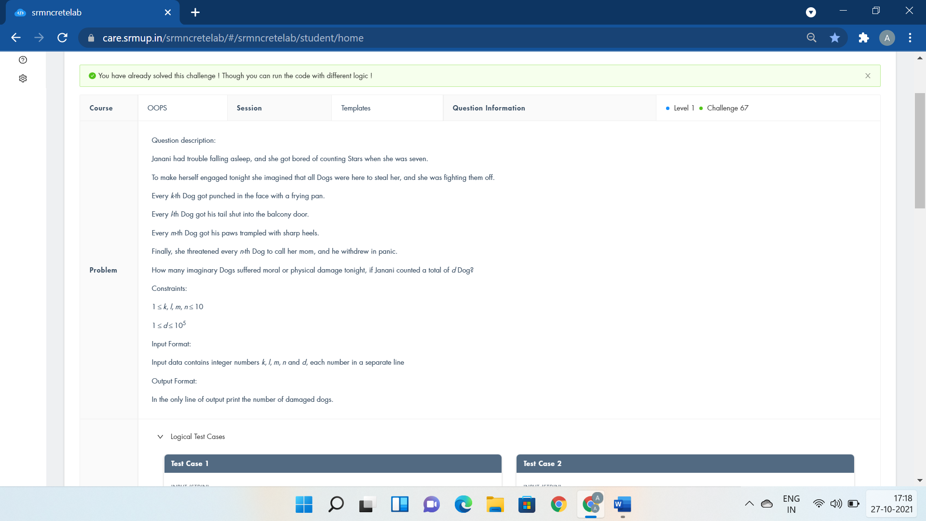

#include <iostream>

using namespace std;

template <class LackofSleep>

LackofSleep Counting(LackofSleep k,LackofSleep l,LackofSleep m,LackofSleep n,LackofSleep d)

{

int c=0;

for(int i=0;i<=d;i++){

if(i%k==0||i%l==0||i%m==0||i%n==0)

c++;

}

return c-1;

}

int main()

{

int k,l,m,n,d;

cin>>k>>l>>m>>n>>d;

cout<<Counting(k,l,m,n,d);

return 0;

}



#include <iostream>

using namespace std;

template <class Universe>

Universe Planet (Universe x1,Universe y1,Universe z1,Universe x2,Universe y2,Universe z2){

if(x1==x2 || y1 == y2 || z1==z2)

cout<<"YES";

else

cout<<"NO";

return 1;

}

int main()

{

int x1,y1,z1,x2,y2,z2;

cin>>x1>>y1>>z1>>x2>>y2>>z2;

Planet(x1,y1,z1,x2,y2,z2);

return 0;

}



#include<bits/stdc++.h>

using namespace std;

template <class Ribbon>

Ribbon Pieces(Ribbon n,Ribbon a,Ribbon b,Ribbon c){

int d=1,e,i,j;

for(i=0;i<=4000;i++)

for(j=0;j<=4000;j++) {

e=n-a*i-b*j;

if(e>=0&&e%c==0)

d=max(d,i+j+e/c);

}

cout<<d;

return 1;

}

int main(){

int n,a,b,c;

cin>>n>>a>>b>>c;

Pieces(n,a,b,c);

}



#include <iostream>

using namespace std;

template<class T>

T DivideMangosteen(T PurchasedWeight){

if(PurchasedWeight%2==0)

cout<<"YES";

else

cout<<"NO";

return 1;

}

int main()

{

int PurchasedWeight;

cin>>PurchasedWeight;

DivideMangosteen(PurchasedWeight);

return 0;

}

Exceptional Handling:-



#include <iostream>

using namespace std;

int main()

{

string str1,str2;

try{

cin>>str1>>str2;

int count, n=str1.size();

if(cin){

for(int i=0;i<n;i++){

if((str1[i]>=48 && str1[i]<=57) || (str2[i]>=48&&str2[i]<=57) )

throw 0;

if(str1[i]==str2[i])

count++;

}

if(count!=n)

cout<<str1<<" is not "<<str2;

else

cout<<str1<<" is "<<str2;

}

}

catch (int i){

cout<<"Inappropriate Input";

}

return 0;

}

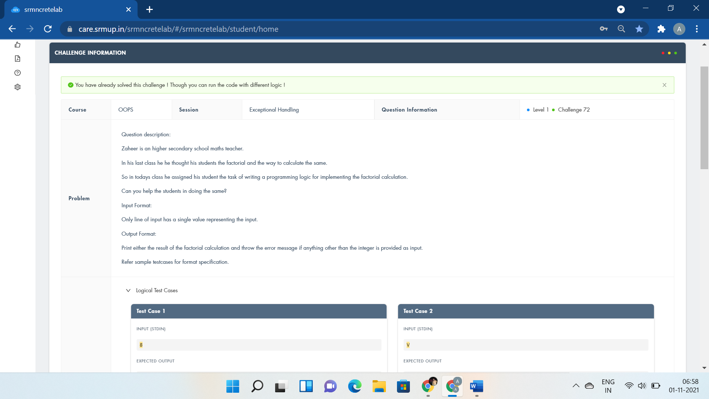

#include <bits/stdc++.h>

#include <string.h>

using namespace std;

int main()

{

int k;

try{

cin>>k;

if(cin)

cout<<fixed<<setprecision(0)<<tgamma(k+1);

else

throw "e";

}

catch (int i){

}

catch (const char *exp){

cout<<"Input should be a Integer";

}

return 0;

}



#include <iostream>

using namespace std;

int main()

{

int n,m;

try{

cin>>n;

cin>>m;

if(cin){

cout<<n-1+(1+2*(n-1))*(m-1);

}

else

throw 0;

}

catch(int griddimensions)

{

cout<<"Invalid Grid Dimensions";

}

return 0;

}

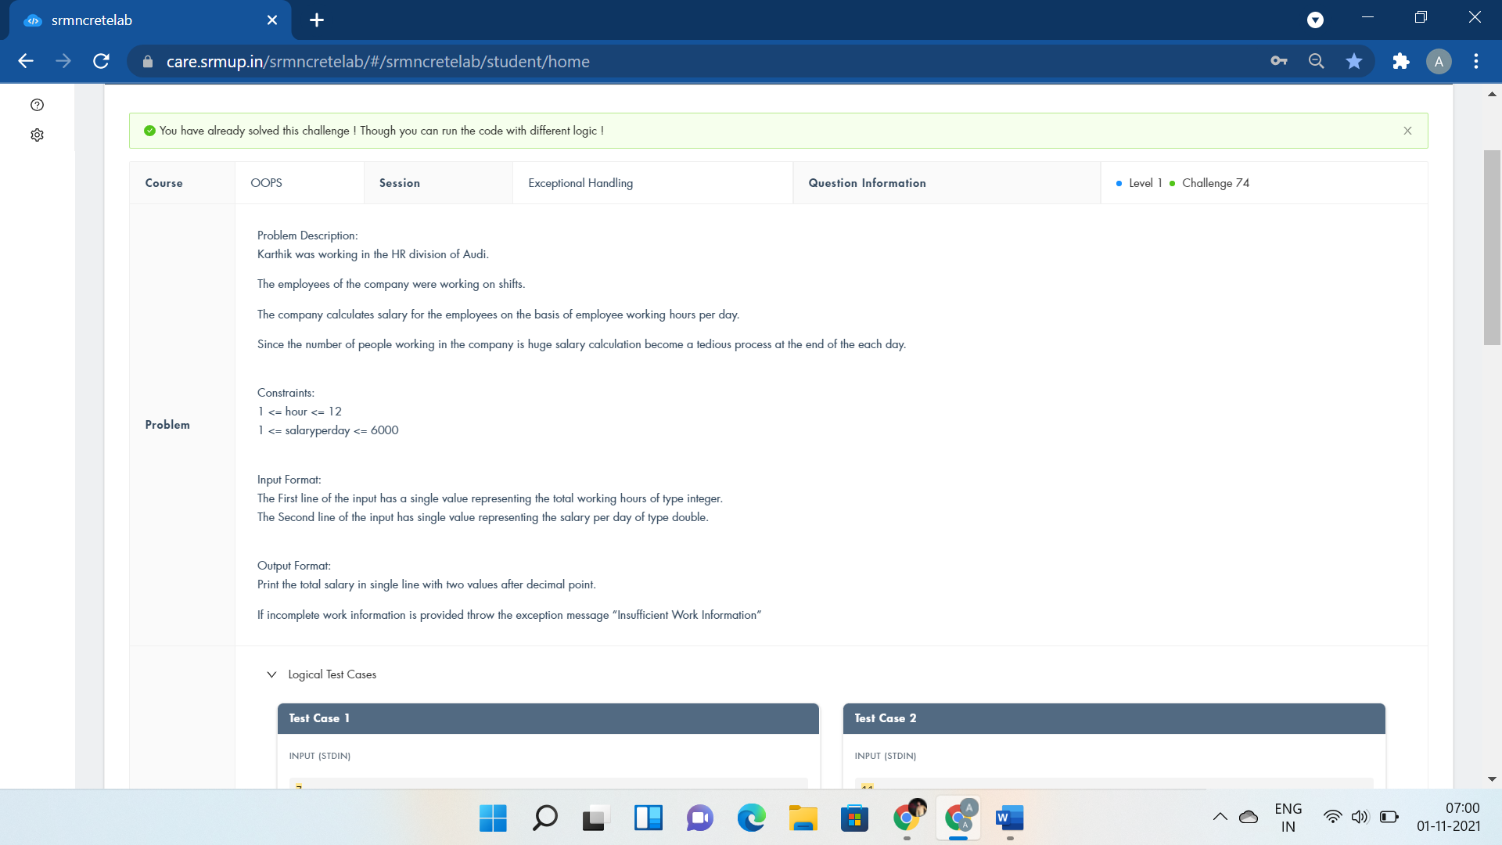

#include<bits/stdc++.h>

using namespace std;

int main()

{

float hour,salaryperday;

try{

cin>>hour;

cin>>salaryperday;

if(cin){

cout<<fixed<<setprecision(2)<<hour*salaryperday;

}

else

throw 0;

}

catch(int workstatus)

{

cout<<"Insufficient Work Information";

}

return 0;

}

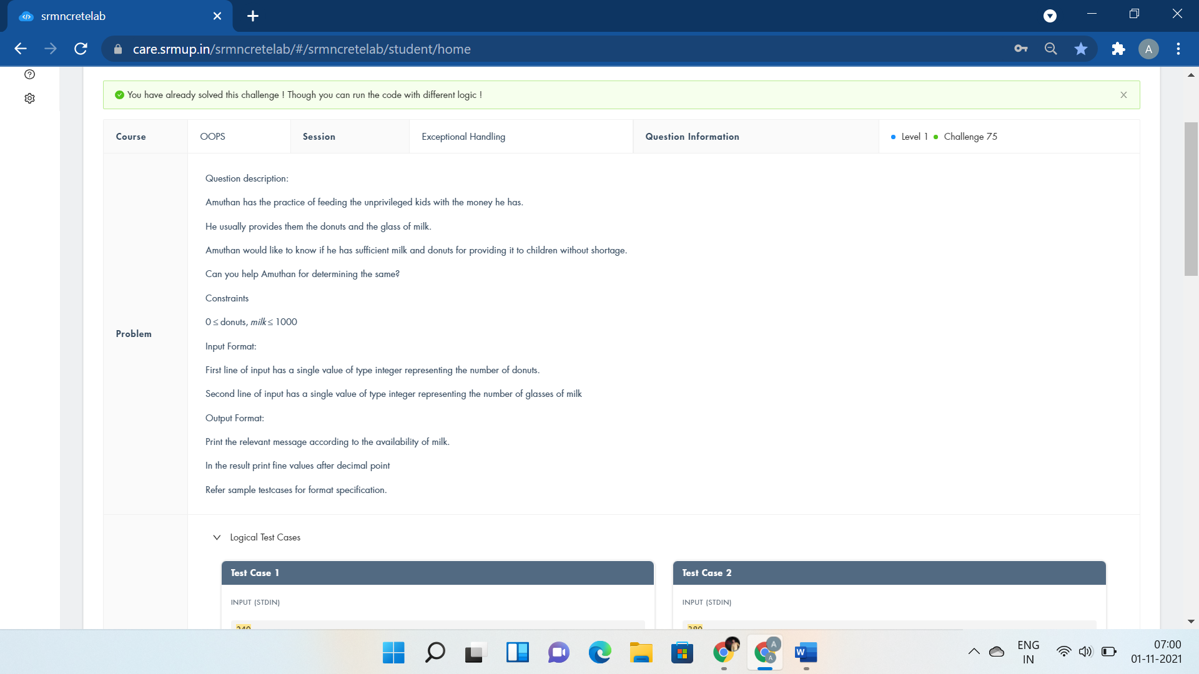

#include <iostream>

using namespace std;

int main()

{

int donuts,milk;

try{

cin>>donuts;

cin>>milk;

if(milk==0)

throw donuts;

else

cout<<"You have "<<(float)donuts/milk<<" donuts for each glass of milk";

}

catch(int e){

cout<<e<<" donuts and No Milk\nGo buy some milk";

}

return 0;

}

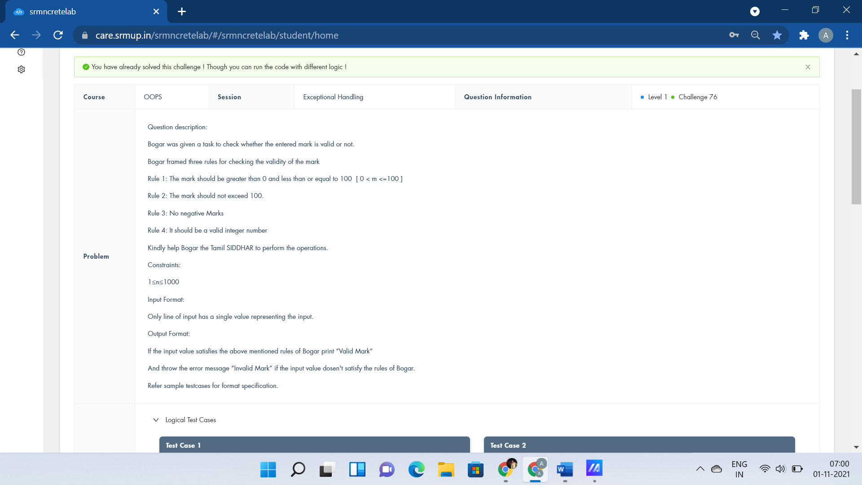

#include <iostream>

#include <math.h>

using namespace std;

int main()

{

int a;

try {

cin>>a;

if (a>0 && a<=100)

cout<<"Valid Mark";

else

throw "e";

}

catch(const char* t){

cout<<"Invalid Mark";

}

}

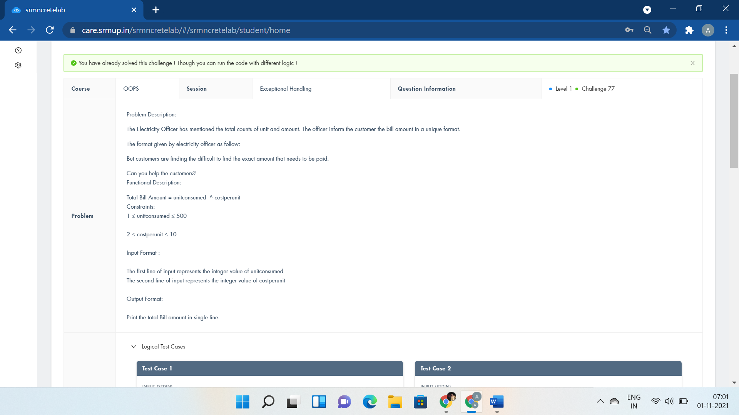

#include <bits/stdc++.h>

using namespace std;

int main()

{

int unitconsumed,costperunit;

try{

cin>>unitconsumed;

cin>>costperunit;

long int res;

res=pow(unitconsumed,costperunit);

if(cin){

cout<<res;

}

else

throw 0;

}

catch(int unit){

cout<<"Incomplete Data";

}

return 0;

}

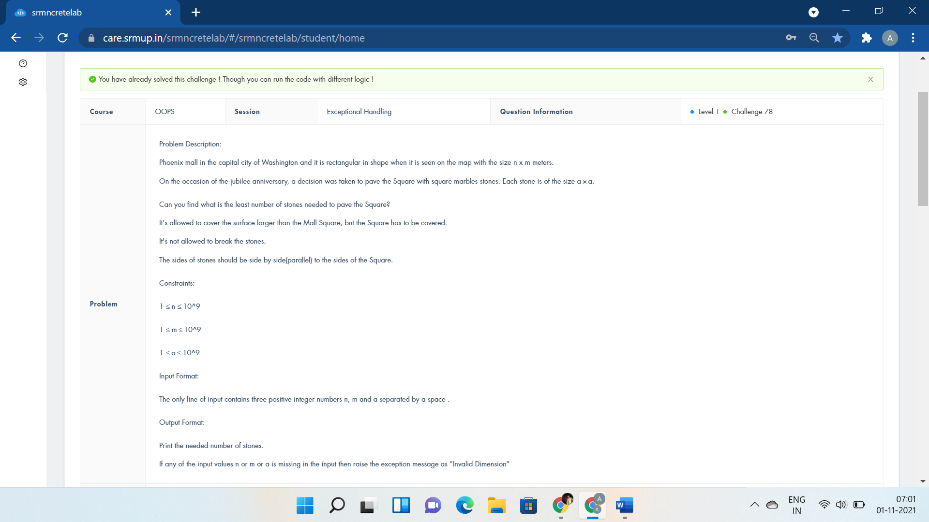

#include <iostream>

using namespace std;

int main()

{

int n,m,a;

try{

cin>>n>>m>>a;

if(cin){

cout<<((n+a-1)/a)*((m+a-1)/a);

}

else

throw 0;

}

catch(int dimension){

cout<<"Invalid Dimension";

}

return 0;

}



#include<bits/stdc++.h>

#define f(i,a,n) for(i=a;i<n;i++)

using namespace std;

int main(){

int t,i,j;

cin>>t;

string str;

f(j,0,t){

f(i,0,2){

try{

cin>>str[i];

if(isalpha(str[i]))

cout<<str[i]<<" is alphabetic"<<endl;

else

throw str[i];

}

catch (char f){

cout<<f<<" is not alphabetic"<<endl;

}

}

}

}

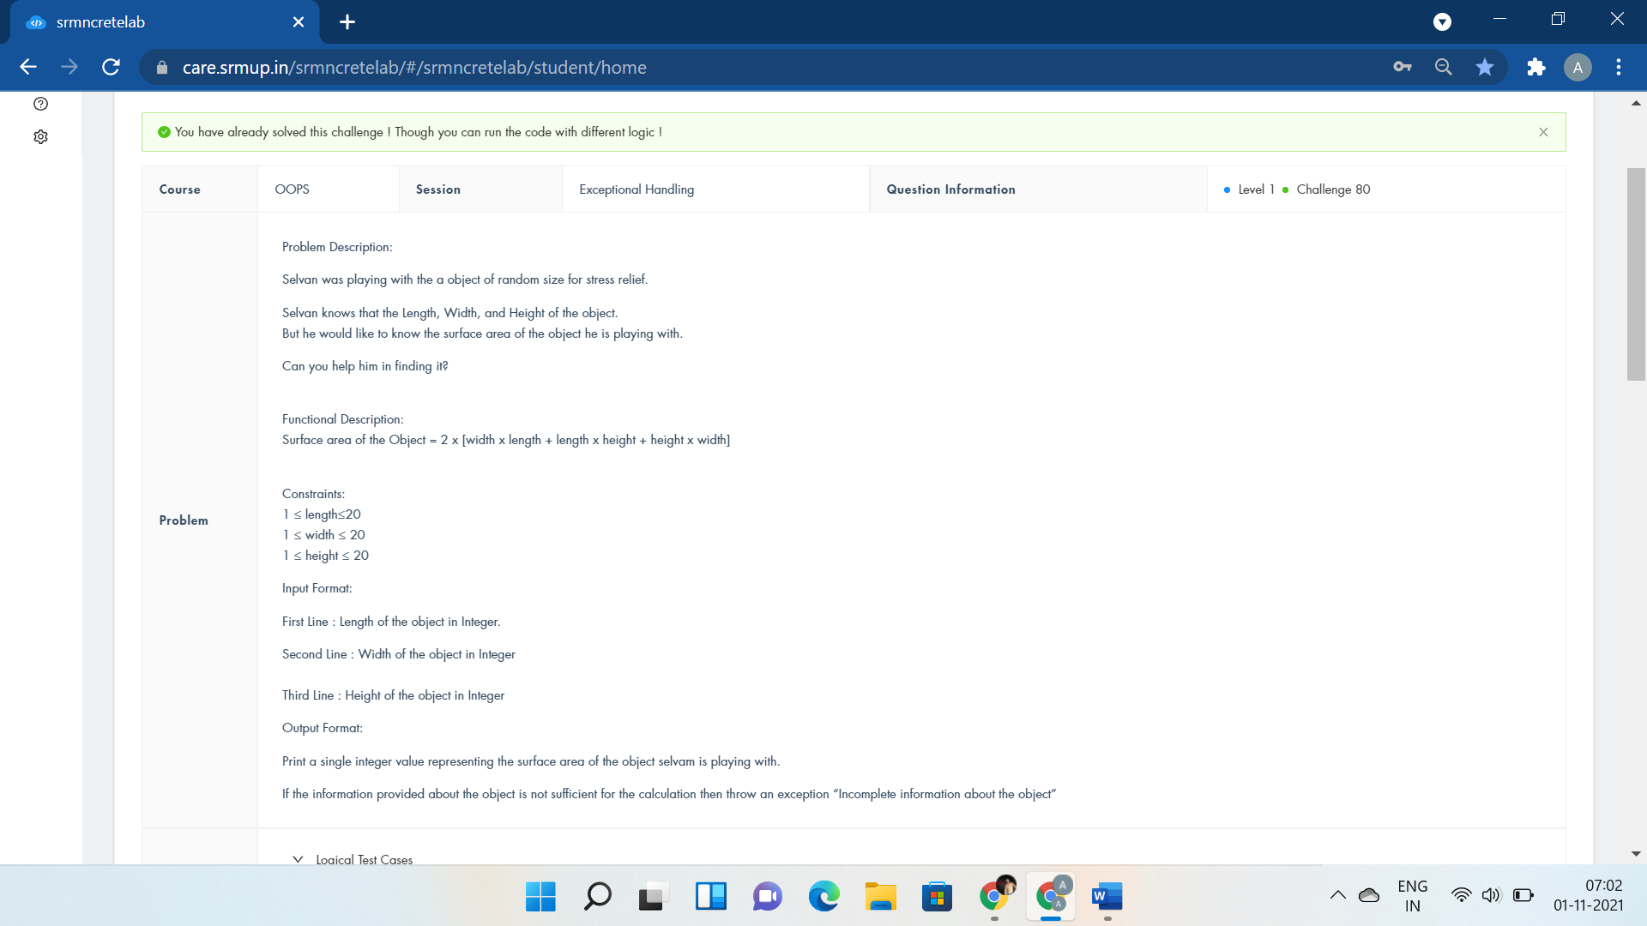

#include <iostream>

using namespace std;

int main()

{

int a,b,c;

try{

cin>>a>>b>>c;

if(cin){

cout<<2*(a*b+b*c+c*a);

}

else

throw 0;

}

catch(int objectinfo){

cout<<"Incomplete information about the object";

}

return 0;

}

STL:-

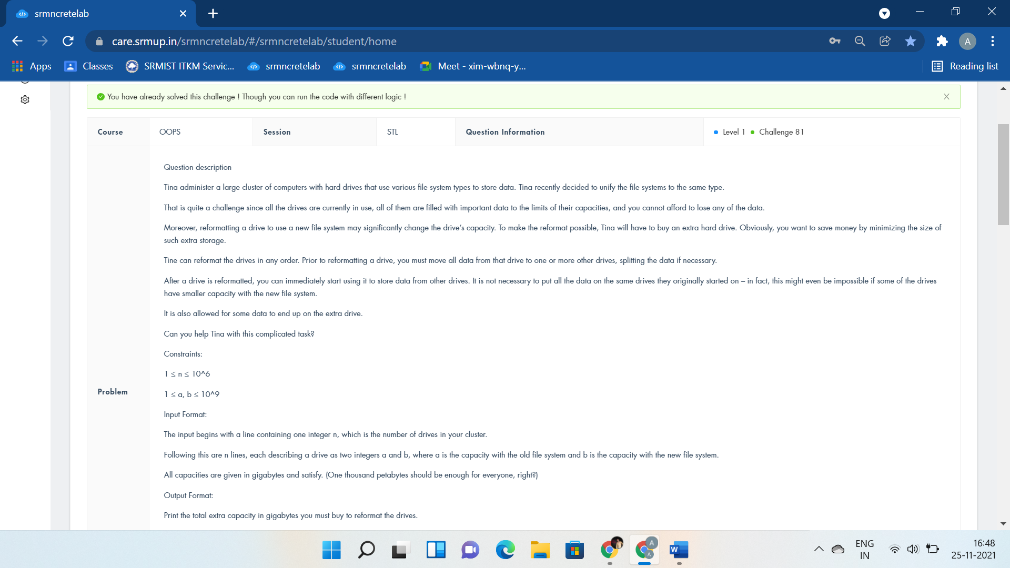

#include <algorithm>

#include <iostream>

#include <vector>

using namespace std;

int main() {

int N, a, b;

while (cin>>N) {

vector<pair<int,pair<int,int>>>StorageDrives;

for (int i = 0; i < N; i++) {

cin>>a>>b;

StorageDrives.push_back(make_pair((b>a) ? a : 2000000001-b, make_pair(a, b)));

}

long long ret = 0, cap = 0;

sort(StorageDrives.begin(),StorageDrives.end());

int z=StorageDrives.size();

for (int i = 0; i < z; i++) {

if (cap < StorageDrives[i].second.first) {

ret += StorageDrives[i].second.first - cap;

cap = StorageDrives[i].second.first;

}

cap += StorageDrives[i].second.second - StorageDrives[i].second.first;

}

cout << ret << endl;

}

}

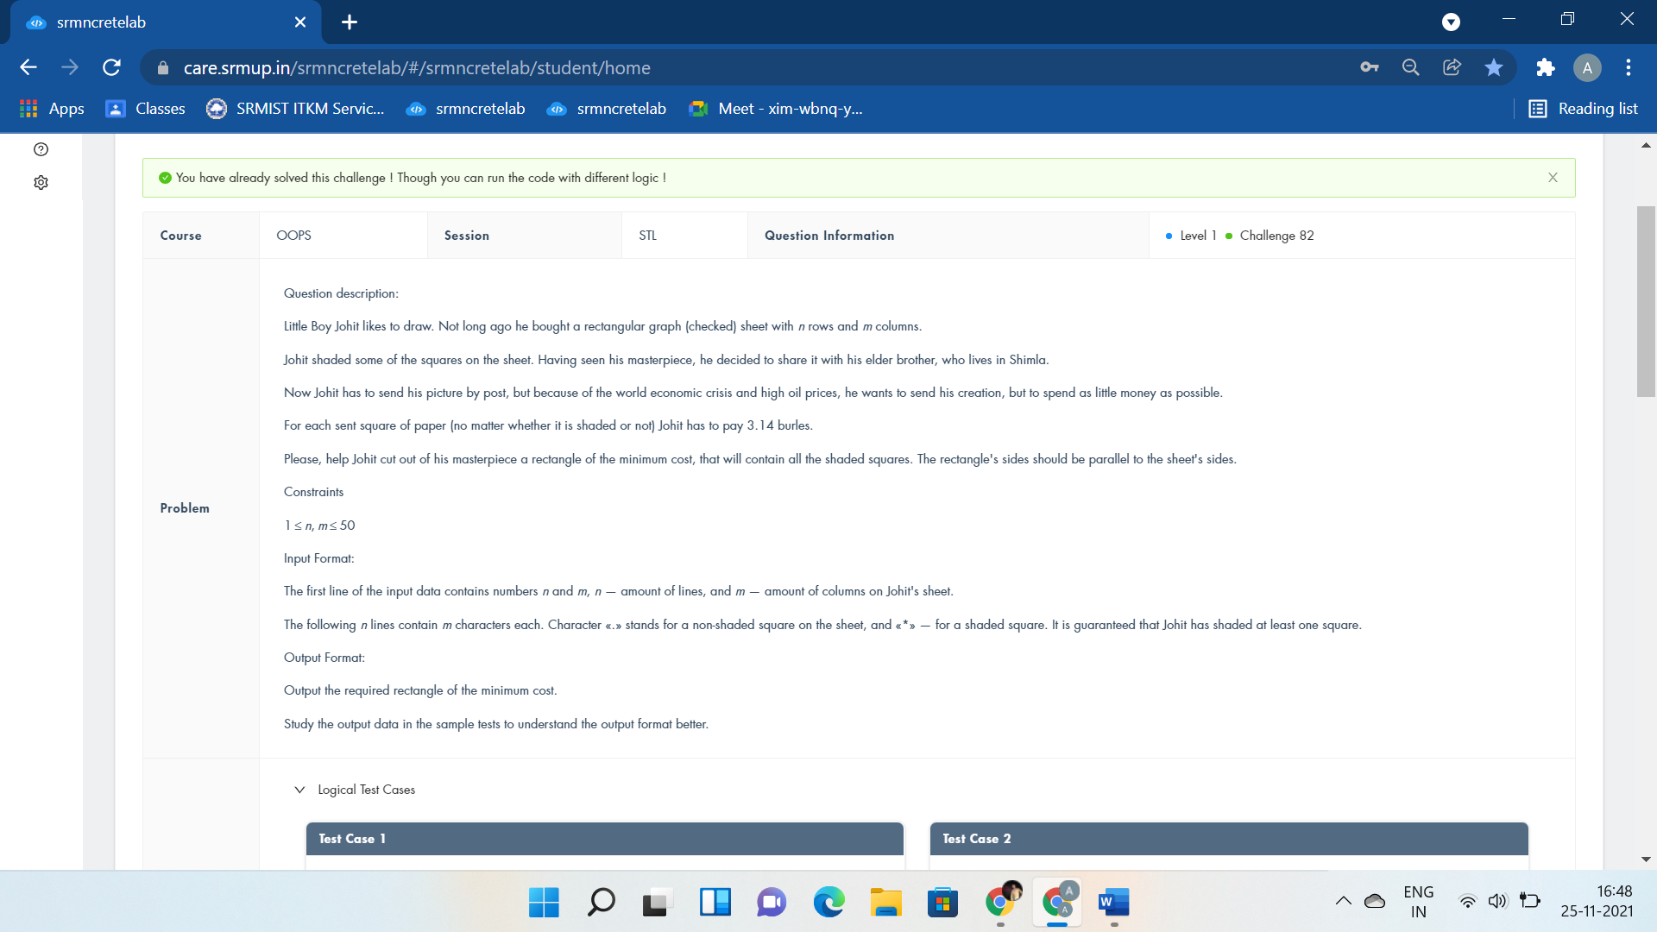

#include<bits/stdc++.h>

using namespace std;

int n,m,sx=99999,sy=99999,x,y;

char a[55][55];

int main(){

cin>>n>>m;

for(int i=1;i<=n;i++){

for(int j=1;j<=m;j++){

cin>>a[i][j];

if(a[i][j]=='*'){

x=max(x,i),y=max(y,j),sx=min(sx,i),sy=min(sy,j);

}

}

}

for(int i=sx;i<=x;i++){

for(int j=sy;j<=y;j++) cout<<a[i][j];

cout<<endl;

}

return 0;

cout<<"vector<vector<char>>drawing(n,vector<char>(m,'0')); drawing[row][col]";

}

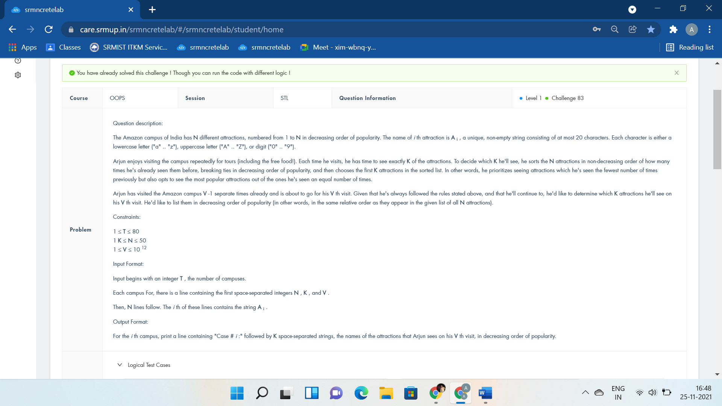

#include <bits/stdc++.h>

using namespace std;

typedef long long LL;

const int N=55;

LL n, k, v, idx;

string name[N];

int main(){

LL t; cin>>t; while(t--){

cin>>n>>k>>v;

for(int i=0; i<n; i++)

cin>>name[i];

LL st=((v-1)*k)%n;

//cout<<"Case #"<<(++idx)<<":";

vector<int> ans;

for(int i=0; i<k; i++)

ans.push_back((st+i)%n);

sort(ans.begin(), ans.end());

for(int id: ans)

cout<<name[id]<<" ";

cout<<"\n";

}

return 0;

cout<<"vector<string>visit(n); vector<pair<int,string>>seenattraction; sort(seenattraction.begin(),seenattraction.end());";

}

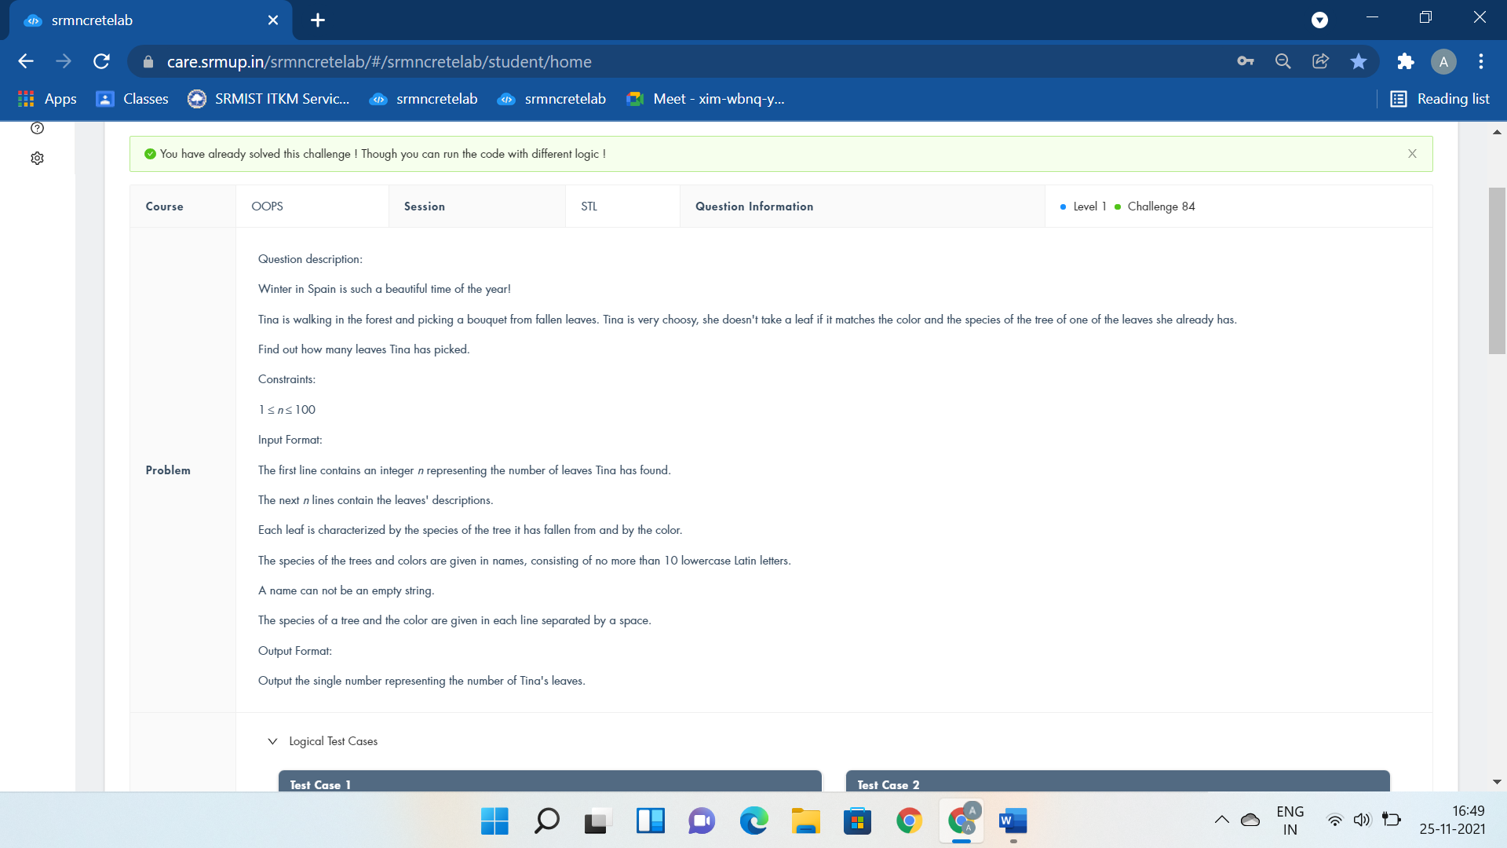

#include <bits/stdc++.h>

using namespace std;

int main()

{

int n;

cin>>n;

set<pair<string,string>>Descriptionofleaves;

string species,color;

while(n--){

cin>>species>>color;

Descriptionofleaves.insert(make_pair(species,color));

}

cout<<Descriptionofleaves.size();

return 0;

}

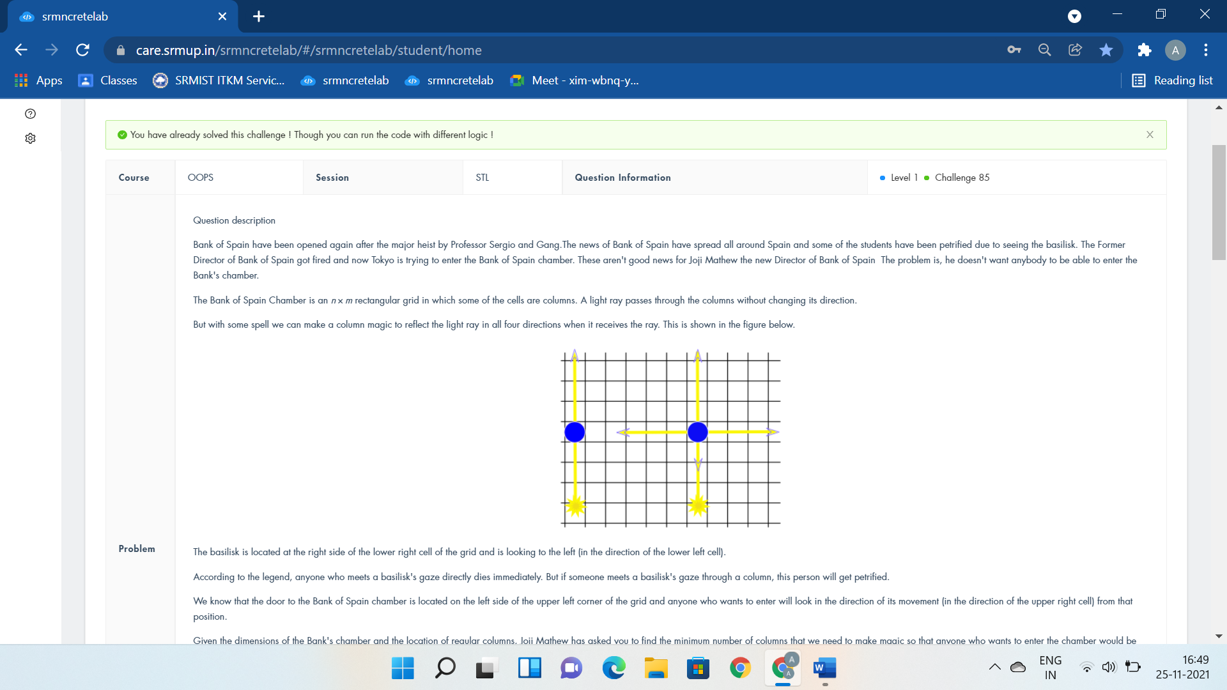

#include <bits/stdc++.h>

using namespace std;

void sum(){}

int n,m;

vector <int> use[2020];

int cost[2020];

string g[1010];

int main()

{

cin>>n>>m;

for(int i=0;i<n;i++)

{

cin>>g[i];

for(int j=0;j<m;j++)

{

if(g[i][j]=='#')

{

use[i].push_back(j+n);

use[j+n].push_back(i);

}

}

}

queue<int>BankChamber;

BankChamber.push(n-1);

cost[n-1]=1;

while(!BankChamber.empty())

{

int t=BankChamber.front();

BankChamber.pop();

int z=use[t].size();

for(int i=0;i<z;i++)

{

if(cost[use[t][i]]==0)

{

cost[use[t][i]]=cost[t]+1;

BankChamber.push(use[t][i]);

}

}

}

cout<<cost[0]-1<<endl;

sum();

return 0;

cout<<"BankChamber.push(n);";

}

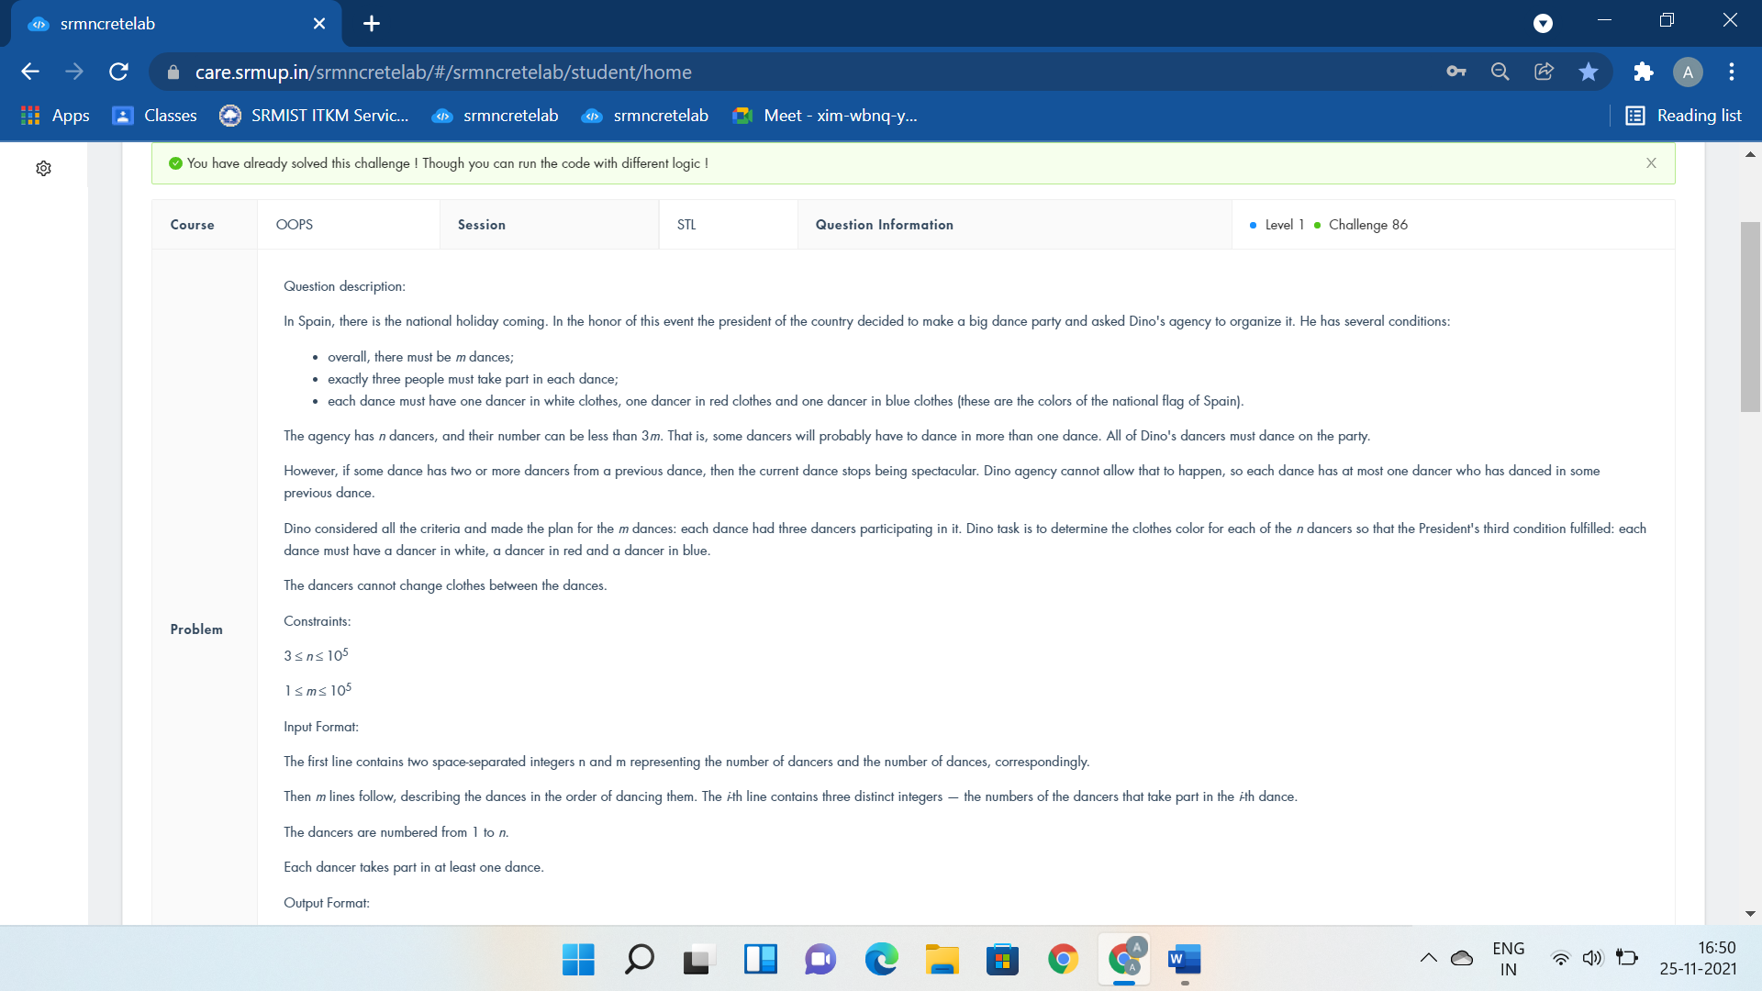

#include<bits/stdc++.h>

using namespace std;

typedef long long int ll;

ll a[100006],c[3];

int main()

{

ll n,m,i,j,k,l,sum=0;

cin>>n>>m;

for(i=0;i<m;i++)

{

sum=0;

for(j=0;j<3;j++)

{

cin>>c[j];

sum=sum+a[c[j]];

}

l=1;

for(k=0;k<3;k++)

{

if(l==sum)

l++;

if(a[c[k]]==0)

{

a[c[k]]=l++;

}

}

}

for(i=1;i<=n;i++)

cout<<a[i]<<" ";

return 0;

cout<<"map<int,int>dance; set<int>dancer;";}

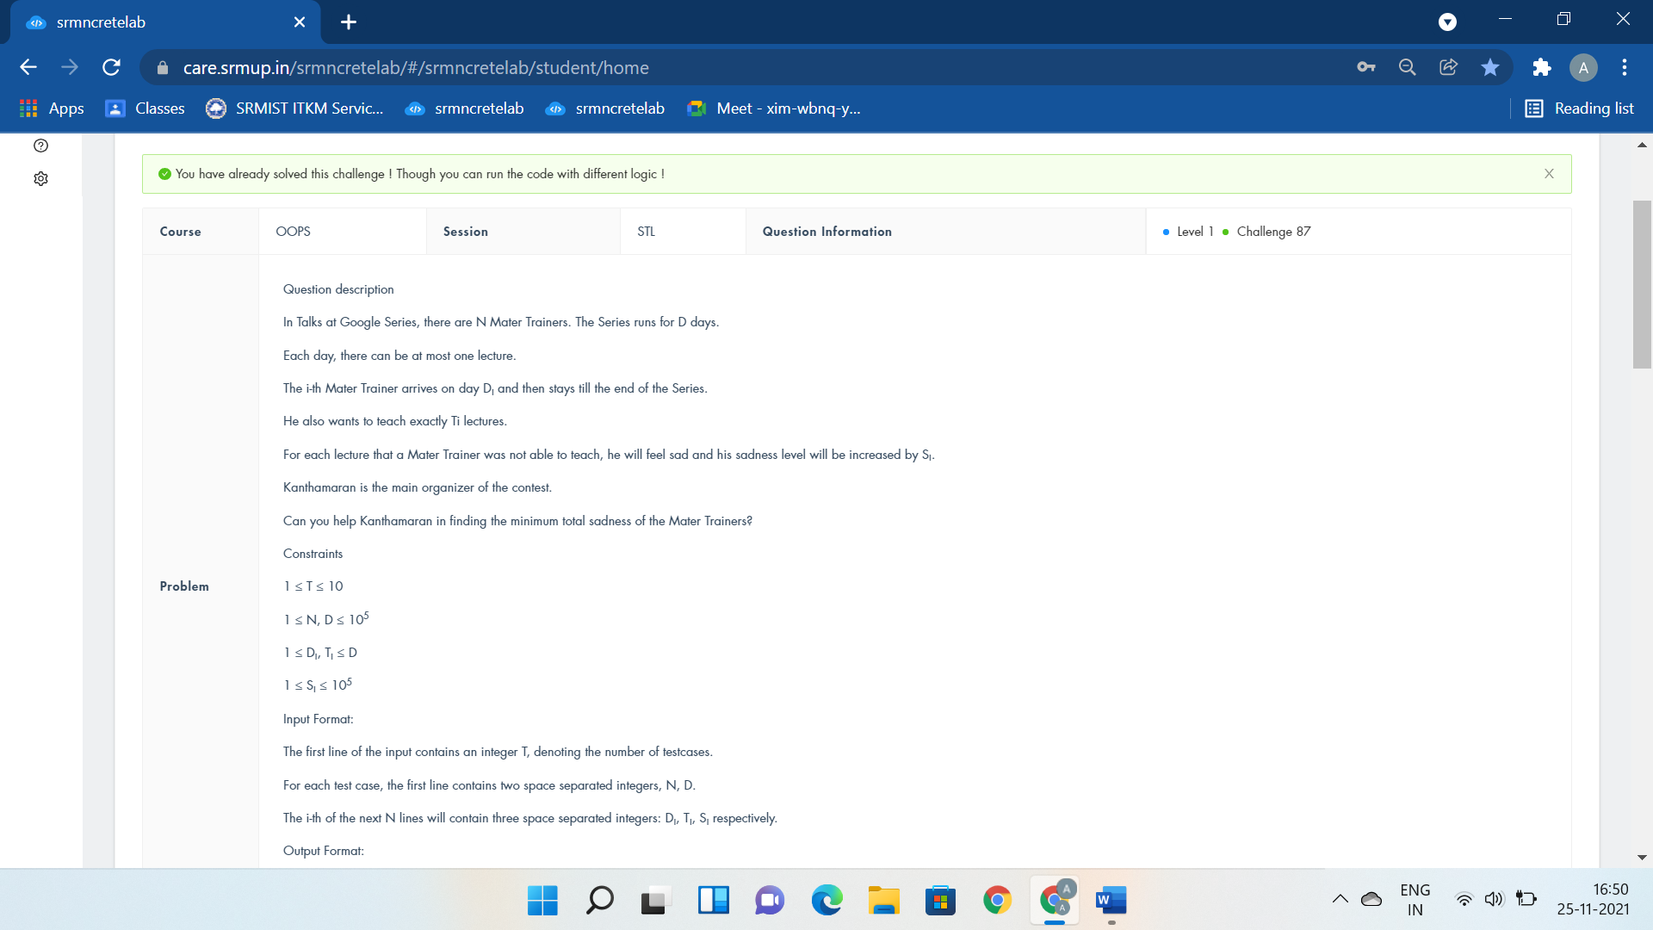

#include <bits/stdc++.h>

#define ll long long

using namespace std;

int main(){

int t;

cin >> t;

while (t--) {

int n, d;

cin >> n >> d;

map<ll, vector<pair<long,long>>>TGS;

for (int i = 0; i < n; i++){

ll day, lec, sad;

cin >> day >> lec >> sad;

TGS[day].push_back({sad, lec}); }

priority_queue<pair<long,long>>PQ;

for (int i = 1; i <= d; i++) {

for (auto x : TGS[i])

PQ.push(x);

if (!PQ.empty())

{

pair<ll, ll> p = PQ.top();

PQ.pop();

p.second--;

if (p.second == 0) {}

else

PQ.push({p.first, p.second});

}

}

ll cnt = 0;

while (!PQ.empty()) {

pair<ll, ll> p = PQ.top();

cnt += (p.first * p.second);

PQ.pop();

}

cout << cnt << endl;

}

return 0;

cout<<"vector<pair<long,long>>TGS PQ.top().first;PQ.top().second ";}



#include <bits/stdc++.h>

using namespace std;

long long ans=1e15;

deque<char>Operations(20);

void solve(vector<long long> a,int id){

if((int)a.size()==1){

ans=min(ans,a[0]);

return;

}

for(int i=0;i<(int)a.size();i++){

for(int j=0;j<i;j++){

vector<long long> b;

if(Operations[id]=='+') b.push_back(a[i]+a[j]);

else b.push_back(a[i]*a[j]);

for(int k=0;k<(int)a.size();k++){

if(k!=i && k!=j) b.push_back(a[k]);

}

solve(b,id+1);

}

}

}

int main() {

vector<long long>numbers(4);

for(int i=0;i<4;i++) cin>>numbers[i];

for(int i=0;i<3;i++) cin>>Operations[i];

solve(numbers,0);

cout<<ans;

return 0;

}



#include <bits/stdc++.h>

using namespace std;

#define f(i,a,n) for(i=a;i<n;i++)

int i,j,n,x[110],d[110];

int main(){

cin>>n;

f(i,1,n+1) cin>>x[i]>>d[i];

f(i,1,n+1){

f(j,i+1,n+1){

if(x[i]+d[i]==x[j] && x[j]+d[j]==x[i]){

cout << "YES\n";

return 0;

}

}

}

cout << "NO";

return 0;

cout<<"map<long long,long long>palm; ";

}



#include<bits/stdc++.h>

using namespace std;

int i,n;

string s,t,u;

int D()

{

for(i=0;s[i];i++)if(s[i]^t[i])return 0;

return 1;

}

int main()

{

for(cin>>s>>n;n--;)

{

cin>>t;

if(D()&&(u.empty()||t<u))u=t;

}

if(u.empty())cout<<s;

else cout<<u;

return 0;

cout<<"unordered_map<string,string>website; map<string,bool>searchlist; cin>>n;";

}

Advanced Inheritance:-

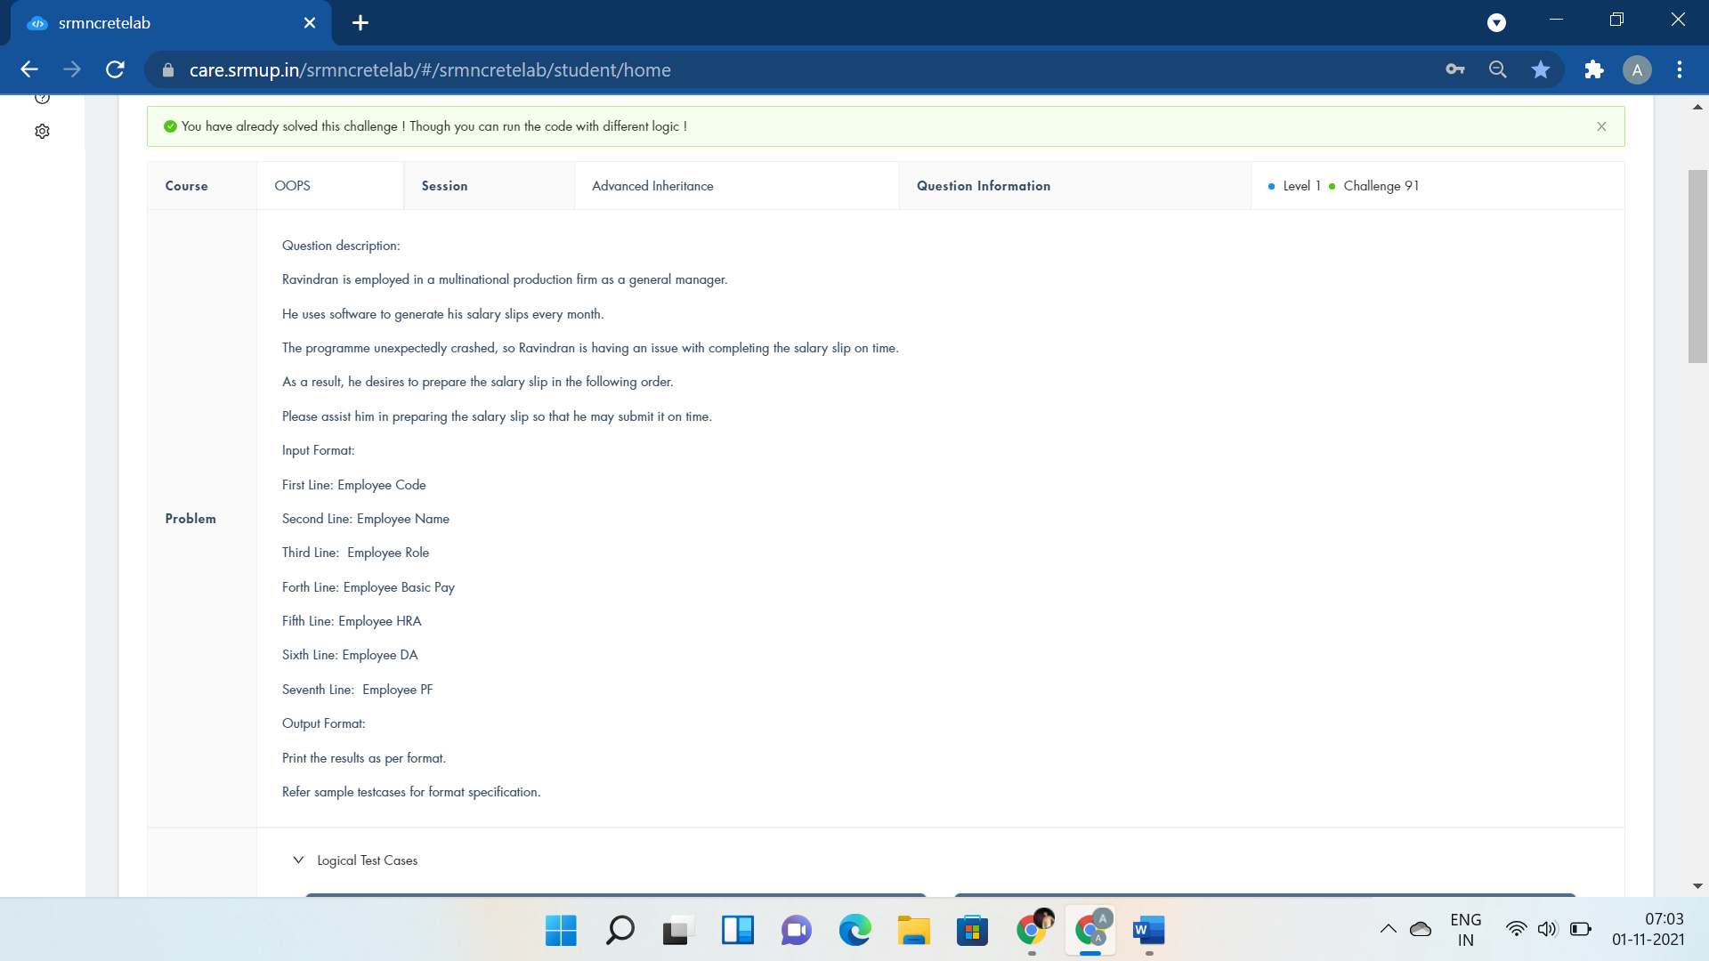

#include <iostream>

using namespace std;

class Employee{

public:

};

class Salary : public Employee{

public:

int code,basic,hra,da,pf,total;

string name,position;

void getEmpDetails(){

cin>>code>>name>>position;

}

void getPayDetails(){

cin>>basic>>hra>>da>>pf;

}

void calculate(){

total=basic+hra+da-pf;

}

void display(){

cout<<"Employee Number:"<<code<<endl;

cout<<"Employee Name:"<<name<<endl;

cout<<"Employee Role:"<<position<<endl;

cout<<"Employee Net Pay:"<<total<<endl;

}

};

int main()

{

Salary s;

s.getEmpDetails();

s.getPayDetails();

s.calculate();

s.display();

return 0;

}

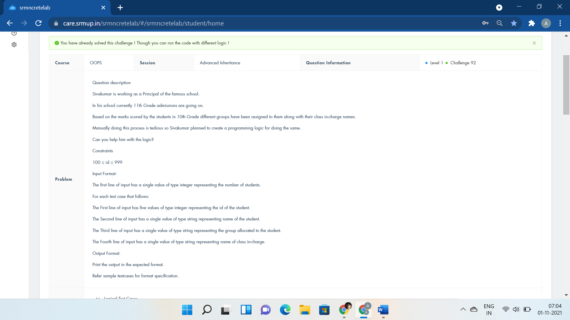

#include <iostream>

using namespace std;

class Person{

};

class Teaching : public Person{

};

class Instructor : public Teaching{

public:

int id;

string name,group,staff;

void accept_instructor_details(){

cin>>id>>name>>group>>staff;

}

void display_instructor_details(){

cout<<"Id:"<<id<<endl;

cout<<"Name:"<<name<<endl;

cout<<"Group:"<<group<<endl;

cout<<"Staff:"<<staff<<endl;

}

};

int main()

{

int n;

cin>>n;

Instructor inst[n];

for(int i=0;i<n;i++){

inst[i].accept_instructor_details();

inst[i].display_instructor_details();

}

return 0;

cout<<"Instructor *inst;";

}

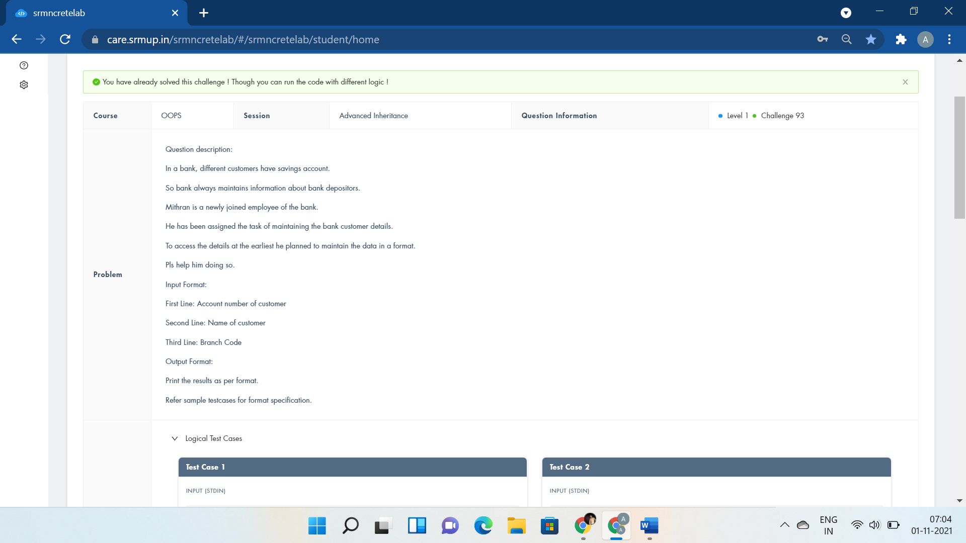

#include <iostream>

using namespace std;

class acc{

public:

int no;

void getacc(){

cin>>no;

}

};

class branch:public acc{

public:

string name;

int code;

void getbranch(){

cin>>name>>code;

}

void display(){

cout<<"Acc No:"<<no<<endl;

cout<<"Name:"<<name<<endl;

cout<<"Branch Code:"<<code<<endl;

}

};

int main()

{

branch b;

b.getacc();

b.getbranch();

b.display();

return 0;

}

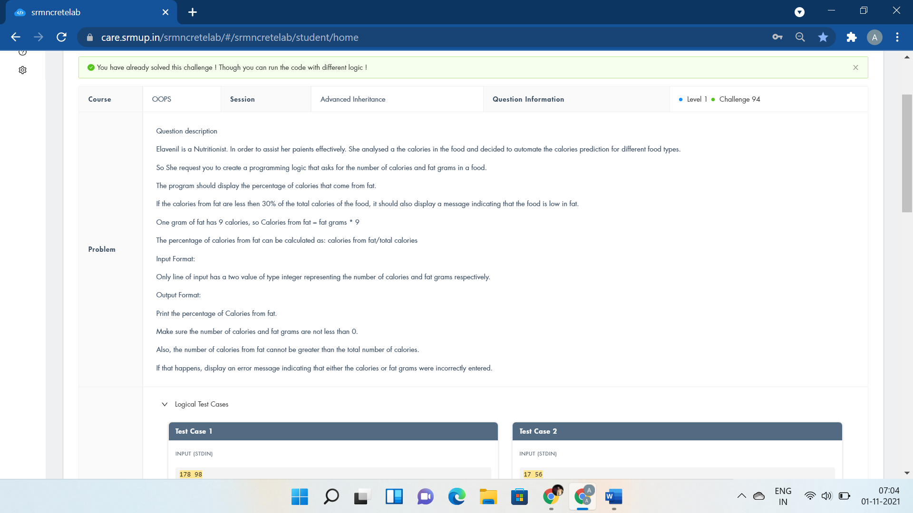

#include <iostream>

using namespace std;

class Food{

};

class Nutritionist:public Food{

};

class Patient:public Nutritionist{

public:

float cal,fat;

void calorie(){

cin>>cal>>fat;

}

void dplan(){

if(cal<fat)

cout<<"Fatgrams cannot be less than 0 or greater than calories"<<endl;

cout<<"Calories from fat: "<<fat*9/cal*100<<"%";

}

};

int main()

{

Patient p;

p.calorie();

p.dplan();

return 0;

}



#include <iostream>

using namespace std;

class Sam{

};

class Robin:public Sam{

public:

int rows;

void read(int y){

rows=y;

}

void display(){

for(int i=0;i<rows;i++){

for(int j=0;j<rows;j++){

cout<<"* ";

}

cout<<endl;

}

}

};

int main()

{

Robin obj;

int y;

cin>>y;

obj.read(y);

obj.display();

return 0;

}



#include <iostream>

using namespace std;

class student{

public:

int roll,m1,m2;

void get(){

cin>>roll>>m1>>m2;

}

};

class sports{

public:

int sp;

void getsm(){

cin>>sp;

}

};

class statement : public student, public sports{

public:

void display(){

cout<<"Roll No:"<<roll<<endl;

cout<<"Total:"<<m1+m2+sp<<endl;

cout<<"Average:"<<(m1+m2+sp)/3<<endl;

}

};

int main()

{

statement obj;

obj.get();

obj.getsm();

obj.display();

return 0;

}



#include <iostream>

using namespace std;

class Shape{

public:

int len,wid;

void input(int l,int b){

len=l;

wid=b;

}

};

class Rectangle: public Shape{

public:

void output(){

cout<<len*wid<<endl;

}

};

class Triangle: public Shape{

public:

void output(){

//if((len*wid)%2==0)

cout<<0.5*len*wid<<endl;

//else

//cout<<len*wid/2+1<<endl;

}

};

int main()

{

int l,b;

cin>>l>>b;

Rectangle rect;

Triangle tri;

rect.input(l,b);

tri.input(l,b);

rect.output();

tri.output();

return 0;

}

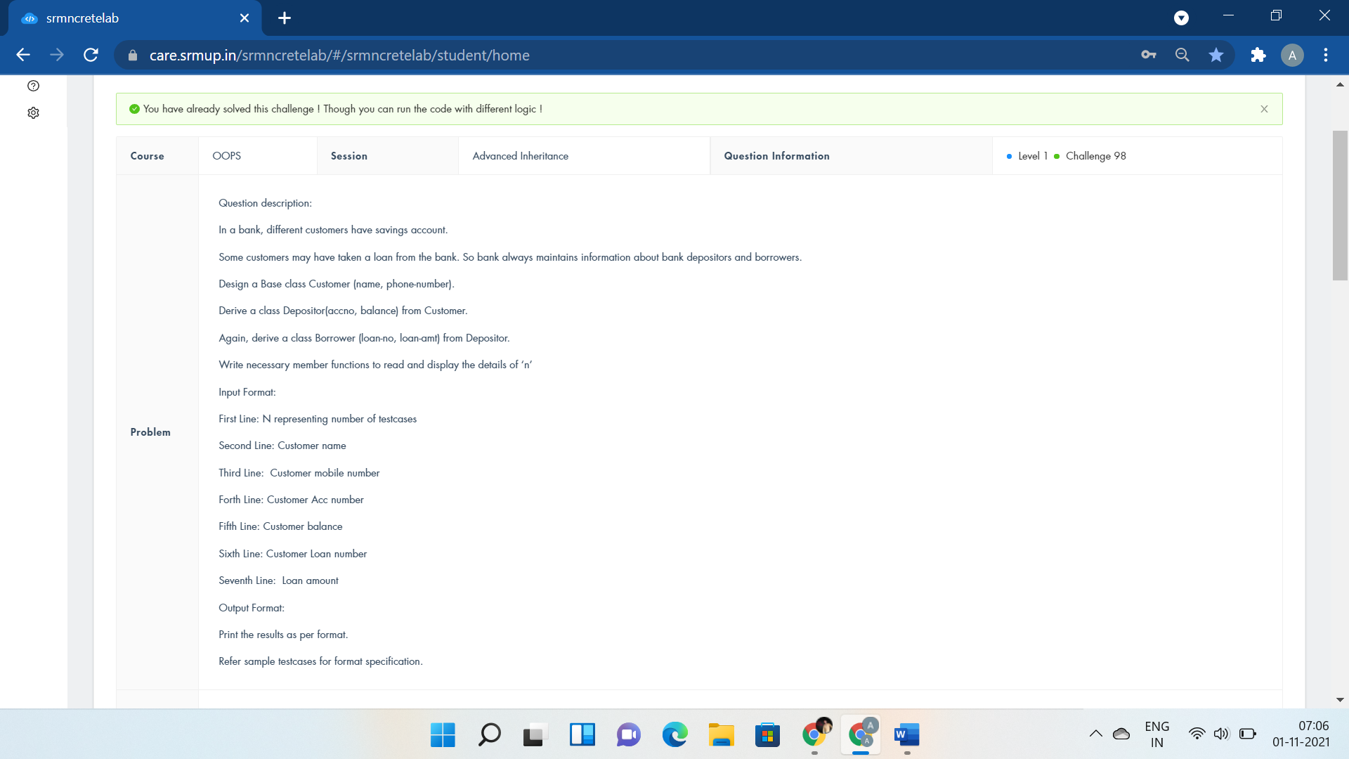

#include <iostream>

using namespace std;

class customer{

public:

int no;

long long int mobile;

string name;

void acceptc(){

cin>>name>>mobile>>no;

}

};

class deposit:public customer{

public:

int bal;

void acceptd(){

cin>>bal;

}

void dispd(){

cout<<"Customer Name:"<<name<<endl;

cout<<"Customer Phone No:"<<mobile<<endl;

cout<<"Customer A/c No:"<<no<<endl;

cout<<"Balance:"<<bal<<endl;

}

};

class borrow:public deposit{

public:

long long int loan_no,amt;

void acceptb(){

cin>>loan_no>>amt;

}

void dispb(){

cout<<"Loan No:"<<loan_no<<endl;

cout<<"Loan Amount:"<<amt<<endl;

}

};

int main()

{

int n;

cin>>n;

borrow b1[n];

for(int i=0;i<n;i++){

b1[i].acceptc();

b1[i].acceptd();

b1[i].acceptb();

b1[i].dispd();

b1[i].dispb();

}

return 0;

}



#include <iostream>

using namespace std;

class Receive{

public:

int r1,i1,r2,i2,r3,i3;

void getdata(){

cin>>r1>>i1>>r2>>i2;

}

};

class Operate : public Receive{

public:

void add(){

r3=r1+r2;

i3=i1+i2;

}

};

class Present :public Operate{

public:

void output(){

cout<<r1<<"+"<<i1<<"i"<<endl;

cout<<r2<<"+"<<i2<<"i"<<endl;

cout<<r3<<"+"<<i3<<"i"<<endl;

}

};

int main()

{

Present calc;

calc.getdata();

calc.add();

calc.output();

return 0;

}

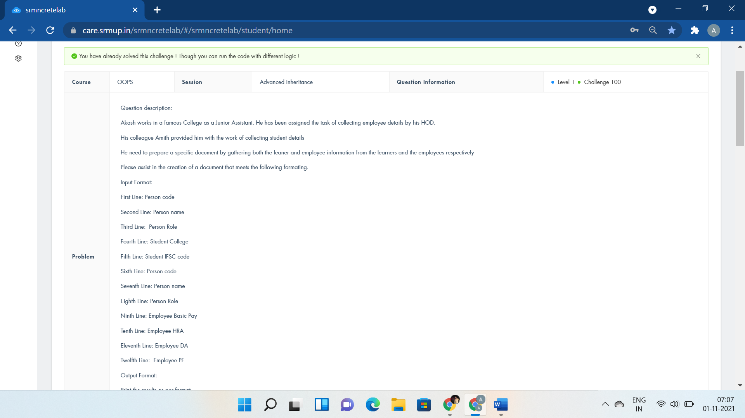

#include <iostream>

using namespace std;

class Person{

};

class Employee : private Person{

};

class Student : private Person{

public:

int n1,n2,basic,hra,da,pf;

string name1,role1,col,ifsc,name2,role2;

void getdetail(){

cin>>n1>>name1>>role1>>col>>ifsc>>n2>>name2>>role2;

}

void getEmployeeDetails(){

cin>>basic>>hra>>da>>pf;

}

void student_display(){

cout<<"Person number:"<<n1<<endl;

cout<<"Person name:"<<name1<<endl;

cout<<"Person Role:"<<role1<<endl;

cout<<"Student college Name:"<<col<<endl;

cout<<"Student IFSC:"<<ifsc<<endl;

cout<<"Person number:"<<n2<<endl;

cout<<"Person name:"<<name2<<endl;

cout<<"Person Role:"<<role2<<endl;

}

void employee_display(){

cout<<"Employee Basic pay:"<<basic<<endl;

cout<<"Employee HRA:"<<hra<<endl;

cout<<"Employee DA:"<<da<<endl;

cout<<"Employee PF:"<<pf<<endl;

cout<<"Employee Net Pay:"<<basic+hra+da-pf<<endl;

}

};

int main()

{

Student e;

e.getdetail();

e.getEmployeeDetails();

e.student_display();

e.employee_display();

return 0;

cout<<"s.student_display();";

}